Job Description & Person Specification

Position: | Service Delivery Coordinator | Division: | DHU - UEC
Location: | LLR / UCD / UCN | Reporting to: | Deputy Operations Manager

Purpose of the Role

The role will play an integral part of the urgent care team providing real time coordination of the operational shift. Additional responsibilities are to provide a smooth and efficient running of the service, capturing patient information, maintaining delivery performance of the service in line with key KPI’s & Quality assurances and ensuring compliance with standards in line with agreed policies and procedures.

The post holder will participate in promoting DHU Health Care CIC.

Key Areas of Responsibility & Accountability

• Co-ordinating the Operational team and providing support, guidance, advice, and feedback to employees in all locations within the shift.
• Co-ordinating external communications that fall outside of established call pathways.
• Determine which roles within the service each member of the clinical and operational team will occupy during their shift, in line with activity and levels of demand and lead accordingly.
• Actively monitor the call volumes within the services to ensure optimum service delivery to patients and maintenance of service standards.
• Ensure the shift staffing and resources are appropriate, arranging additional staff as required to ensure capacity is available to meet the demands of the service, maintaining service standards (Not UCN). Ensure remote workers are logged on and working allocated hours.
• Compliance and achievement of DHU and National quality standards.
• Pro-actively liaise with all clinical staff to ensure the smooth running of the service.
• Ensure business Continuity plan is followed for any emergency/Incident.
• Act as Fire Warden when on shift and ensure that the emergency services are notified in the event of an alarm.
• Update the CAS dashboard / SitRep on a regular basis routinely and hourly at times of peak demand as per specific site requirement.
• Ensure that all calls are completed on Adastra SystmOne before leaving shift.
• Maintaining equipment – checking systems and printers as necessary and reporting any faults to IT and appropriate manager.
• Complete and review incident log report (LLR only).
• Ensure that any unresolved matters are handed over to the duty manager and the next coordinator before ending your shift on all work shifts.
• Co-ordination of the operations within the out-of-hour service utilising escalation and contingency plans, reporting to Clinical Lead and or Tactical on Call Manager for any unresolved issues for escalation.
• Adhere to Health and Safety policy.
• Monitoring calls and home visits to mitigate any breaches.
• In accordance with DHU Policies & procedures maintain their own development and competence through attendance at mandatory training and specific developments as identified via PDP in the appraisal process
• At all times ensure own work practices, conduct, behavior and attitudes provide an example of professionalism for all staff. Be a role model for DHU values.
• Consistently guarantee uphold and advance the equality, diversity, as well as the rights of patients, the public, and colleagues in the service.
• Ensure effective management of risk within sphere of responsibility in accordance with DHU Risk Strategy, ensuring compliance with Health & Safety legislation and Clinical Governance Policies and Guidelines.
• Receive calls from other healthcare providers and action as appropriate.

General duties

• Adhere to all procedures, protocols and other relevant calls as appropriate.

• Aid assistance/training to new members of staff to ensure the maintenance of a high-quality service.

• Attend training and meetings as and when required to do so by Management.

• Assist in general duties, administrative and clerical duties and maintain manual/computerised records as required.

• Maintain strict confidentiality in relation to all issues concerned within the service and adhere to the requirements of the Data Protection Act 2018

• To be flexibility in availability to support rota fulfilment.

• Notify Line Managers of any circumstances which may affect the provision of a high-quality service.

• Keeping our patients, the public and ourselves safe and well is part of every role in DHU. To maintain high levels of safety all staff are encouraged to openly report incidents and any risk identified using Datix. Where this is not possible, to provide appropriate support to ensure accurate and timely reporting of information in a secure manner.

• Any other duties commensurate with the post.

• Travel to other sites may be necessary in course of duties.

• As you will expect the organisation may change from time to time and you will be expected to meet the operational requirements.

• Any other reasonable duties or administration duties as required from time to time.

Communications and Working Relationships

• Staff within DHU Health Care CIC and related organisations

• Clinical and managerial staff within participating Primary Care Trusts

• Staff within the local authority Social Services

• In/Out of Hours and other related services within the local health economy, Internal and External stakeholders

• Ambulance services

The job description may be subject to review over time in discussion with the Job holder,

This position will operate both ‘in’ and ‘out’ of hours.

This job description is not exhaustive, and it is expected that the job holder will be flexible in their approach, and undertake any reasonable duties as requested by Management/Directors.

Person Specification

The Job holder will have:

Post: Service Delivery Coordinator
Education / Qualification | Essential | Desirable | Assessment Criteria
5 GCSE's - including math’s and English or Equivalent | x |  | Certificate /Application
Good standard of literacy and numeracy | x |  | Certificate /Application
IT Qualification or relative experience | x |  | Certificate /Application
Experience | Essential | Desirable | Assessment Criteria
Previous experience of working with the public in a busy environment | x |  | Application / Interview
Previous IT experience | x |  | Application / Interview
Communication with all people | x |  | Application/Interview
Good attendance record | x |  | Reference
Skills and Ability | Essential | Desirable | Assessment Criteria
Excellent communication both written and verbal/interpersonal | x |  | Interview/Reference
Ability to analyse data and draw conclusions, when required | x |  | Interview/Reference
Ability to use own initiative | x |  | Interview/Reference
Ability to uphold confidentiality | x |  | Interview/Reference
Accurate record keeping | x |  | Interview/Reference
Listening skills | x |  | Interview/Reference
Computer skills | x |  | Cert / App/Int
Excellent telephone manner | x |  | Application / Interview
Effective time management and organisational skills | x |  | Interview/Reference
Able to use problem solving skills | x |  | Application / Interview
Job Circumstances | Essential | Desirable | Assessment Criteria
Ability to work flexible hours at weekends and bank holidays | x |  | Application / Interview
Willingness to undergo training as required | x |  | Application / Interview
Personal Qualities | Essential | Desirable | Assessment Criteria
Team Player | X |  | App/Int/Ref
Sense of humour | x |  | Interview
Conscientious | X |  | App/Int/Ref
Reliable | X |  | App/Int/Ref
Demonstrates enthusiasm and flexibility | X |  | App/Int/Ref
Role Model | X |  | App/Int/Ref

Behavioral Qualities

We value our people through a coaching culture offering staff engagement, well-being support, career progression and inspirational, visible leadership.

At the heart of everything we do, you will find our CARE values – principles, standards and behaviours we live by:

We CARE for you. We are always….

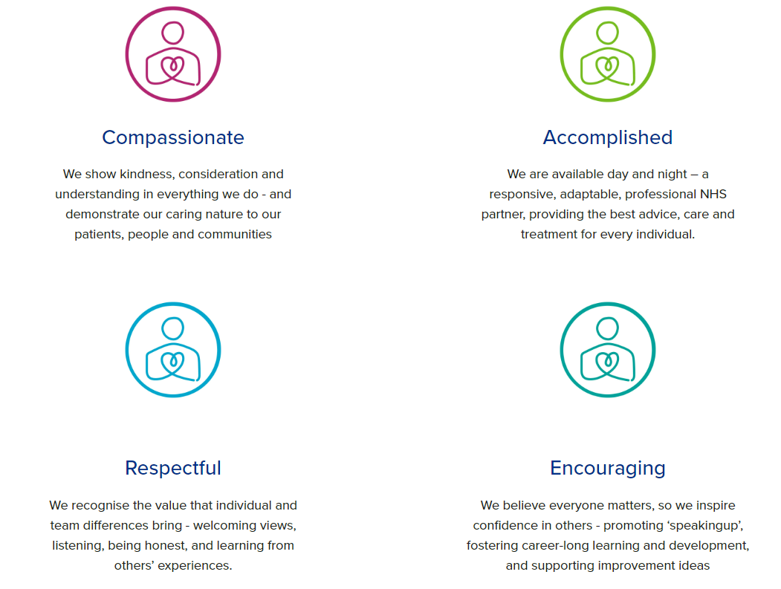

Diversity

DHU believe our workforce should be as diverse as the range of services we offer, and the communities we serve. We are committed to valuing and encouraging diversity throughout our workforce, regardless of age, disability, gender reassignment, marriage or civil partnership, pregnancy and maternity, race, religion or belief, sex or sexual orientation. As part of our mission we are dedicated to eliminating discrimination

Acknowledgment

I acknowledge receipt and confirm my understanding and acceptance of the responsibilities specified in my Job Description.

Please Note: If you are unclear of any requirement in this document obtain clarification from your line manager.

Signature of Post Holder: |  | Date:
Name:

