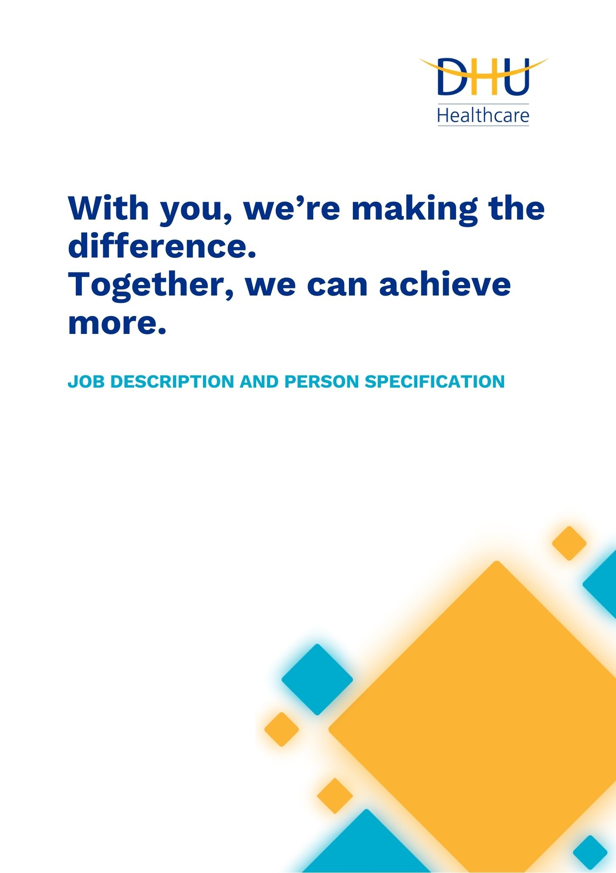
Personal Assistant (Senior)
111/UEC/Primary Care
Reference: F3082
Issue: 1.0
Date: 03/2025
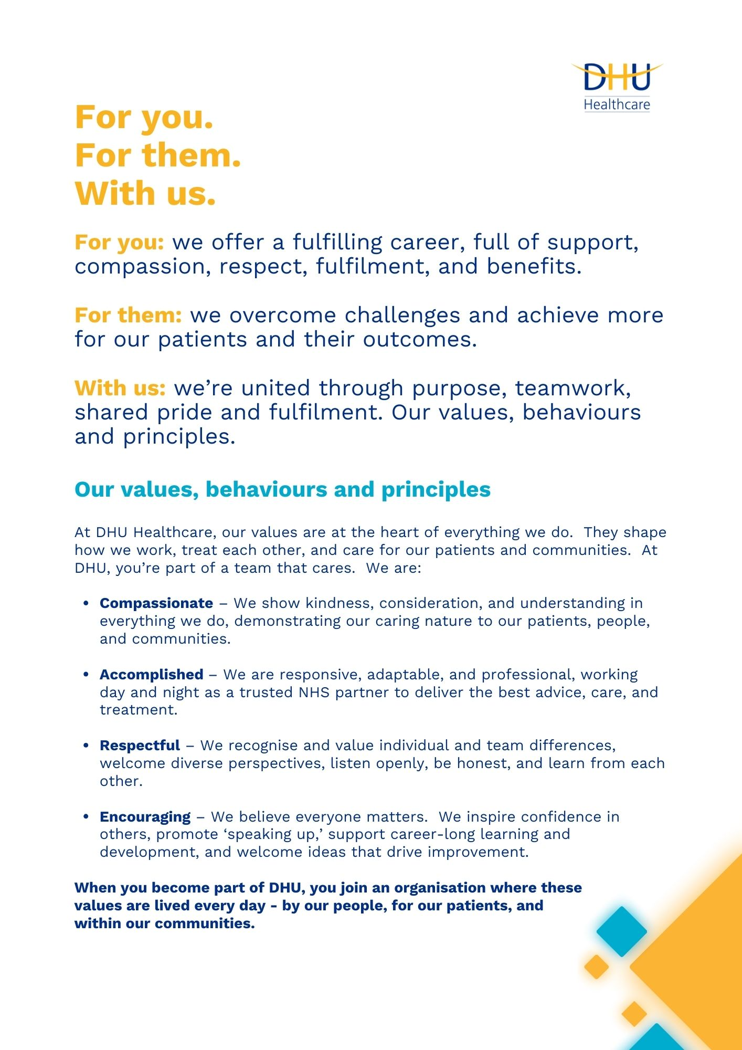

Job Description and Person Specification
Position: | Personal Assistant (Senior)
Division: | 111 / UEC / Primary Care
Location: | Regional – with travel across sites within the DHU portfolio, (2-3 times per week), as required
Reporting to: | Executive Director
Band: | 6.0
Last reviewed: | September 2025

Purpose of the role

As a not-for-profit Community Interest Company, DHU Healthcare’s mission is to deliver compassionate, high-quality patient care every day. The Personal Assistant (PA) provides high-quality, proactive administrative and business management support to one of our Executive Directors, enabling them to carry out their responsibilities effectively. Acting as a trusted partner, the PA will provide first-class organisational support, manage complex and busy diaries, prepare high-quality documents, and foster strong relationships with internal and external stakeholders.
Performance measures
- Diary and workload management – 95% of meetings scheduled with no conflicts or double bookings; all diary changes communicated within 1 working day.
- Meeting readiness – Agendas, briefing notes, and papers prepared and distributed at least 2 working days before meetings in 95% of cases.
- Communication effectiveness – 90% of emails and correspondence acknowledged within 1-2 working days; 100% of confidential matters handled without breach.
- Document quality – 100% of minutes issued within 5 working days; reports and presentations produced with less than 2% requiring rework due to errors.
- Stakeholder relationships – Positive feedback from 90%+ of surveyed stakeholders on professionalism, responsiveness, and reliability.
- Service reliability – 95% of assigned tasks delivered within agreed deadlines; issues escalated within 24 hours of identification.
- Project co-ordination & Tracking – Assist in the planning and execution of strategic projects assigned by the Executive Lead.

Key areas of accountability and responsibility

Executive and administrative line management support
- Provide a comprehensive personal administrative service to the Executive Director, including proactive diary management, meeting coordination and preparation of agendas, papers and minutes.
- Draft correspondence, reports, briefing papers and presentations; produce accurate analysis and documentation for project work.
- Manage incoming correspondence and enquiries, prioritising and filtering items, responding where appropriate and ensuring timely replies.
- Maintain effective electronic and paper filing systems and reading room applications, ensuring easy retrieval and adherence to information governance requirements.
- Screen telephone calls and act as an initial point of contact, representing the Director with professionalism and courtesy.
- Line management of admin/support staff.

Meeting and event coordination
- Arrange meetings, drafting agendas, preparing and circulating papers, taking high-quality minutes and maintaining reporting schedules.
- Liaise with internal and external stakeholders to coordinate complex diaries and organise events, conferences and workshops, including logistics, travel and accommodation.
- Commission briefing papers or other materials to ensure the Director is well prepared for meetings.
- Assist in organising visits and events involving commissioners, regulators or partners, ensuring the Director’s office projects DHU’s professional image.

Business management and projects
- Support project management and procurement activities, including raising purchase orders, requisitions and receipts for goods and services.
- Manage expenses and maintain asset registers, tracking orders and supplies across the division.
- Assist the Director with project or bid work, maintaining progress against milestones, gathering information and producing summary reports.
- Work with senior leaders to support service reviews, gap analysis and service improvement and new service proposals.

Governance and compliance
- Ensure that confidentiality is always maintained, releasing information only to authorised individuals and in line with the Data Protection Act.
- Comply with health and safety regulations and equalities legislation; promote equal opportunities and diversity within DHU.
- Maintain up-to-date knowledge of administrative and organisational policies and procedures, including NHS and DHU guidelines, and adopt emerging technologies to improve efficiency.

Person specification
This role would suit someone who:
- Is a trusted partner – highly organised, discreet and able to build strong working relationships across all levels, comfortable handling confidential and sensitive information.
- Can take initiative and ownership – proactively manage diaries and priorities, anticipate needs and resolve issues independently.
- Can communicate with clarity and empathy – have excellent verbal and written communication skills and adapt your style to suit different audiences.
- Can demonstrate adaptability and resilience – manage competing demands, juggle multiple tasks, and maintain composure when priorities change.
- Believes in inclusive teamwork – value different perspectives and encourage colleagues to speak up and develop, contributing to an inclusive workplace
Experience & Qualifications
- Previous experience as a personal assistant supporting a senior Executive or Director within a complex organisation (Essential).
- Demonstrable experience of managing diaries, balancing multiple commitments and organising meetings and events (Essential).
- Experience of servicing and supporting senior committees and executive groups, including taking high-quality minutes and actions (Essential).
- Experience of working with Chief Officers and Directors, demonstrating professionalism and discretion (Essential).
- Experience of working in an NHS or healthcare environment (Desirable).
- Experience of supporting more than one Director simultaneously (Desirable).
- Experience of working within a large, complex organisation or multi-site environment (Desirable).
Knowledge & Skills

- Excellent communication skills, both verbal and non-verbal, with a professional telephone manner and the ability to engage with a wide range of stakeholders.
- Accurate and efficient minute-taking skills; the ability to summarise discussions, capture actions and follow up progress.
- Strong organisational and planning skills; ability to prioritise and deliver work to challenging deadlines.
- Can act autonomously and make sensible judgements involving complex facts and situations.
- Excellent writing skills with strong attention to detail and good use of grammar.
- Knowledge of administrative policies and procedures, advanced keyboard skills and proficiency in Microsoft Word, Outlook, Excel, PowerPoint and internet/intranet applications.
Personal Attributes

- Professional, approachable, and values driven.
- Be proactive, creative and solutions-focused, taking pride in ensuring the Director’s office runs smoothly and effectively.
- Detail-oriented with a high standard of presentation and accuracy.
- Confident in building relationships and communicating with diverse stakeholders.
- Flexible and open to working across a range of projects and subject areas.
- Enthusiastic about DHU’s mission and committed to supporting patients, colleagues, and communities.
- Ethical, discreet handling of business and patient-related data under GDPR.

Reference: F3082
Issue: 1.0
Date: 03/2025
Signature: Date:
Surname:
First name:
Key policies and expectations
Belonging
DHU believe our workforce should be as diverse as our services and the communities we serve. We value and encourage diversity throughout our workforce, regardless of age, disability, gender reassignment, marriage or civil partnership, pregnancy and maternity, race, religion or belief, sex, or sexual orientation. As part of our mission, we actively work to eliminate discrimination and create a place where everyone can belong.
Diversity
DHU Health Care CIC believe our workforce should be as diverse as the range of services we offer, and the communities we serve. We are committed to valuing and encouraging diversity throughout our workforce, regardless of age, disability, gender reassignment, marriage or civil partnership, pregnancy and maternity, race, religion or belief, sex or sexual orientation. As part of our mission, we are dedicated to eliminating discrimination.
Safeguarding
DHU Health Care CIC is committed to safeguarding and promoting the welfare of Adults, Children and Young People and expects all staff and volunteers to share this commitment.
Health & safety
The post holder is required to take responsibility for their own personal safety and that of other persons who may be affected by his/her acts or omissions at work. The post holder is required to comply with DHU Health Care CIC’s Health & Safety Policy and Procedures.
Infection prevention and control
Infection prevention and control is pivotal in ensuring a safe & clean environment for both patients and staff. IP&C is everyone’s responsibility and strict adherence to the IP&C policy is expected of ALL employees of the organisation.
General
As you will expect, the organisation may change and from time to time you will be expected to meet the operational requirements of the business and any other reasonable duties as required.
Postholder acknowledgement
I acknowledge receipt and confirm my understanding and acceptance of the responsibilities specified in my Job Description.
Please Note: If you are unclear of any requirement in this document obtain clarification from your line manager.

DHU Healthcare is the trading name of DHU Health Care C.I.C., a limited company registered in England and Wales. Registration no. 05834163. Registered office: No:2, Roundhouse Rd, Derby, DE24 8JE.

