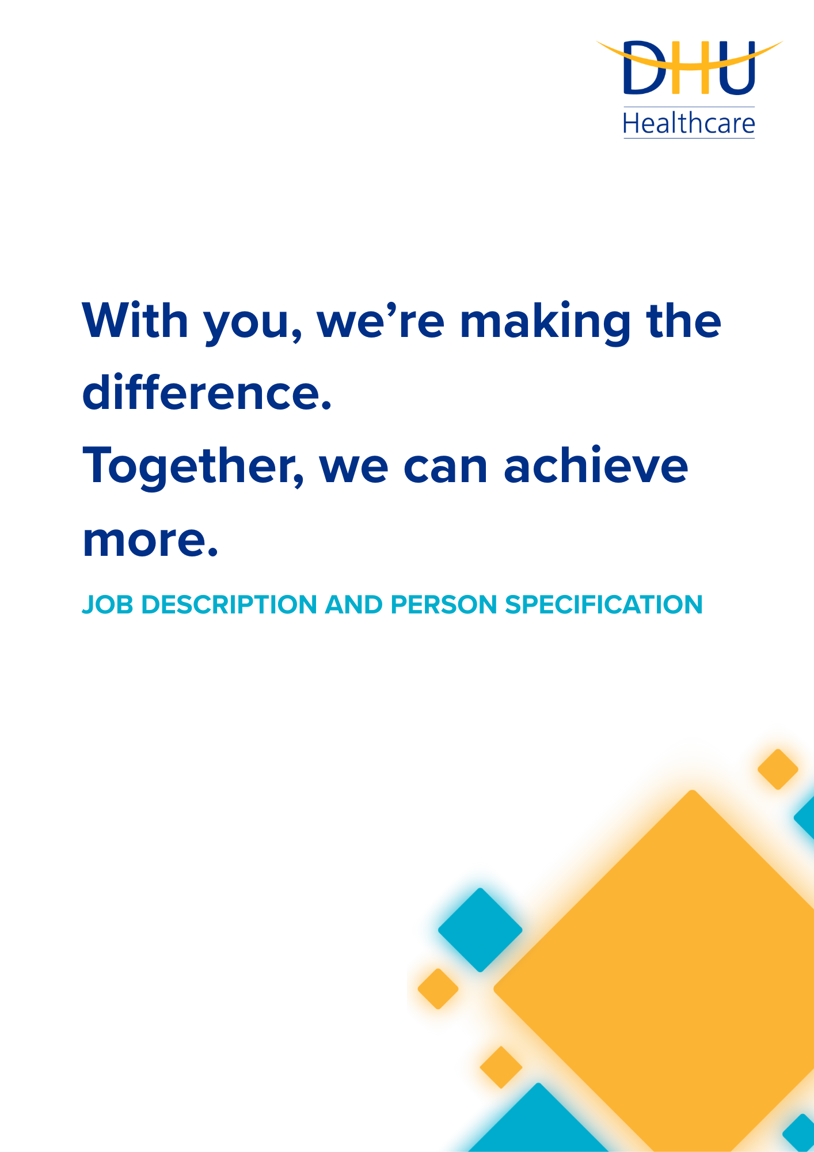

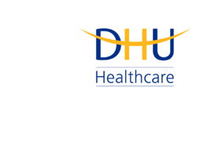
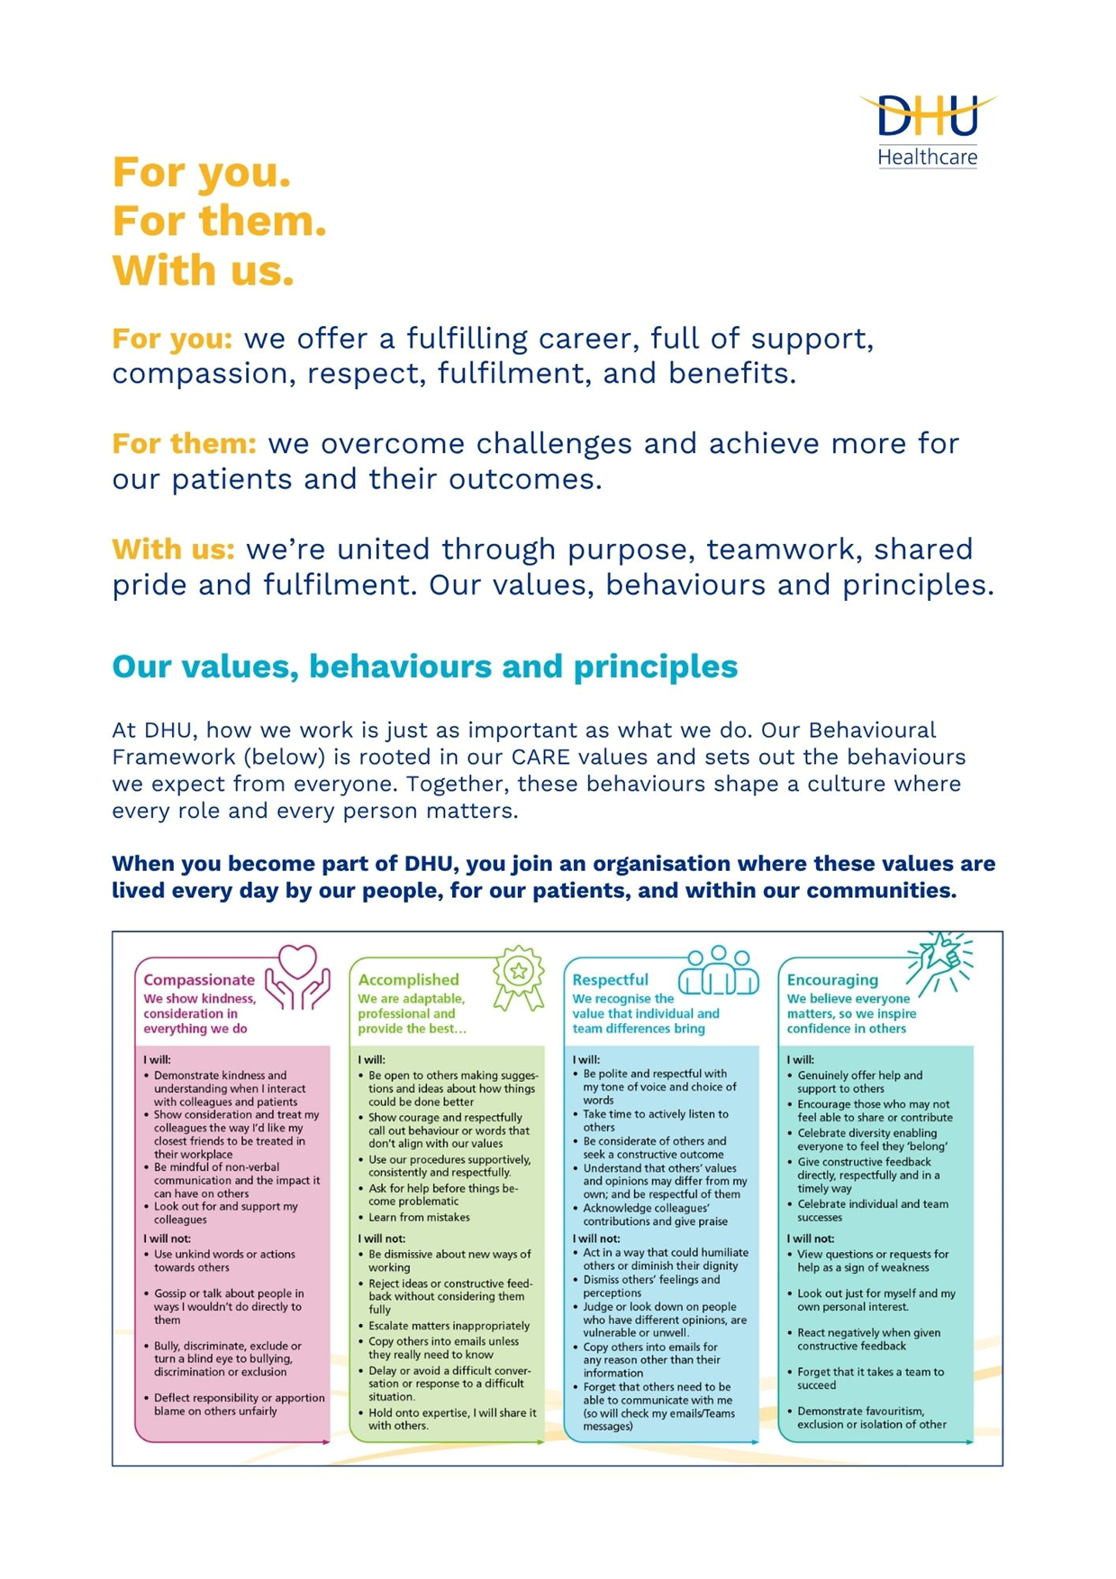

Job Description and Person Specification
Position: | First Line Analyst
Division: | Corporate
Location: | Hybrid
Reporting to: | Lead Reporting Analyst
Band: | 5
Last reviewed: | 2026-07-06

Purpose of the role
DHU’s First Line Analysts are responsible for providing the first line of support for Data Services reporting requests and issues, and ensuring the timely delivery of recurring reporting, dashboards, and analytical products across DHU.
Working as the primary operational resource within the Data Services department, the role is responsible for managing assigned requests, maintaining existing reporting solutions, and completing recurring, BAU, activities.
First Line Analysts develop and maintain reports using SQL, Power BI, SSRS, and Excel, ensuring all outputs are accurate, validated and delivered on time. They investigate data issues, support continuous improvements, and work closely with the rest of the Data Services department.

Key Success Measures

- Delivery of all recurring reporting activities within agreed timescales
- Timely management of assigned service requests
- High levels of report accuracy and data quality
- Positive stakeholder feedback
- Contribution towards improving existing reports and processes
- Consistent adherence to Data Services standards and documentation

Key areas of accountability and responsibility

Service Delivery

- Act as the first point of contact for assigned reporting requests.
- Own assigned tickets through to completion.
- Deliver recurring reports and dashboards.
- Complete scheduled BAU reporting activities.

Reporting

- Develop and maintain reports using SQL, Power BI, and SSRS.
- Produce ad-hoc reports where required.
- Refresh, validate and publish reporting outputs.
- Maintain existing reporting solutions.

Data

- Extract and manipulate data using SQL.
- Validate datasets prior to publication.
- Investigate data quality issues.
- Escalate complex technical issues where appropriate.

Continuous Improvement

- Identify opportunities to improve reporting processes.
- Assist with automation initiatives.
- Produce and maintain technical documentation.
- Participate in knowledge sharing across the team.

Person specification

Education & Qualifications

- Minimum of 2 years’ experience within a reporting or data focused role - *Essential
- Relevant technical qualification or equivalent experience - *Desirable
- Degree or equivalent qualification - *Desirable
- Microsoft Certification - *Desirable

Technical Skills

- Strong SQL development - *Essential
- Experience developing PowerBi reports - *Essential
- Experience maintaining SSRS reports - *Essential
- Strong Microsoft Excel skills - *Essential
- Ability to troubleshoot reporting issues - *Essential
- DAX knowledge - *Desirable
- GitHub utilisation - *Desirable
- Data Modelling qualification - *Desirable

Experience

- Delivering operational reporting - *Essential
- Managing workload through a ticketing system - *Essential
- Producing recurring reporting - *Essential
- NHS or health-sector exposure - *Desirable
- Adastra - *Desirable
- SystmOne - *Desirable
- Workforce Management systems - *Desirable
- Telephony systems - *Desirable

Key policies and what we expect from each other
Belonging: At DHU, we want everyone to feel like they truly belong. We believe our team should be just as diverse as the people and communities we care for. Whoever you are, wherever you're from - you’re welcome here. We’re all about building a culture where everyone feels seen, heard, and valued.
Diversity: We’re proud of the different backgrounds, experiences and perspectives our people bring. That’s what makes us strong. We treat everyone fairly and respectfully, and we’re committed to creating a workplace that celebrates what makes each of us unique. No one should ever feel left out, left behind, or treated differently.
Safeguarding: Keeping people safe is at the heart of what we do. Whether it’s patients or colleagues, children or adults - we all share a responsibility to look out for one another and speak up if something doesn’t feel right.
Health & safety: Everyone has a part to play in staying safe at work. Be mindful of how your actions affect others and follow our health and safety guidance. If you see something that’s not safe, speak up.
Wellbeing: Look after your own health and wellbeing, and help create a positive, supportive workplace for everyone. Use the resources available, treat colleagues with respect, and speak up if something isn’t right. Together, we can make DHU a place where everyone can thrive.
Infection prevention and control: A clean and safe space is everyone’s responsibility. Stick to our infection prevention guidance - it helps protect you, your team, and the people we care for.
Looking after our planet: We all have a part to play in protecting the environment. At DHU, we do our bit by using resources wisely and keeping waste to a minimum. That means recycling and sorting waste properly, switching off lights and equipment when we’re not using them, reporting heating or cooling issues as soon as they happen, and cutting down on unnecessary travel. Small actions, big difference - especially when we all do them together.
Teamwork: As part of our DHU team, you might be asked to take on different tasks now and then to help us meet our goals. We all pitch in where we can, support each other, and stay flexible to keep things running smoothly.
Postholder acknowledgement
I acknowledge receipt and confirm my understanding and acceptance of the responsibilities specified in my Job Description.
Please Note: If you are unclear of any requirement in this document obtain clarification from your line manager.

DHU Healthcare is the trading name of DHU Health Care C.I.C., a limited company registered in England and Wales. Registration no. 05834163. Registered office: No:2, Roundhouse Rd, Derby, DE24 8JE.

