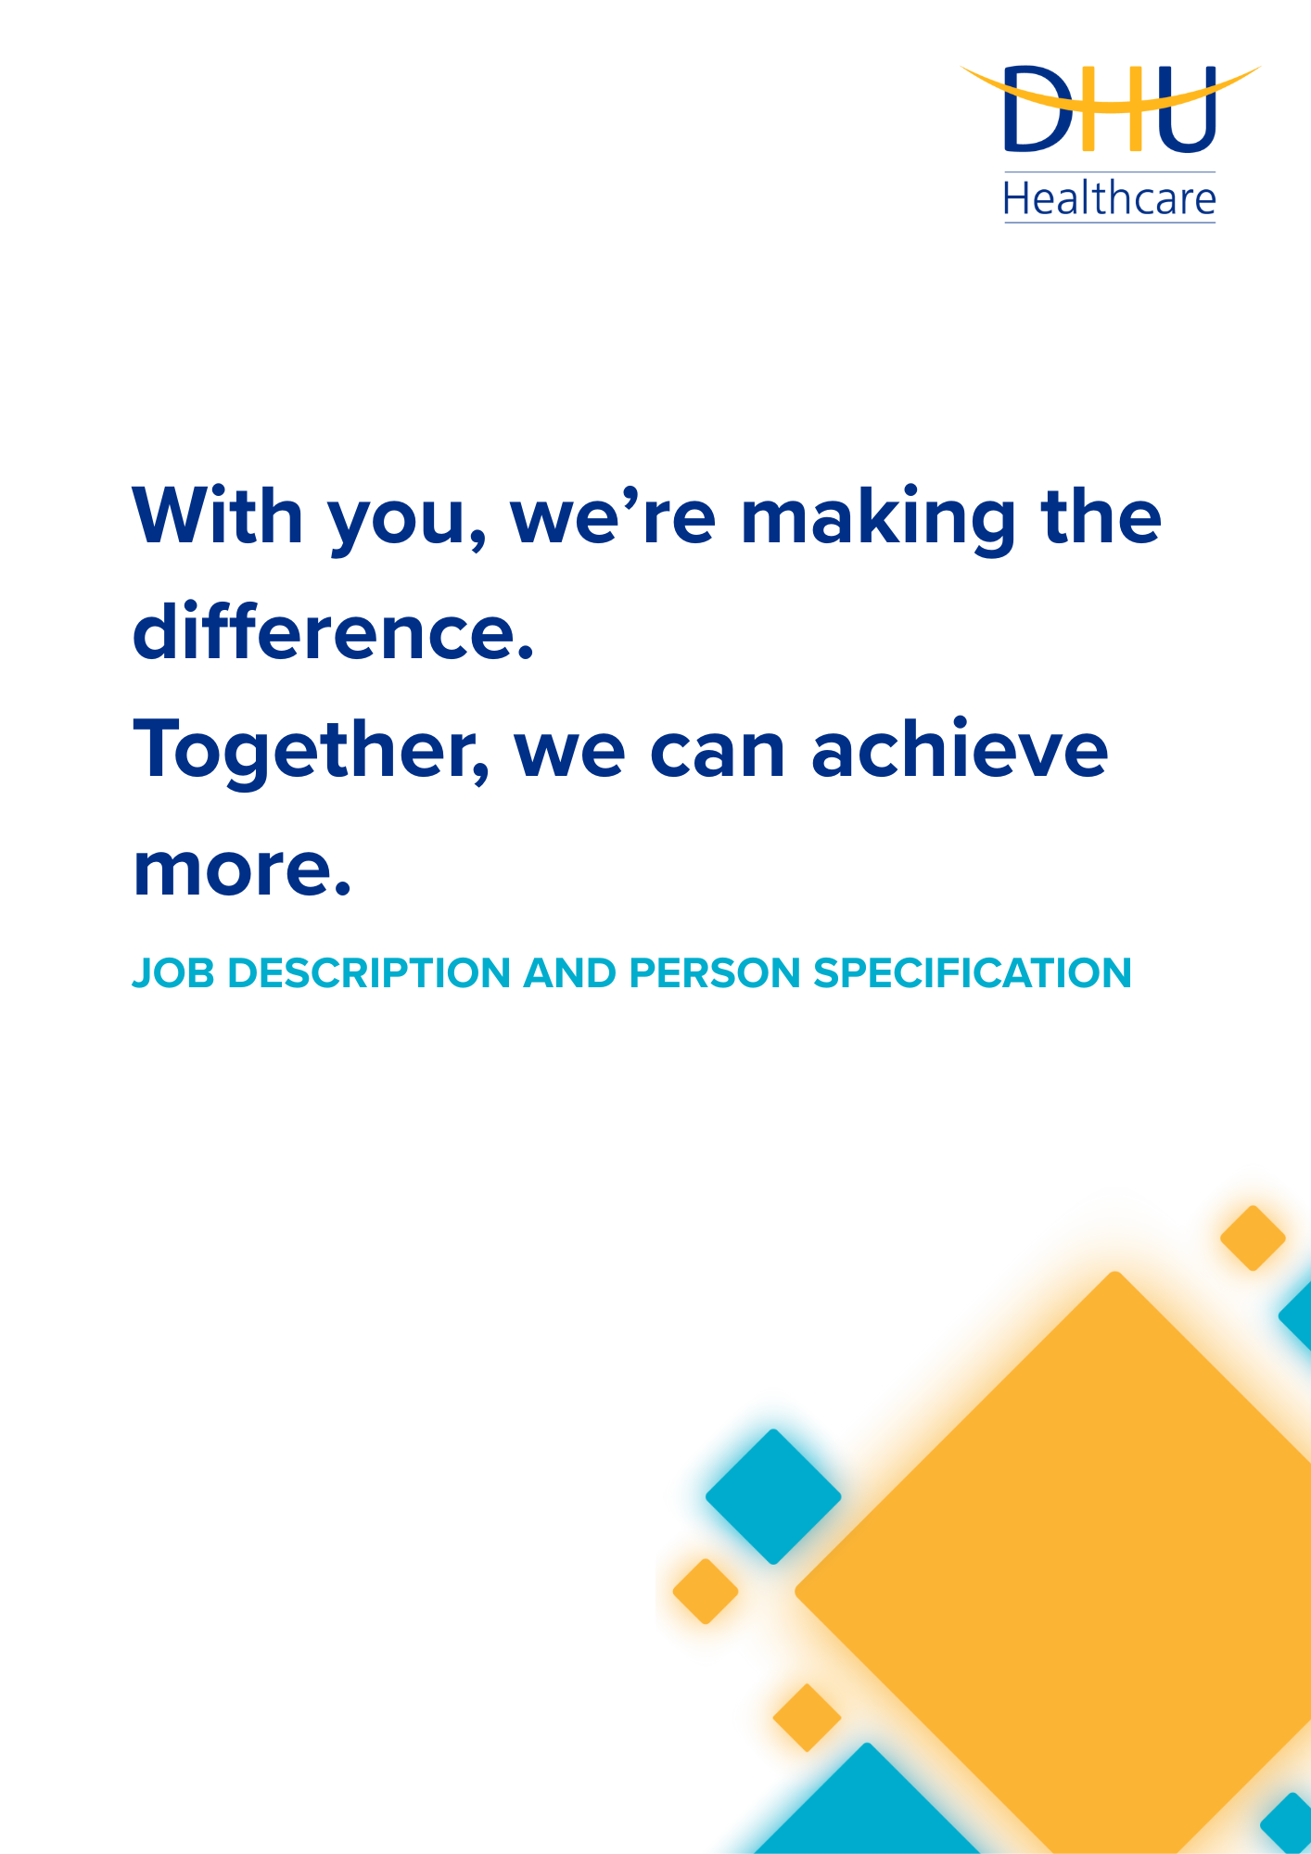
TRANSFORMATION & IMPROVEMENT JUNIOR PROJECT MANAGER
CORPORATE

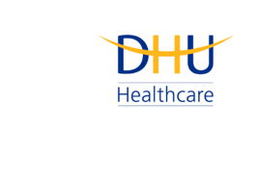
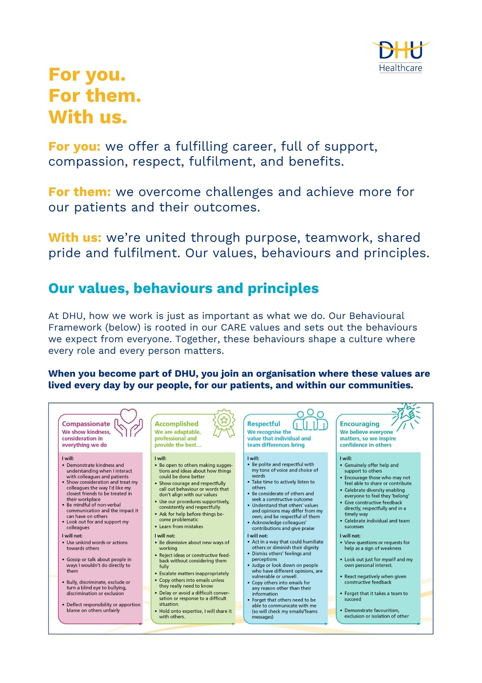

Job Description and Person Specification
Position: | Transformation & Improvement Junior Project Manager
Division: | Corporate
Location: | Derby or Leicester
Reporting to: | TBC
Band: | 6.0
Last reviewed: | August 2026

Purpose of the role
- To drive improvements in efficiency, clinical effectiveness and outcomes, value for money and improvements to staff and patient experience, reduce unwarranted variation and strengthen business effectiveness across agreed priority areas by planning and delivering low complexity improvement and transformation initiatives.

- To play a supporting role in delivering larger scale, more complex transformation under the leadership of senior Project Managers.
Performance Measures
The postholder will work closely with colleagues across the organisation and with external stakeholders such as suppliers to plan, coordinate and facilitate delivery of projects, ensuring clearly defined schedules and key milestones making project progress visible.
They will follow agreed governance, risk management, reporting and performance assurance, processes producing reports that clearly communicate progress, impact, risks, and outcomes to ensure that projects deliver on time.

Key areas of accountability and responsibility
Transformation and Improvement:
- Plan, coordinate and facilitate delivery of low-complexity projects
- Maintain effective project documentation to agreed standards, including minutes of meetings, action logs, project plans, risk logs and highlight reports
- Support the delivery of larger scale, more complex transformation under the direction of senior Project Managers
- Ensure all deliverables meet required standards and comply with information governance, data protection and confidentiality requirements
- Build strong, positive relationships with internal and external stakeholders to ensure consistent communication and aligned ways of working
- As you will expect, the organisation may change from time to time, and you will be expected to meet the operational requirements
- Any other reasonable duties as required from time to time

Person specification
Experience & Qualifications

- Proven successful planning and organisation experience including project management
- Training in project management, service improvement or change management
- Relevant project management qualification for example PRINCE 2 Foundation, MSP or equivalent, or the willingness to complete training in own time

Knowledge & Skills

- Influencing skills with the ability to present to and engage a wide range of stakeholders in ideas and proposals and reach agreements
- Analytical skills and the ability to draw qualitative and quantitative data from a wide range of sources and present in a clear and concise manner
- Ability to manage complex workload under pressure and prioritise to meet deadlines
- A good standard of written English
- Excellent interpersonal skills - ability to form positive relationships and coach proactively and cooperatively at all levels
- IT literate with excellent knowledge of Microsoft Office packages
- Ability to work effectively within a team

Personal Attributes

- Consistently professional, demonstrating discretion and full adherence to confidentiality and information governance requirements
- Enthusiasm and ability to seek out and resolve problems including an ability to challenge the status quo
- Reliability and flexibility, able to contribute to changing demands of projects

Key policies and what we expect from each other
Belonging: At DHU, we want everyone to feel like they truly belong. We believe our team should be just as diverse as the people and communities we care for. Whoever you are, wherever you're from - you’re welcome here. We’re all about building a culture where everyone feels seen, heard, and valued.
Diversity: We’re proud of the different backgrounds, experiences and perspectives our people bring. That’s what makes us strong. We treat everyone fairly and respectfully, and we’re committed to creating a workplace that celebrates what makes each of us unique. No one should ever feel left out, left behind, or treated differently.
Safeguarding: Keeping people safe is at the heart of what we do. Whether it’s patients or colleagues, children or adults - we all share a responsibility to look out for one another and speak up if something doesn’t feel right.
Health & safety: Everyone has a part to play in staying safe at work. Be mindful of how your actions affect others and follow our health and safety guidance. If you see something that’s not safe, speak up.
Wellbeing: Look after your own health and wellbeing, and help create a positive, supportive workplace for everyone. Use the resources available, treat colleagues with respect, and speak up if something isn’t right. Together, we can make DHU a place where everyone can thrive.
Engagement: Support and promote employee engagement by collaborating effectively, communicating openly, and contributing to a positive team culture.

Infection prevention and control: A clean and safe space is everyone’s responsibility. Stick to our infection prevention guidance - it helps protect you, your team, and the people we care for.
Looking after our planet: We all have a part to play in protecting the environment. At DHU, we do our bit by using resources wisely and keeping waste to a minimum. That means recycling and sorting waste properly, switching off lights and equipment when we’re not using them, reporting heating or cooling issues as soon as they happen, and cutting down on unnecessary travel. Small actions, big difference - especially when we all do them together.
Teamwork: As part of our DHU team, you might be asked to take on different tasks now and then to help us meet our goals. We all pitch in where we can, support each other, and stay flexible to keep things running smoothly.
Postholder acknowledgement
I acknowledge receipt and confirm my understanding and acceptance of the responsibilities specified in my Job Description.
Please Note: If you are unclear of any requirement in this document obtain clarification from your line manager.

DHU Healthcare is the trading name of DHU Health Care C.I.C., a limited company registered in England and Wales. Registration no. 05834163. Registered office: No:2, Roundhouse Rd, Derby, DE24 8JE.

