Job Description & Person Specification

Position: | Dispatch Controller | Division: | Operations
Location: | Northampton General Hospital | Reporting to: | Operational Manager

Purpose of the Role

To manage the effective distribution of all calls to available clinical resources across Northamptonshire contract to ensure optimum results against Quality Requirement standards. Continuously monitor all call activity and work closely with the Duty Manager and on call Manager to urgently resolve problems. To respond to calls using NHS Pathways as required.

Key Success Measures

- Caring & Compassion - We will actively listen to understand and empathise with others’, with a desire to support both patients and colleagues.
- Always Professional - We will be accountable for consistently delivering high quality healthcare for our patients
- Respect & Dignity - We will actively listen to each other and our patients to answer their concerns or questions. We will maintain and respect patient’s dignity and must ensure it is never compromised.
- Everyone Matters - We will actively encourage feedback from both patients and colleagues to continually improve our service, ensure everyone has an opportunity to have their voice heard, and everyone has an opportunity to further develop their skills and competencies.

Key Areas of Responsibility & Accountability

  - Maintain awareness of the location of all supporting non-clinical and clinical staff at all bases at all times and highlight any shortfall or problems to the Duty Manager.
  - Track location of drivers/ GP’s on home visits and ensures call allocation of calls and is efficiently managed to provide seamless patient care and avoid breaches of procedure.
  - Dispatch calls within 2 minutes of receipt ensuring effective and efficient use of all available resources.
  - Continuously monitor service levels and re-dispatching ensuring that internal processes and procedures are strictly adhered to.
  - Monitor and prioritise urgent call backs ensuring immediate management of call amalgamation.
  - Receive and dispatch calls from secondary partners e.g., EMAS ensuring that procedures are clearly followed.
  - Ensure effective and efficient handover to change of shifts takes place and urgent, important, and other relevant information is available to ensure continuity of patient care on shift reports.
  - Ensure the effective and efficient utilization of clinicians through equal distribution of workload across the organisation. Utilise cross border agreements with other OHH organisations appropriately for dispatch of calls to ensure continuity of patient care.
  - Take responsibility for ensuring that regional information on available clinical resources is accurate and provided prior to each shift. Adopt a flexible and holistic view to managing across all localities and bases.
  - Ensure your knowledge of locations is up to date and understand the availability of base staff.
  - Develop and maintain effective working relationships with receptionists and clinical staff.
  - Maintain systems knowledge and understanding bespoke Contact Centre services contracts in delivering call handling and administrative services to ad hoc requirements inclusive of health alert 24 contracts.
  - Offer an administrative service for a variety of activities within Wooding dean as required and on request of the CC Management team.
  - To be able to accurately fill out any requested data spreadsheets when and if required.
  - As you will expect the organisation may change from time to time and you will be expected to meet the operational requirements.
  - Any other reasonable duties as required from time to time.

Form No: F3082 | Issue No: 1.2 | Date: 10- 2019

Person Specification

The job holder will have;

Criteria | Standard | Essential / Desirable
Qualifications / Training | To GCSE Level  Good standard of English | D E
Skills and Knowledge | A high standard of interpersonal and communications skills and able to build good internal working relationships.  Demonstrate the ability to manage high levels of workflow at busy times and take an operationally strategic view.  Confident in decision making.  Familiar with clinical/ Customer Management systems and navigates confidently.  Demonstrates accountability for own actions and the ability to support the contact centre management team where necessary.  To successfully undertake NHS 111 pathways training. | E  E  E  E E  E
Previous Experience | Call handling and dispatching in an OOH primary care environment.  Demonstrates a good understanding of operations in Out of Hours Primary Care of the Health Sector. | D  E
Personal Attributes | Professional in approach and leads by example. Adopts a consistently positive approach to new ideas.  Proactive and energetic in seeking service improvements.  Able to work effectively on own initiative at times of high pressure | E E  E E
Page 2

Form No: F3082 | Issue No: 1.0 | Date: 12-2018

Diversity

DHU Health Care CIC believe our workforce should be as diverse as the range of services we offer, and the communities we serve. We are committed to valuing and encouraging diversity throughout our workforce, regardless of age, disability, gender reassignment, marriage or civil partnership, pregnancy and maternity, race, religion or belief, sex or sexual orientation. As part of our mission we are dedicated to eliminating discrimination

Safeguarding

DHU Health Care CIC is committed to safeguarding and promoting the welfare of Adults, Children and Young People and expects all staff and volunteers to share this commitment.

Infection Prevention & Control

Infection Prevention & Control is pivotal in ensuring a safe & clean environment for both patients and staff. IP&C is
everyone’s responsibility and strict adherence to the IP&C policy is expected of ALL employees of the organisation.

General
As you will expect the organisation may change from time to time and you will be expected to meet the operational requirements of the business and any other reasonable duties as required from time to time.

Acknowledgment

I acknowledge receipt and confirm my understanding and acceptance of the responsibilities specified in my Job Description.
Please Note: If you are unclear of any requirement in this document obtain clarification from your line manager.

Behavioural Qualities

We value our people our people through a coaching culture offering staff engagement, wellbeing support, career progression and inspirational, visible leadership.

At the heart of everything we do, you will find our CARE values – principles, standards and behaviours we live by:

We CARE for you. We are always….

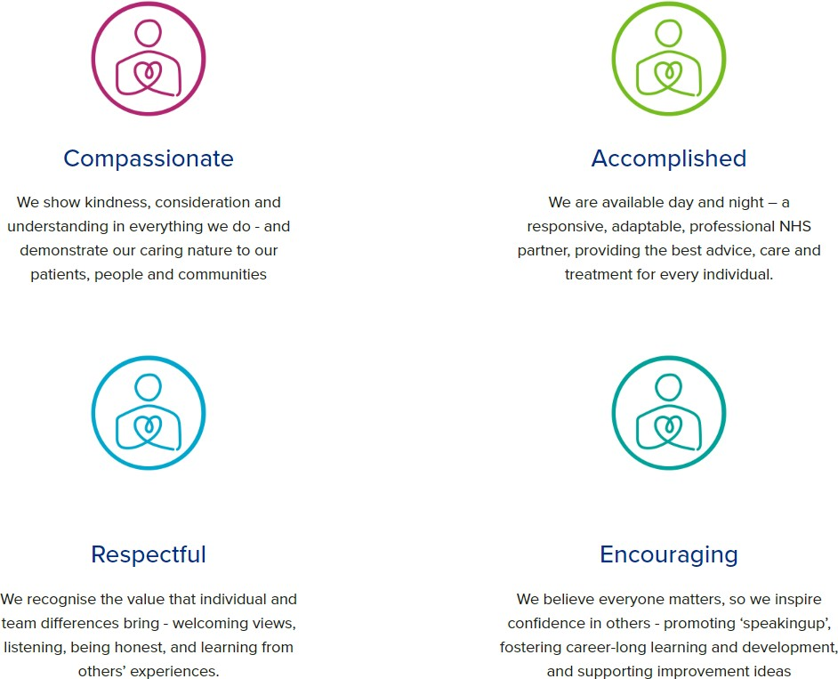

Diversity

DHU believe our workforce should be as diverse as the range of services we offer, and the communities we serve. We are committed to valuing and encouraging diversity throughout our workforce, regardless of age, disability, gender reassignment, marriage or civil partnership, pregnancy and maternity, race, religion or belief, sex or sexual orientation. As part of our mission we are dedicated to eliminating discrimination

Acknowledgment

I acknowledge receipt and confirm my understanding and acceptance of the responsibilities specified in my Job Description.

Please Note: If you are unclear of any requirement in this document obtain clarification from your line manager.

Signature of Post Holder: |  | Date:

Name:

