
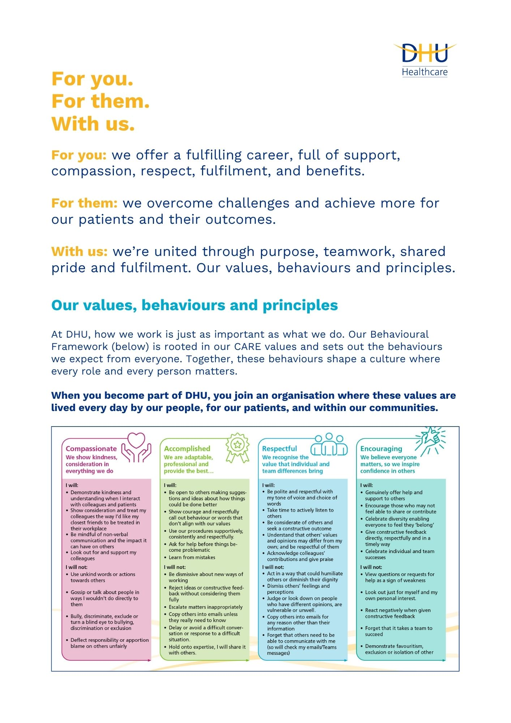

Job Description and Person Specification
Position: | People Programme Manager – Absence Improvement Programme
Division: | People & Culture
Location: | Multi-site with regular travel across DHU locations
Reporting to: | Programme Lead – Absence Improvement Programme
Band: | Band 7
Last reviewed: | Month 2025

Purpose of the role

- The People Programme Manager will lead the implementation of DHU's Absence Improvement Programme across designated services and sites.

- Working alongside operational leaders and People colleagues, the postholder will build leadership capability, support the adoption of improved attendance management practices and facilitate sustainable behavioural and cultural change.

- The role will act as a catalyst for improvement, using data, coaching and practical support to enable managers to address attendance challenges confidently and consistently.

- The postholder will work collaboratively across organisational boundaries to strengthen management capability, improve colleague experience and support the successful delivery of programme outcomes.

Key areas of accountability and responsibility

- Programme Implementation
- Support the delivery of programme initiatives across assigned services and locations.
- Translate programme plans into practical local implementation activity.
- Monitor progress and escalate barriers appropriately.
- Identify local risks, barriers and dependencies that may impact implementation and escalate appropriately.
- Ensure interventions are delivered consistently and effectively.
- Support the embedding of programme outputs into local management practice and business-as-usual processes.
- Capability Building
- Coach managers to improve confidence in attendance management.
- Facilitate workshops and learning sessions.
- Support managers to undertake high-quality return-to-work discussions and wellbeing conversations.
- Reinforce accountability for attendance management across leadership teams.
- Practice Improvement
- Review local attendance practices and identify opportunities for improvement.
- Support the implementation of new tools, processes and ways of working.
- Promote evidence-based approaches to attendance management.
- Ensure programme activity supports consistent application of DHU's attendance management policies, employee relations frameworks and wellbeing approach.
- Promote a fair, compassionate and inclusive approach to attendance management, ensuring wellbeing, reasonable adjustments and colleague experience remain central to programme delivery.
- Share examples of effective practice across services.
- Data and Insight
- Analyse workforce information to identify trends and hotspots.
- Develop targeted interventions based on local needs.
- Use data to evaluate the effectiveness of improvement activity.
- Contribute to benefits delivery through effective local implementation and evidence of sustained practice improvement.
- Support services to interpret and utilise workforce intelligence.
Key areas of accountability and responsibility
- Stakeholder Engagement
- Build effective relationships with operational leaders, People colleagues and specialist services.
- Work collaboratively with People Practices teams to ensure aligned support.
- Act as a trusted advisor and critical friend to managers.
- Encourage engagement and ownership of improvement activity.
- Support local communication and engagement activity to encourage ownership and participation across services.
- Scope and Boundaries
- The People Programme Manager is responsible for enabling the delivery of the Absence Improvement Programme.
- The role is not accountable for:
- Undertaking return-to-work meetings on behalf of managers.
- Assuming line management responsibility for operational teams.
- Providing routine employee relations advice.
- Managing formal absence cases directly.
- Replacing the advisory support provided by People Practices teams.
- Managers remain accountable for attendance management within their teams.
- People Practices teams remain accountable for employee relations advice and case support.
- Working Relationships
- Programme Lead – Absence Improvement Programme.
- Chief People Officer.
- Heads of Service and Operational Leaders.
- People Practices Managers.
- People Advisors.
- People Business Partners.
- Occupational Health and Wellbeing Teams.
- Workforce Information and Planning Teams.
- Learning and Development colleagues.
- Success Measures
- Improved consistency in attendance management practices.
- Increased manager confidence and capability.
- Delivery of programme milestones within designated areas.
- Positive feedback from operational leaders.
- Evidence of sustainable changes in practice.
- Contribution to improvements in attendance performance.

Person specification
- Essential Criteria
- CIPD Level 7 qualification or equivalent experience.
- Significant experience within HR, workforce improvement, organisational development or operational leadership roles.
- Experience leading or supporting change initiatives.
- Experience coaching and influencing managers.
- Experience using workforce data to inform interventions.
- Strong facilitation and stakeholder engagement skills.
- Ability to work effectively within complex operational environments.
- Ability to influence without direct authority.
- Ability to operate with credibility, resilience and sound judgement in complex and sensitive workforce environments.
- Desirable Criteria
- Experience of attendance improvement initiatives.
- Experience within NHS, healthcare or contact centre environments.
- Experience supporting operational teams working within 24/7 services.
- Knowledge of change management methodologies.
- Experience of quality improvement approaches.
Key policies and what we expect from each other
Belonging: At DHU, we want everyone to feel like they truly belong. We believe our team should be just as diverse as the people and communities we care for. Whoever you are, wherever you're from - you’re welcome here. We’re all about building a culture where everyone feels seen, heard, and valued.
Diversity: We’re proud of the different backgrounds, experiences and perspectives our people bring. That’s what makes us strong. We treat everyone fairly and respectfully, and we’re committed to creating a workplace that celebrates what makes each of us unique. No one should ever feel left out, left behind, or treated differently.
Safeguarding: Keeping people safe is at the heart of what we do. Whether it’s patients or colleagues, children or adults - we all share a responsibility to look out for one another and speak up if something doesn’t feel right.
Health & safety: Everyone has a part to play in staying safe at work. Be mindful of how your actions affect others and follow our health and safety guidance. If you see something that’s not safe, speak up.
Infection prevention and control: A clean and safe space is everyone’s responsibility. Stick to our infection prevention guidance - it helps protect you, your team, and the people we care for.
Looking after our planet: We all have a part to play in protecting the environment. At DHU, we do our bit by using resources wisely and keeping waste to a minimum. That means recycling and sorting waste properly, switching off lights and equipment when we’re not using them, reporting heating or cooling issues as soon as they happen, and cutting down on unnecessary travel. Small actions, big difference - especially when we all do them together.
Teamwork: As part of our DHU team, you might be asked to take on different tasks now and then to help us meet our goals. We all pitch in where we can, support each other, and stay flexible to keep things running smoothly.
Postholder acknowledgement
I acknowledge receipt and confirm my understanding and acceptance of the responsibilities specified in my Job Description.
Please Note: If you are unclear of any requirement in this document obtain clarification from your line manager.

DHU Healthcare is the trading name of DHU Health Care C.I.C., a limited company registered in England and Wales. Registration no. 05834163. Registered office: No:2, Roundhouse Rd, Derby, DE24 8JE.

Signature: Date:
Surname:
First name:

