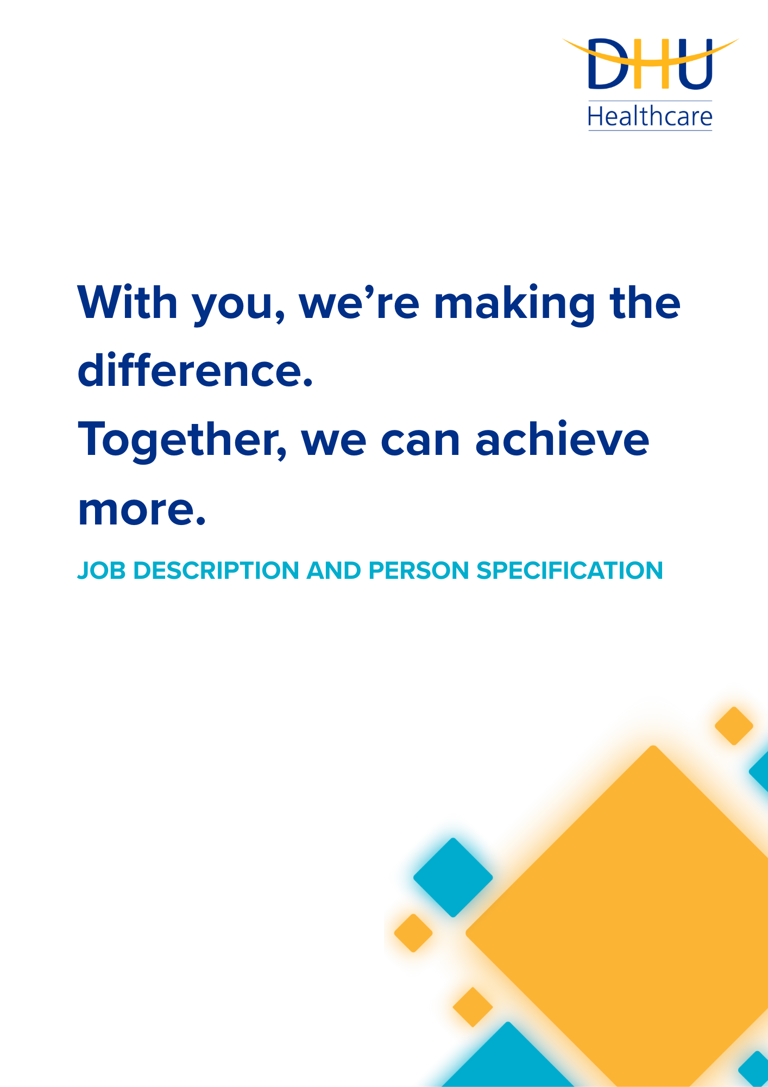

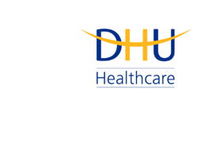
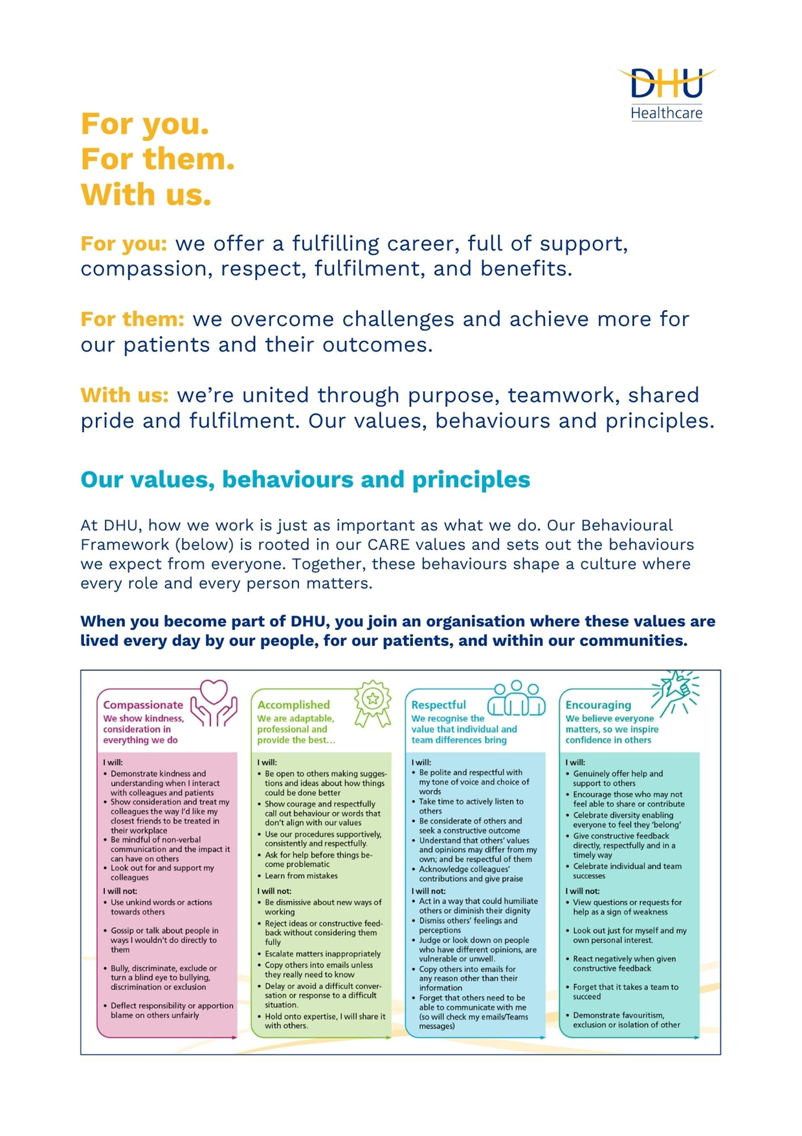

Job Description and Person Specification
Position: | Data Engineer
Division: | Corporate
Location: | Hybrid
Reporting to: | Lead Data Engineer
Band: | 7
Last reviewed: | 2026-07-08

Purpose of the role
DHU’s Data Engineers are responsible for designing, developing, and supporting robust data engineering solutions that enable reliable, secure, and scalable data throughout the organisation. This includes developing and maintaining ETL processes, databases, data models, APIs, and integrations that support all reporting and automation requirements.
You will work closely with internal and external stakeholders to translate complex data requirements into efficient engineering solutions, ensuring data is accurate, performant, and available when needed. You will continually seek opportunities to improve existing processes through automation, optimisation, and adoption of modern development practices.
Data Engineers play a key role in maintaining the integrity, quality, and performance of DHU's data estate, contributing to technical standards, supporting colleagues, and helping to deliver innovative data solutions that support the organisation's strategic objectives.

Key Success Measures

- Delivery of strategic data engineering solutions
- High quality, scalable, and reusable ETL/ELT processes
- Reliable, secure, and performant data platforms
- High quality SQL code and database design
- Successful onboarding of new services and data sources
- Positive stakeholder feedback on technical solutions
Key areas of accountability and responsibility

Technical Leadership

- Provide technical leadership across Data Services
- Promote engineering best practices throughout DHU
- Support colleagues with complex SQL, ETL/ELT and integration challenges
- Establish and maintain engineering standards
- Review technical solutions developed by colleagues
- Contribute to and challenge the technical roadmap of Data Services
- Mentor and coach colleagues across the department

Data Engineering

- Design, develop, and maintain ETL/ELT processes
- Develop scalable data integration solutions
- Design and maintain enterprise data models
- Support data warehouse development
- Develop APIs and automated data exchange processes
- Ensure data solutions are reliable, secure and maintainable
- Optimise data movement and processing performance

SQL Development

- Design advanced SQL solutions
- Develop and maintain stored procedures, views and functions
- Optimise database object performance
- Support data warehouse development
- Troubleshoot complex data issues

Solution Design

- Translate business requirements into technical solutions
- Lead technical design discussions
- Evaluate new technologies
- Ensure engineering solutions are robust, maintainable, and future proof

Governance

- Own and maintain technical documentation
- Promote development standards
- Ensure reporting solutions comply with governance and security requirements
- Support data quality improvement initiatives

Person specification

Education & Qualifications

- Significant experience in a data engineering environment - *Essential
- Degree or equivalent qualification - *Desirable
- Microsoft Certification - *Desirable

Technical Skills

- Advanced SQL development - *Essential
- ETL/ELT solution development - *Essential
- Database design and optimisation - *Essential
- SQL Server Integration Services (SSIS) - *Essential
- Data Modelling - *Essential
- Performance Optimisation - *Essential
- API integration and JSON/XML data structures - *Essential
- Source Control using GitHub - *Desirable
- Data warehouse principles - *Desirable
- KingswaySoft Integration Toolkit - *Desirable

Experience

- Designing and developing enterprise ETL/ELT solutions - *Essential
- Integrating data from multiple source systems - *Essential
- Translating business requirements into technical solutions - *Essential
- Performance tuning - *Essential
- Delivering technical projects - *Essential
- NHS or health-sector exposure - *Desirable
- Agile delivery - *Desirable
- CI/CD for reporting solutions - *Desirable
- Mentoring technical staff - *Desirable
- Adastra - *Desirable
- SystmOne - *Desirable
- Workforce Management systems - *Desirable
- Telephony systems - *Desirable

Key policies and what we expect from each other
Belonging: At DHU, we want everyone to feel like they truly belong. We believe our team should be just as diverse as the people and communities we care for. Whoever you are, wherever you're from - you’re welcome here. We’re all about building a culture where everyone feels seen, heard, and valued.
Diversity: We’re proud of the different backgrounds, experiences and perspectives our people bring. That’s what makes us strong. We treat everyone fairly and respectfully, and we’re committed to creating a workplace that celebrates what makes each of us unique. No one should ever feel left out, left behind, or treated differently.
Safeguarding: Keeping people safe is at the heart of what we do. Whether it’s patients or colleagues, children or adults - we all share a responsibility to look out for one another and speak up if something doesn’t feel right.
Health & safety: Everyone has a part to play in staying safe at work. Be mindful of how your actions affect others and follow our health and safety guidance. If you see something that’s not safe, speak up.
Wellbeing: Look after your own health and wellbeing, and help create a positive, supportive workplace for everyone. Use the resources available, treat colleagues with respect, and speak up if something isn’t right. Together, we can make DHU a place where everyone can thrive.
Infection prevention and control: A clean and safe space is everyone’s responsibility. Stick to our infection prevention guidance - it helps protect you, your team, and the people we care for.
Looking after our planet: We all have a part to play in protecting the environment. At DHU, we do our bit by using resources wisely and keeping waste to a minimum. That means recycling and sorting waste properly, switching off lights and equipment when we’re not using them, reporting heating or cooling issues as soon as they happen, and cutting down on unnecessary travel. Small actions, big difference - especially when we all do them together.
Teamwork: As part of our DHU team, you might be asked to take on different tasks now and then to help us meet our goals. We all pitch in where we can, support each other, and stay flexible to keep things running smoothly.
Postholder acknowledgement
I acknowledge receipt and confirm my understanding and acceptance of the responsibilities specified in my Job Description.
Please Note: If you are unclear of any requirement in this document obtain clarification from your line manager.

DHU Healthcare is the trading name of DHU Health Care C.I.C., a limited company registered in England and Wales. Registration no. 05834163. Registered office: No:2, Roundhouse Rd, Derby, DE24 8JE.

