Job Description & Person Specification

Position: | Medical Administrator | Division: | Primary Care – Buxton
Location: | Buxton Medical Practice | Reporting to: | Serena Linnell-Bennett (Practice Manager)

Purpose of the Role

To correctly input and check data entering the medical system. To then use the system to produce appropriate reports, searches and letters. You will also help in controlling the system with backups, maintenance and training. At all times being aware of the importance of proper procedure, confidentiality and accuracy of information. You will ensure to keep the Practice Computer system running efficiently and effectively, both by personal knowledge and use of help lines. The role also incorporates sometimes within the reception area as per respective rotas and holiday/sickness cover.

Key Success Measures

- Input onto the medical system which must include all clinical investigations, letters and results. This is through either direct input, scanning or links.
- Input consultations and visits when requested by the medical staff and doctors.
- All medical search criteria.
- Updating of all incorrect or ambiguous data.
- Design and run report parameters as requested.
- Produce monthly/quarterly/annual returns for required and approved agencies as well as the Practice.
- Production of standard patient letters.
- Managing the computerised appointments system
- Work flowing the appropriate information to colleagues using the Docman (or any future replacement) system.

Key Areas of Responsibility & Accountability

- As you will expect, the organisation may change from time to time, and you will be expected to meet the operational requirements
- Any other reasonable duties as required from time to time.
- Back up of computer and other IT systems.
- Maintenance and troubleshooting of IT systems.
- Checking and acting upon the Practice email.
- To keep abreast of new information technology, medical terminology and developments.
- Helping to teach other staff the computer systems installed in the GP practice.
- Covering for colleagues for sickness, holiday or other absence.
- Taking part in tea, coffee and washing up rota.
- To keep the general working areas tidy

Person Specification

- Previous experience in an administrative or IT-based role, ideally within a healthcare or medical setting.
- Excellent computer literacy and attention to detail, with the ability to manage data accurately and confidentially.
- Strong communication skills, both verbal and written, and the ability to work effectively within a busy, multi-disciplinary team.
- A proactive approach to problem-solving and the confidence to manage your own workload.
- Flexibility to assist colleagues and cover reception or secretarial duties as required.

Behavioral Skills

We value our people our people through a coaching culture offering staff engagement, wellbeing support, career progression and inspirational, visible leadership.

At the heart of everything we do, you will find our CARE values – principles, standards and behaviours we live by:

We CARE for you. We are always….

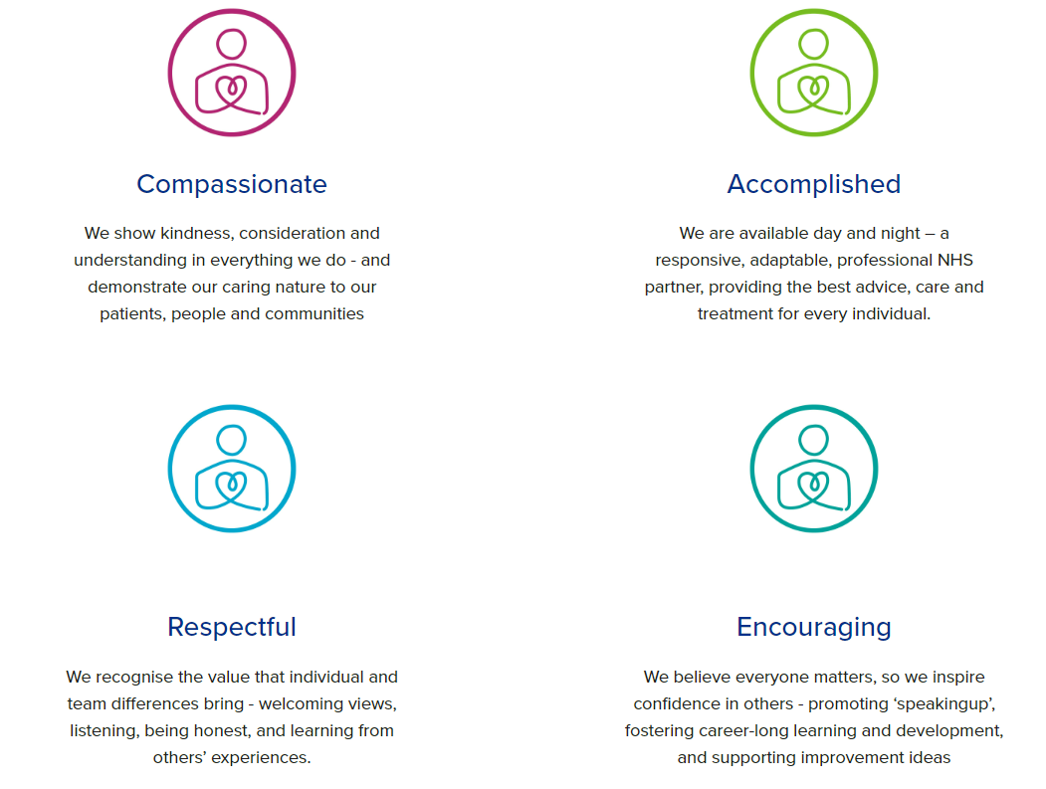

Diversity

DHU believe our workforce should be as diverse as the range of services we offer, and the communities we serve. We are committed to valuing and encouraging diversity throughout our workforce, regardless of age, disability, gender reassignment, marriage or civil partnership, pregnancy and maternity, race, religion or belief, sex or sexual orientation. As part of our mission we are dedicated to eliminating discrimination

Acknowledgment

I acknowledge receipt and confirm my understanding and acceptance of the responsibilities specified in my Job Description.

Please Note: If you are unclear of any requirement in this document obtain clarification from your line manager.

Signature of Post Holder: |  | Date:
Name:

