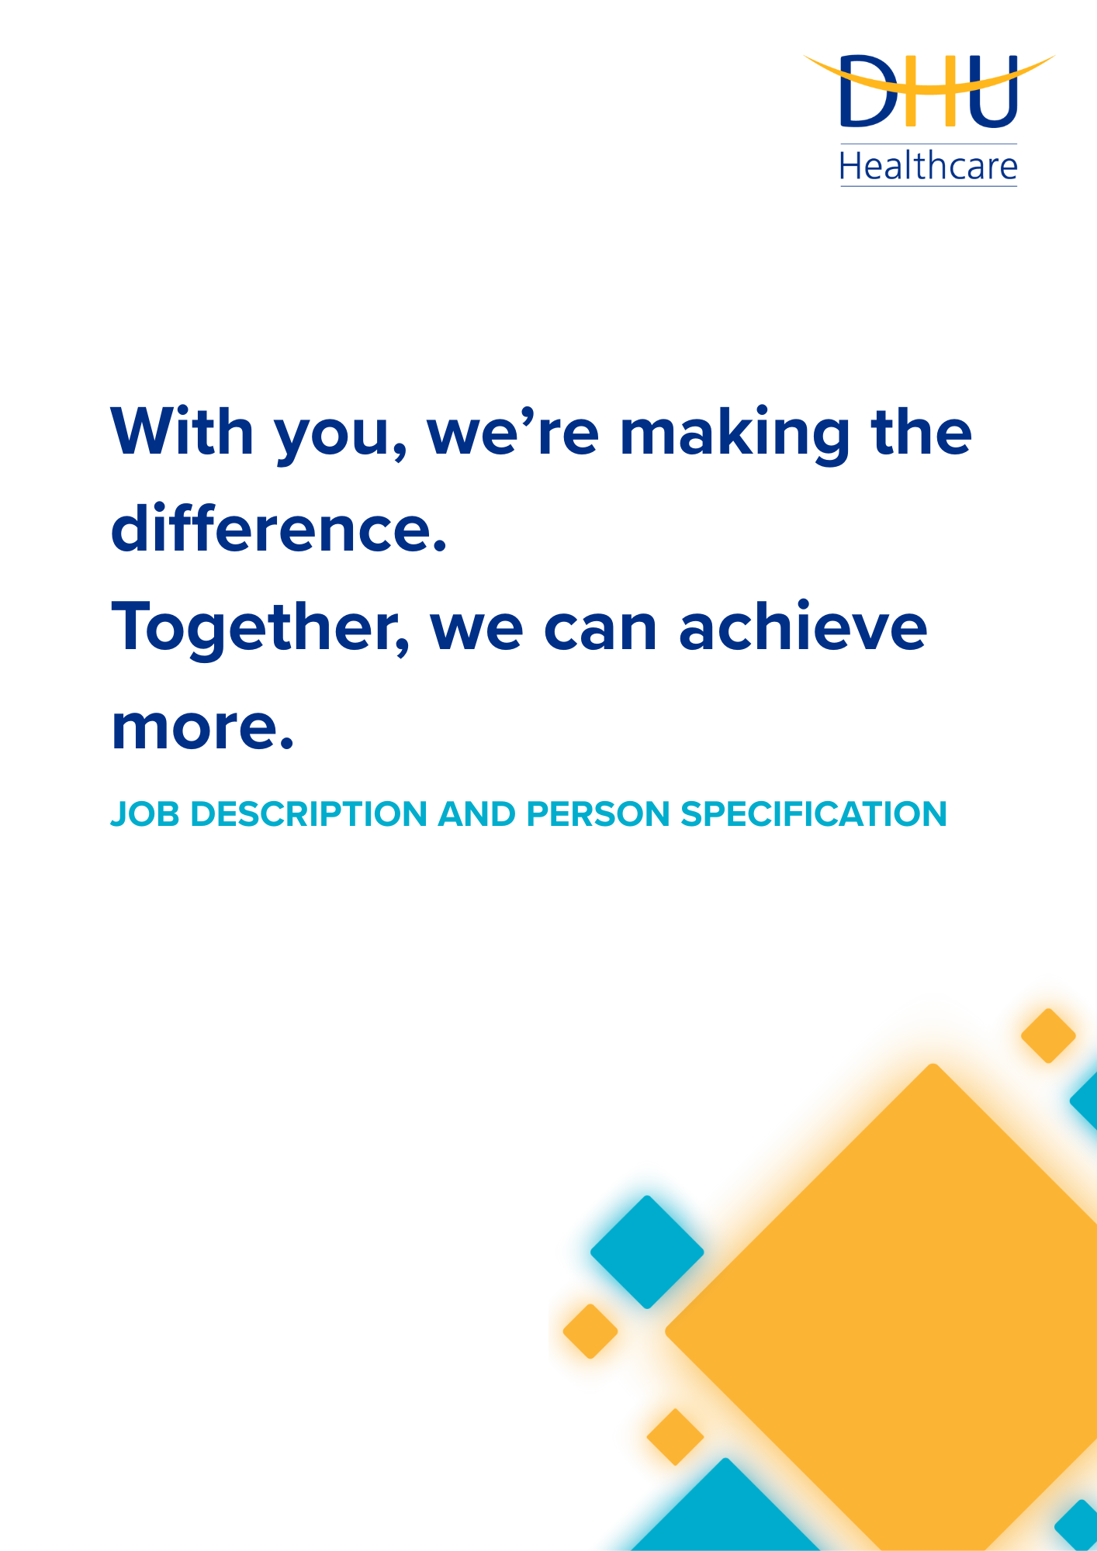
TRANSFORMATION & IMPROVEMENT PROJECT SUPPORT OFFICER
CORPORATE

DEPARTMENT

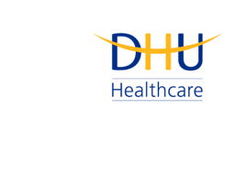
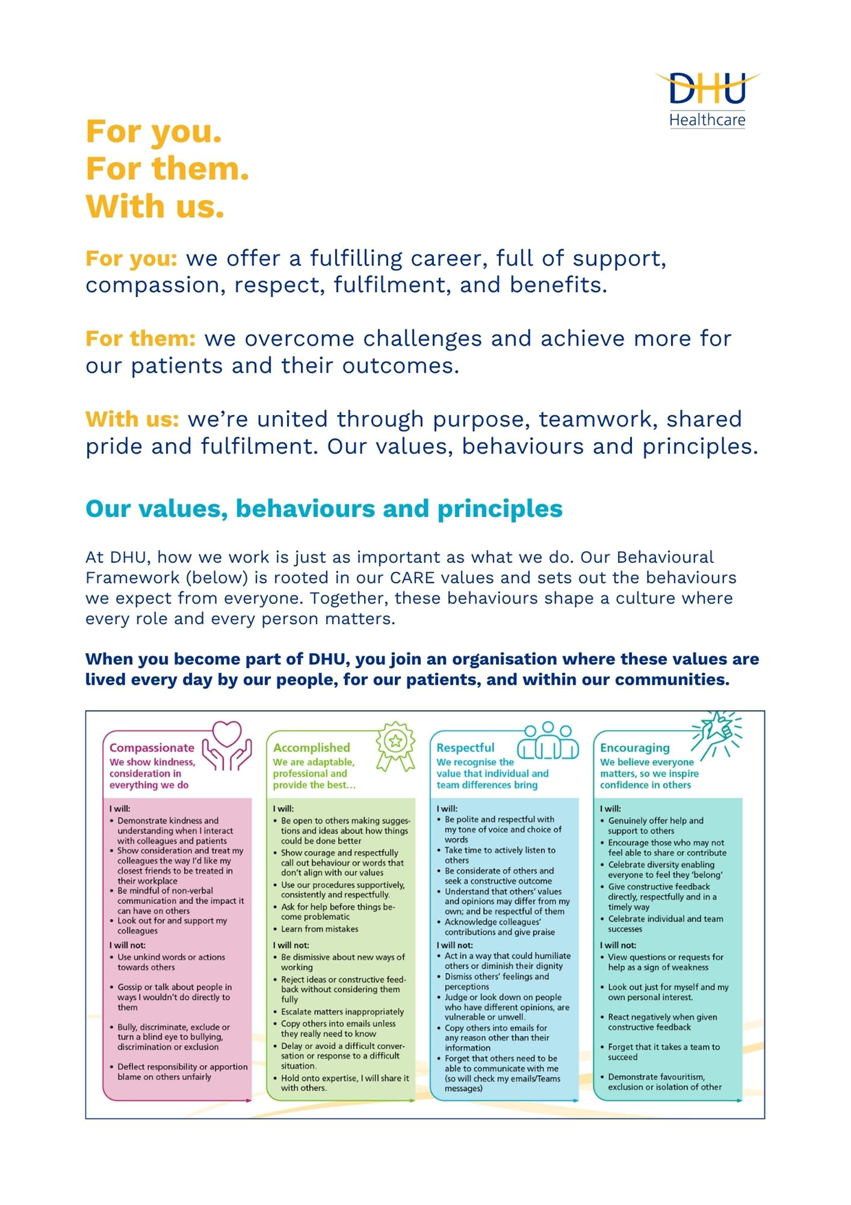

Job Description and Person Specification
Position: | Transformation & Improvement Project Support Officer
Division: | Corporate
Location: | Derby or Leicester
Reporting to: | TBC
Band: | 4.0
Last reviewed: | August 2026

Purpose of the role
- To provide project support, administrative leadership and stakeholder engagement to deliver a high
- quality, comprehensive project support service.

- The post holder will be responsible for their own workload, including having responsibility for
- coordinating project tasks, updating project documentation and dealing with project stakeholders and
- multi-disciplinary teams.
Performance Measures
The Project Support Officer plays a crucial role in the successful implementation and management of projects. The role involves assisting in the planning, coordination and monitoring of project activities to ensure they are completed on time and within budget. The Project Support Officer will be based in the Transformation & Improvement Team and will provide project support to projects delivered by the team.
The post holder will fulfil all project administration tasks (such as arranging meetings, minute taking, recording and ensuring the completion of actions, drafting project documentation under the direction of project managers and maintaining data) and work as part of a team.

Key areas of accountability and responsibility
Transformation and Improvement:

- Support the Project Manager in planning and coordinating project activities, including setting up meetings, preparing agendas, taking minutes, and following up on action points
- Assist in the preparation and management of key project documents such as project plans, risk registers, issue logs, and status reports. Ensure these are kept up-to-date and shared with relevant stakeholders
- Maintain project tracking tools, monitoring project progress, risks, issues, and dependencies. Ensure that any risks or issues are highlighted to the Project Manager and help with follow-up actions
- Help monitor the allocation and utilisation of project resources, including maintaining resource schedules and tracking any changes in resource needs
- Assist with internal and external stakeholder communications, ensuring that key information is shared effectively, and project updates are delivered on time
- Support the Project Manager with project budgeting and financial administration, including tracking project expenditure
- Manage and update project management software (e.g. MS Project), ensuring project data is maintained accurately
- Supporting the maintenance and troubleshooting of project management systems to ensure smooth operation
- Maintains project library, database, documentation, resources
- As you will expect, the organisation may change from time to time and you will be expected to meet the operational requirements
- Any other reasonable duties as required from time to time
Person specification
Experience & Qualifications

- Experience working on projects in a supporting role
- High level and experience of administration skills, in particular the ability to accurately record minutes and actions and to record, organise and retrieve information effectively

Knowledge & Skills

- An interest in and understanding of project management
- Advanced IT/Keyboard skills, IT literate
- Good standard of written English and a confident communicator
- Highly organised and able to identify and develop improvements to documentation systems
- Ability to work independently, within a team

Personal Attributes

- Reliability and flexibility, able to contribute to changing demands of projects

Behavioural Skills

- We value our people our people through a coaching culture offering staff engagement, wellbeing support, career progression and inspirational, visible leadership.

Key policies and what we expect from each other
Belonging: At DHU, we want everyone to feel like they truly belong. We believe our team should be just as diverse as the people and communities we care for. Whoever you are, wherever you're from - you’re welcome here. We’re all about building a culture where everyone feels seen, heard, and valued.
Diversity: We’re proud of the different backgrounds, experiences and perspectives our people bring. That’s what makes us strong. We treat everyone fairly and respectfully, and we’re committed to creating a workplace that celebrates what makes each of us unique. No one should ever feel left out, left behind, or treated differently.
Safeguarding: Keeping people safe is at the heart of what we do. Whether it’s patients or colleagues, children or adults - we all share a responsibility to look out for one another and speak up if something doesn’t feel right.
Health & safety: Everyone has a part to play in staying safe at work. Be mindful of how your actions affect others and follow our health and safety guidance. If you see something that’s not safe, speak up.
Wellbeing: Look after your own health and wellbeing, and help create a positive, supportive workplace for everyone. Use the resources available, treat colleagues with respect, and speak up if something isn’t right. Together, we can make DHU a place where everyone can thrive.
Engagement: Support and promote employee engagement by collaborating effectively, communicating openly, and contributing to a positive team culture.

Infection prevention and control: A clean and safe space is everyone’s responsibility. Stick to our infection prevention guidance - it helps protect you, your team, and the people we care for.
Looking after our planet: We all have a part to play in protecting the environment. At DHU, we do our bit by using resources wisely and keeping waste to a minimum. That means recycling and sorting waste properly, switching off lights and equipment when we’re not using them, reporting heating or cooling issues as soon as they happen, and cutting down on unnecessary travel. Small actions, big difference - especially when we all do them together.
Teamwork: As part of our DHU team, you might be asked to take on different tasks now and then to help us meet our goals. We all pitch in where we can, support each other, and stay flexible to keep things running smoothly.
Postholder acknowledgement
I acknowledge receipt and confirm my understanding and acceptance of the responsibilities specified in my Job Description.
Please Note: If you are unclear of any requirement in this document obtain clarification from your line manager.

DHU Healthcare is the trading name of DHU Health Care C.I.C., a limited company registered in England and Wales. Registration no. 05834163. Registered office: No:2, Roundhouse Rd, Derby, DE24 8JE.

