Job Description & Person Specification

Position: | Apprentice Data Technician – Quality Management & Interaction Analytics  (Level 3) | Division: | NHS 111
Location: | Orbis Building, Pride Park, Derby | Reporting to: | 111 Systems Development Manager

Title: Apprentice Data Technician – Quality Management & Interaction Analytics (Level 3)

Reports To: Head of 111 System Development and Intelligence

Who are we?

DHU Healthcare is one of the UK's leading providers of NHS 111 services, delivering urgent care support to more than 11 million patients across the Midlands, Milton Keynes and London. Rated Outstanding by the Care Quality Commission (CQC), we handle approximately 4.5 million patient contacts each year while remaining committed to delivering safe, compassionate and high-quality care.

Our Aim

To be the best employer and provider of NHS 111 services in the country – delivering consistently high-quality patient care and excellent performance.

Apprentice Data Technician – Quality Management & Interaction Analytics (Level 3)

Location: Orbis Building, Pride Park, Derby – this is a site-based role with no home working

Salary: In line with Agenda for Change apprentice rates

Contract: Fixed term – 14 months (+ 3-month End Point Assessment)

Hours: Full time – 37.5 hours per week

Program: Level 3 Data Technician Apprenticeship

Purpose of the Role

Overview
As an Apprentice Data Technician within the Systems and Intelligence Team, you will support the Quality Management and Interaction Analytics (QM & IA) function by analyzing patient interaction data to improve service quality, compliance and operational performance. Working alongside experienced analysts, you will develop practical data analysis skills while completing a nationally recognized Level 3 Data Technician Apprenticeship.

Key Areas of Responsibility & Accountability

What You’ll Do
- Prepare and validate interaction data for audits, quality reviews and reporting.
- Tag and categories patient interactions within NICE CXOne to support analytical insight.
- Maintain and update reports and dashboards using Microsoft Excel and Power BI.
- Support testing of Quality Management and Interaction Analytics processes.
- Assist analysts in producing performance insights for operational teams.
- Contribute to continuous improvement initiatives across Systems and Intelligence.
- Undertake additional duties appropriate to the apprenticeship under supervision.

What You’ll Learn
- Data collection, cleansing, validation and analysis.
- Data modelling, visualization and reporting.
- Microsoft Excel and Power BI reporting techniques.
- NICE CXOne Interaction Analytics and Quality Central.

Person Specification

Entry Requirements

• A genuine interest in healthcare, digital technologies, data analysis and problem solving.
- GCSE Math’s at grade 4/C or above (or equivalent)

• Willingness to work full time on site and develop through structured learning

Behavioral Skills

Successful applicants will demonstrate:

- Excellent attention to detail
- Analytical thinking
- Strong organisational skills
- Good written and verbal communication
- Curiosity and willingness to learn
- Ability to work collaboratively
- Professionalism and integrity
- Commitment to confidentiality and data security
- Positive attitude towards continuous improvement

We expect all colleagues to demonstrate our CARE values through compassion, accountability, respect and excellence in every interaction with patients, colleagues and partners.

We value our people through a coaching culture offering staff engagement, wellbeing support, career progression and inspirational, visible leadership.

At the heart of everything we do, you will find our CARE values – principles, standards and behaviors we live by:

We CARE for you. We are always….
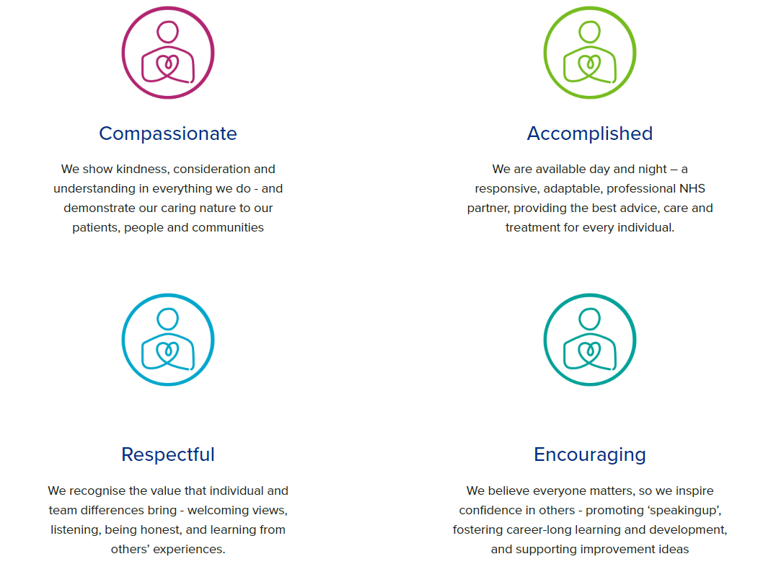

Diversity

DHU believe our workforce should be as diverse as the range of services we offer, and the communities we serve. We are committed to valuing and encouraging diversity throughout our workforce, regardless of age, disability, gender reassignment, marriage or civil partnership, pregnancy and maternity, race, religion or belief, sex or sexual orientation. As part of our mission we are dedicated to eliminating discrimination

Acknowledgment
I acknowledge receipt and confirm my understanding and acceptance of the responsibilities specified in my Job Description.
Please Note: If you are unclear of any requirement in this document obtain clarification from your line manager.

Signature of Post Holder: | Adam Dominic Paginton | Date: | 10/06/2025
Name: | Adam Dominic Paginton

