
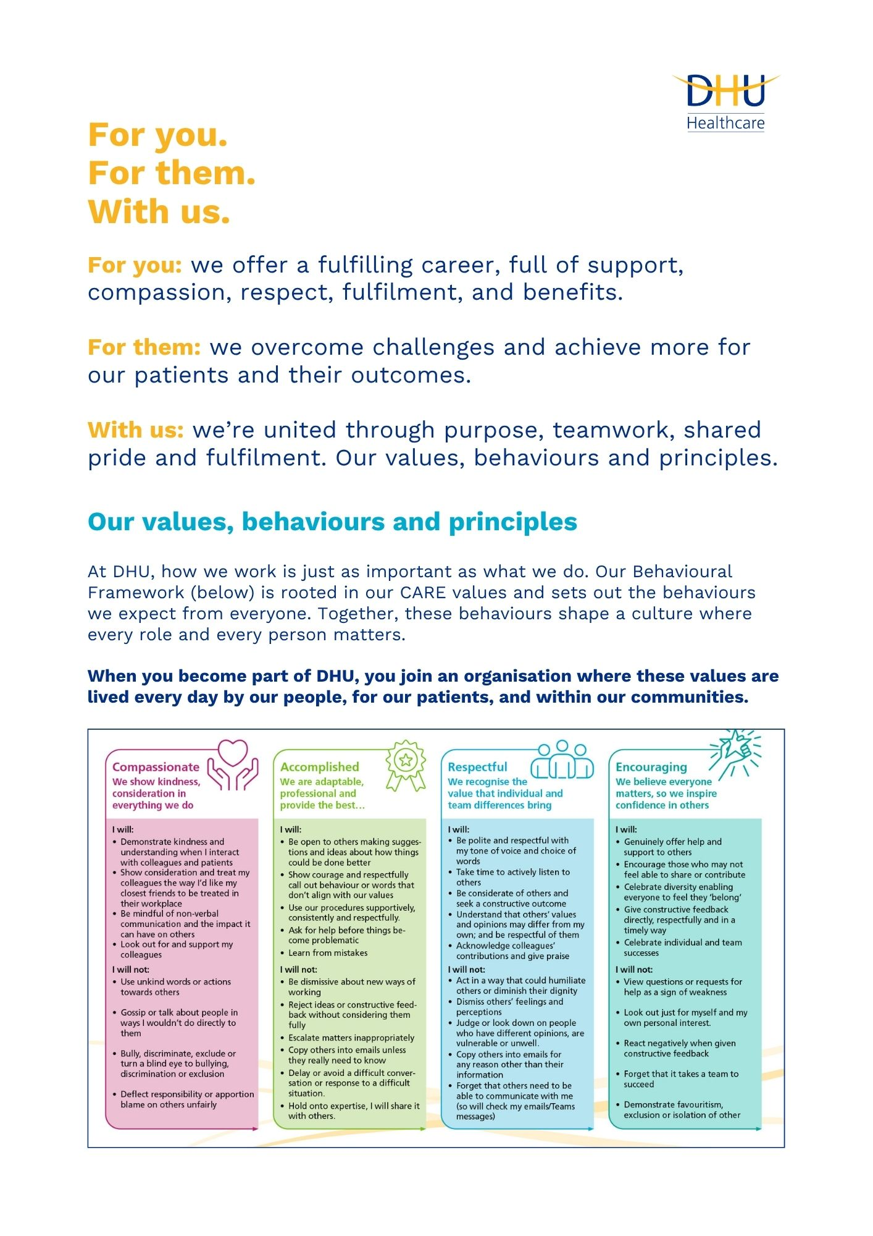

Job Description and Person Specification
Position: | Programme Manager – Absence Improvement Programme
Division: | People & Culture
Location: | Multi-site with regular travel across DHU locations
Reporting to: | Programme Lead – Absence Improvement Programme
Band: | Band 8a
Last reviewed: | October 2026

Purpose of the role

To support the Programme Lead in the design, mobilisation and delivery of a complex, organisation-wide absence improvement programme within a healthcare provider. The postholder will provide strong programme management, coordination and assurance, using workforce insight to help identify the principal drivers of absence and supporting the implementation of sustainable interventions that improve attendance, staff health and wellbeing, management practice and workforce resilience. The programme will support safe, high-quality and compassionate patient care while ensuring fair, consistent and legally compliant employment processes.
Working under the direction of the Programme Lead, the Programme Manager will translate agreed strategic workforce and service objectives into an integrated delivery plan, coordinate workstreams, manage dependencies and resources, and provide clear information and assurance on progress, risk, benefits and impact. They will support the Programme Lead to engage executive and senior leaders and will work collaboratively with clinical and corporate services, people and culture teams, occupational health, staff wellbeing services, trade unions or staff representatives, operational managers, finance, workforce information, quality and safety, and communications colleagues.

Key areas of accountability and responsibility

- Act as the Programme’s principal programme-management support, maintaining oversight of agreed priorities, commitments, milestones and deadlines.
- Translate the Programme’s strategic direction and decisions into clear delivery plans, actions, ownership and timescales.
- Prepare for programme boards, executive meetings and stakeholder sessions by coordinating papers, briefings, performance information, risks, decisions required and recommended actions.
- Maintain a forward plan of key meetings, deliverables, decision points, dependencies and assurance requirements, highlighting emerging pressures at the earliest opportunity.
- Provide concise, accurate and timely updates to the Programme Lead on progress, exceptions, risks, issues, benefits, resources and stakeholder concerns.
- Coordinate actions arising from meetings, confirm ownership and timescales, follow up delivery and escalate overdue or unresolved matters.
- Draft reports, presentations, options appraisals, business cases, briefings and correspondence for the Programme Lead’s review and approval.
- Support the Programme Lead to manage relationships with the executive sponsor, senior clinical and operational leaders, people and culture teams, trade unions or staff representatives, and system partners.
- Represent the Programme Lead at agreed meetings and workstream forums, communicating decisions accurately and escalating matters outside delegated authority.
- Coordinate workstream leads and programme contributors, ensuring they understand required outputs and provide consistent, evidence-based information.
- Maintain effective document control and an auditable record of governance papers, decisions, actions, risks, issues, dependencies, benefits and change requests.
- Identify where Programme Lead intervention or a formal decision is required, presenting clear options, implications and recommendations without exceeding delegated authority.
- Provide constructive challenge, anticipate barriers and recommend practical solutions that protect delivery, staff wellbeing, service continuity and patient care.
- Support the Programme Lead with programme closure, evaluation, benefits realisation, lessons learned and transfer of responsibilities into business as usual.

Key areas of accountability and responsibility
- Support the Programme Lead to develop and maintain the programme mandate, scope, roadmap, delivery plan, milestones, dependencies, resource requirements and critical path, aligned to workforce, quality, safety and service priorities.
- Coordinate programme governance, including programme boards, workstreams, action and decision logs, reporting cycles and clear escalation routes into relevant workforce, quality and executive forums.
- Maintain robust risk, issue, assumption and dependency controls; coordinate mitigation activity and escalate matters with potential impacts on patient care, staff wellbeing, service continuity or programme delivery.
- Support the development of the benefits framework and baseline measures; monitor delivery against agreed workforce, quality, operational, financial and staff-experience outcomes and key performance indicators.
- Analyse and present quantitative and qualitative workforce data to identify absence trends, inequalities, hotspots, root causes and opportunities for targeted intervention across clinical and corporate services.
- Coordinate the design, testing, implementation and evaluation of interventions across policy, process, workforce systems, leadership, management capability, staff wellbeing, occupational health and rehabilitation pathways.
- Support stakeholder mapping, engagement and communications, helping the Programme Lead secure active sponsorship and ownership from executive, clinical, professional and operational leaders.
- Build constructive working relationships with trade unions or staff representatives and relevant staff forums, supporting consultation and effective partnership working.
- Ensure programme documentation and activity take account of employment law, equality duties, data protection, confidentiality, professional standards, clinical governance and organisational policy, seeking specialist advice where required.
- Monitor programme budgets, resources, procurement and external suppliers where applicable, reporting forecasts, variances and risks to the Programme Lead.
- Prepare high-quality reports, dashboards, briefings and recommendations for review by the Programme Lead and submission to executive and governance forums.
- Coordinate, challenge and support workstream leads and managers, escalating promptly where delivery, benefits, safe staffing or service continuity are at risk.
- Support transition, handover, capability-building and sustainability planning so improvements become part of business-as-usual practice across services.
- Maintain programme documentation, capture lessons learned and promote continuous improvement throughout the programme lifecycle.

Working Relationships
- Programme Lead – Absence Improvement Programme.
- Executive leadership team
- Clinical directors
- Professional leads and senior operational leaders
- People and culture teams
- Occupational health and staff wellbeing services
- Clinical and corporate managers;
- Finance and workforce information teams;
- Quality, safety, equality, legal, information governance and communications colleagues;
- Trade unions or staff representatives;
- Programme and project professionals;
- System partners,
- External providers and suppliers.

- Success Measures
- The Programme is supported by a clear, evidence-led programme plan, reliable governance arrangements and timely management information.
- Programme boards and workstreams receive accurate reports, actions, decisions and escalations.
- Improved data quality, insight and confidence in absence reporting and workforce decision-making at organisation, service and team level.
- Coordinated implementation of consistent, timely and compassionate attendance and absence practices across clinical and corporate services.
- Improved manager confidence and capability in applying policy, supporting staff and responding appropriately to health and wellbeing needs.
- Benefits, risks and progress are monitored effectively against agreed absence, wellbeing, staff-experience, quality, operational and financial indicators.
- Programme changes, controls and benefits tracking are transferred effectively into business as usual.

Person specification
Essential Criteria
- Educated to degree level or able to demonstrate equivalent knowledge and experience.
- Recognised programme or project management qualification, or substantial evidence of applying structured programme management methods successfully in a programme-support or delivery role.
- Proven experience of translating strategic direction and decisions into integrated plans, milestones, actions, ownership and timescales.
- Experience of coordinating governance meetings, workstreams, reports, decision and action logs, risks, issues, dependencies, change control and assurance requirements.
- Experience of preparing clear, accurate and timely briefings, board papers, dashboards, presentations, options appraisals or business cases for senior review.
- Ability to build trusted relationships, obtain information and commitments, and communicate decisions accurately across organisational boundaries.
- Experience of supporting engagement, consultation, communications and implementation in a sensitive change environment.
- Demonstrable ability to interpret complex workforce, quality, operational and financial information and present concise conclusions, options and recommendations.
- Experience of maintaining performance measures, baselines, key performance indicators, benefits profiles and evaluation information.
- Strong problem-solving skills, with the ability to identify root causes, test assumptions, anticipate barriers and recommend practical solutions.
- High level of accuracy and attention to detail, including the ability to maintain reliable programme records and an auditable evidence trail.
- Understanding of the respective responsibilities of a Programme Lead and Programme Manager, including delegated authority, escalation and decision-making boundaries.
- Awareness of the need for fair, compassionate and consistent absence management, including equality, confidentiality and data protection considerations.
- Understanding of how workforce attendance, health and wellbeing, staff experience and safe staffing can affect service continuity and patient care.
- Highly effective planning, organisation and prioritisation skills, with the ability to manage competing deadlines.
- Excellent written, verbal and presentation skills, including the ability to draft material for senior audiences and communicate complex or sensitive issues clearly.
- Sound judgement, discretion and political awareness, with a clear understanding of confidentiality and professional boundaries.
- A proactive, dependable and collaborative approach, with the confidence to provide constructive challenge while remaining accountable to the Programme Lead.
- Ability to work independently, use initiative and progress agreed activity without exceeding delegated authority.
- Resilience, adaptability and consistent follow-through in a complex environment with sustained operational pressures.

Desirable Criteria
- MSP, PRINCE2, APM, Agile or comparable practitioner-level qualification.
- Relevant change management, human resources, organisational development or healthcare leadership qualification.
- Experience of organisation-wide workforce, attendance, wellbeing, people transformation or service improvement programmes in a healthcare or similarly complex care environment.
- Experience of facilitating workstream meetings, workshops or senior stakeholder sessions.
- Knowledge of quality improvement methodologies, behavioural insight or human-centred design.
- Experience of workforce analytics, dashboard development or benefits evaluation.
- Understanding of occupational health pathways, employee relations practice, clinical governance and the wider health and care environment.
- Confident facilitation of senior workshops, programme boards and cross-functional groups.
- Experience of coaching or supporting workstream leads and managers through change.
Key policies and what we expect from each other
Belonging: At DHU, we want everyone to feel like they truly belong. We believe our team should be just as diverse as the people and communities we care for. Whoever you are, wherever you're from - you’re welcome here. We’re all about building a culture where everyone feels seen, heard, and valued.
Diversity: We’re proud of the different backgrounds, experiences and perspectives our people bring. That’s what makes us strong. We treat everyone fairly and respectfully, and we’re committed to creating a workplace that celebrates what makes each of us unique. No one should ever feel left out, left behind, or treated differently.
Safeguarding: Keeping people safe is at the heart of what we do. Whether it’s patients or colleagues, children or adults - we all share a responsibility to look out for one another and speak up if something doesn’t feel right.
Health & safety: Everyone has a part to play in staying safe at work. Be mindful of how your actions affect others and follow our health and safety guidance. If you see something that’s not safe, speak up.
Infection prevention and control: A clean and safe space is everyone’s responsibility. Stick to our infection prevention guidance - it helps protect you, your team, and the people we care for.
Looking after our planet: We all have a part to play in protecting the environment. At DHU, we do our bit by using resources wisely and keeping waste to a minimum. That means recycling and sorting waste properly, switching off lights and equipment when we’re not using them, reporting heating or cooling issues as soon as they happen, and cutting down on unnecessary travel. Small actions, big difference - especially when we all do them together.
Teamwork: As part of our DHU team, you might be asked to take on different tasks now and then to help us meet our goals. We all pitch in where we can, support each other, and stay flexible to keep things running smoothly.
Postholder acknowledgement
I acknowledge receipt and confirm my understanding and acceptance of the responsibilities specified in my Job Description.
Please Note: If you are unclear of any requirement in this document obtain clarification from your line manager.

DHU Healthcare is the trading name of DHU Health Care C.I.C., a limited company registered in England and Wales. Registration no. 05834163. Registered office: No:2, Roundhouse Rd, Derby, DE24 8JE.

Signature: Date:
Surname:
First name:

