Job Description & Person Specification

Position: | Clinical Governance Assistant | Division: | Clinical Governance
Location: | Roundhouse Derby | Reporting to: | Senior Clinical Governance Officer (DHU 111)

Purpose of the Role

The post holder will provide administrative support to the Integrated Governance team. The role of Clinical Governance
Assistant is to support the delivery and development of Clinical Governance throughout the organisation, following the DHU Complaints & Incidents Policies. A commitment to a quality service and excellence in all that DHU Health Care CIC undertakes are integral to the role and the development of the service.

Key Success Measures

- Caring & Compassion - We will actively listen to understand and empathise with others’, with a desire to support both patients and colleagues.
- Always Professional - We will be accountable for consistently delivering high quality healthcare for our patients
- Respect & Dignity - We will actively listen to each other and our patients to answer their concerns or questions. We will maintain and respect patient’s dignity and must ensure it is never compromised.
- Everyone Matters - We will actively encourage feedback from both patients and colleagues to continually improve our service, ensure everyone has an opportunity to have their voice heard, and everyone has an opportunity to further develop their skills and competencies.

Key Areas of Responsibility & Accountability

A specific job description will be developed according to service needs as the service develops and role evolves to meet the needs of the company and the service it provides.

Administration

- Proactively provide administrative services and undertake clerical duties in a professional, timely manner including typing, filing, scanning, photocopying, updating spread sheets and general office tasks
- Maintain manual/computerised records as required to a high standard
- To prepare appropriate reports, briefing papers, documents and presentations as required.
- Efficient and accurate collation of data, when requested
- To provide effective and appropriate communication between Integrated Governance department and other parts of the organization and external bodies.
- Accurate typing and compilation of letters
- Arranging meetings as required, including checking meeting rooms and parking facilities are available and ready for use
- Attending meetings and taking minutes as and when required
- To ensure correspondence including e-mail, is effectively and efficiently managed.
- Acknowledging complaints from patient and their representatives.
- Support with locating telephone calls for the investigation of complaints, queries and incidents General Duties
- Logging and maintaining Datix electronic records of incidents, compliments and complaints.
- Answering telephone calls from members of the public / complainants and accurately recording details of their concerns
- Answering queries on complaints and incidents from outside agencies and DHU Managers using agreed protocols and standards in an efficient and courteous manner
- Welcoming visitors with appointments as they arrive within the Integrated Governance Department following invitation
- To promote the corporate image of the company in both its internal and external contacts.
- Informing Managers of queries received, their content and action as appropriate
- Maintaining a tidy office area at all times

- Ensuring only authorised personnel enter the building.
- Providing assistance/training to new members of staff to ensure the maintenance of a high-quality service, as and when required.
- Attending mandatory training on an annual basis
- Maintaining strict confidentiality in relation to all issues concerned within the service and adhering to the requirements of The Data Protection Act and Information Governance
- Checking systems and printers as necessary and reporting any faults
- Adhering to Corporate Policies, procedures, protocols and other relevant memoranda as appropriate
- Liaise with company insurers regarding complaints and incidents.

Communications and Working Relationships

- Staff within DHU Health Care CIC
- Clinical and managerial staff within participating Clinical Commissioning Groups
- Clinical and other appropriate staff in local primary and secondary care services
- Patients; complainants as this includes answering calls - ability to communicate with members of the public in a sensitive and professional manner taking account of any distress, anger or other emotional state. The job description may be subject to review over time in discussion with the post-holder. This job description is not exhaustive and it is expected that the post holder will be flexible in their approach, and undertake any reasonable duties as requested by Management/Directors
- As you will expect the organisation may change from time to time and you will be expected to meet the operational requirements.
- Any other reasonable duties as required from time to time.

Person Specification

Qualifications | - 4 GCSEs Grades A-C or equivalent including English and Maths  - Educated to A Level Standard or equivalent (desirable)  - Typing/Word Processing RSA II qualification or appropriate Keyboard skills  - Qualifications and/or training in current information and office technology (Microsoft packages). Excel qualification desirable.
Experience | - High level of Administration experience desirable  - Communication with a variety of people  - Previous experience in a health care environment desirable  - Competence in office system development & maintenance  - Computer experience (e.g. Word/Excel and other packages) as well as email systems and other electronic media
Skills and Knowledge | - Accuracy and attention to detail  - IT literacy skills in Word, Excel, PowerPoint  - Prepared to participate in service development.  - Excellent telephone manner  - Excellent organisational skills  - Effective diary & time management  - Efficient & effective administration skill
Job Circumstances | - Commitment to role  - Flexible & adaptable to meet changing needs of service  - Able to travel to other DHU bases when required
Personal Qualities | - Confidentiality, discretion and tact  - Proven team player  - Able to work autonomously  - Committed to continual personal development  - Sense of humour

Behavioural Qualities

We value our people our people through a coaching culture offering staff engagement, wellbeing support, career progression and inspirational, visible leadership.

At the heart of everything we do, you will find our CARE values – principles, standards and behaviours we live by:

We CARE for you. We are always….

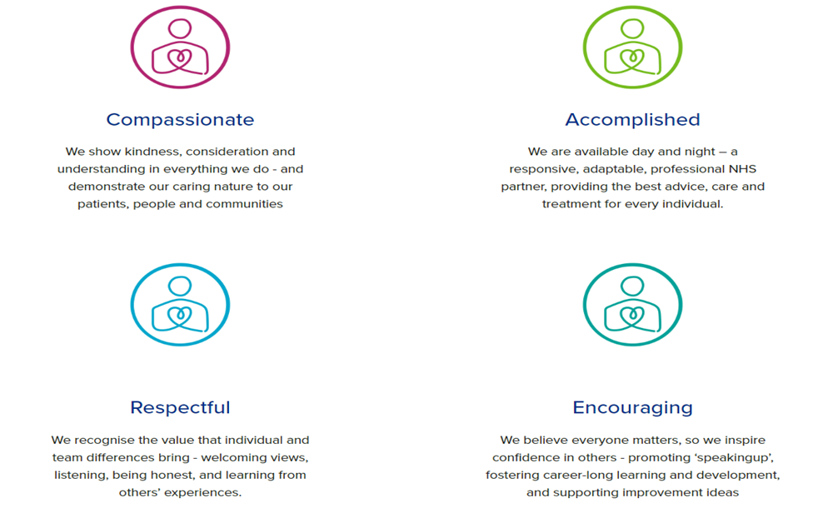

Diversity

DHU believe our workforce should be as diverse as the range of services we offer, and the communities we serve. We are committed to valuing and encouraging diversity throughout our workforce, regardless of age, disability, gender reassignment, marriage or civil partnership, pregnancy and maternity, race, religion or belief, sex or sexual orientation. As part of our mission we are dedicated to eliminating discrimination

Acknowledgment

I acknowledge receipt and confirm my understanding and acceptance of the responsibilities specified in my Job Description.
Please Note: If you are unclear of any requirement in this document obtain clarification from your line manager.

Signature of Post Holder: |  | Date:
Name:

