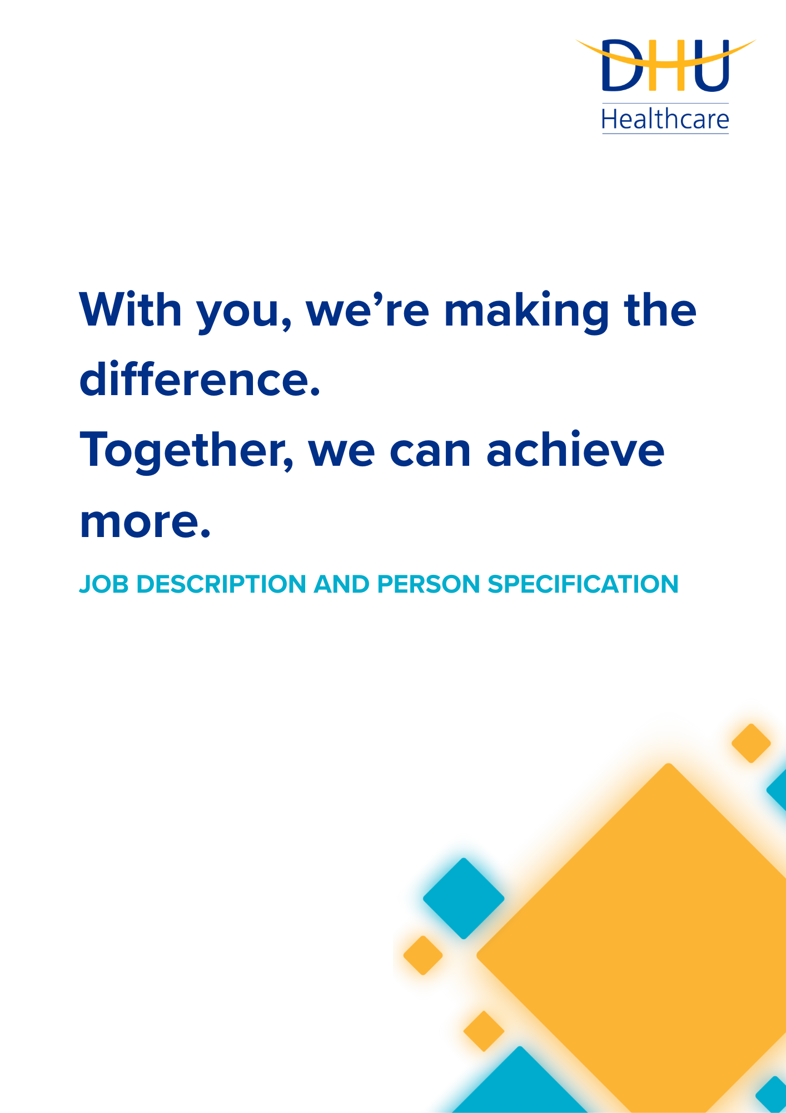
Dental Nurse Advisor
DEPARTMENT: NHS 111

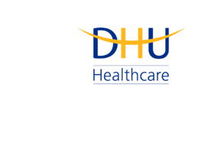
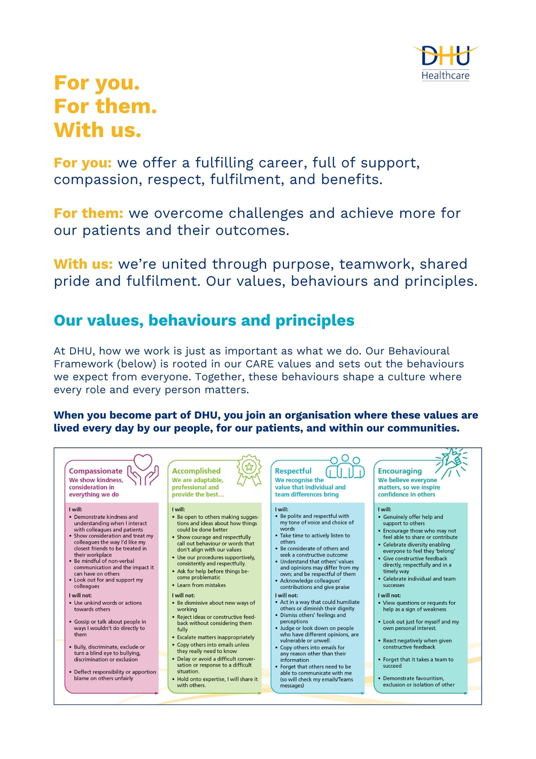

Job Description and Person Specification
Position: | Dental Nurse Advisor
Division: | NHS 111
Location: | Birch, Oldbury
Reporting to: | Dental Performance Manager
Band: | Band 4.0
Last reviewed: | August 2026

Purpose of the role
- The Dental Nurse Advisor provides safe, effective telephone assessments and advice to patients contacting NHS 111 with dental symptoms, using NHS Pathways to support clinical decision-making, symptom management and appropriate onward referral.

- The postholder also supports NHS 111 call handling and triage for patients presenting with a wider range of urgent health needs, accurately capturing information within Adastra and signposting to appropriate services. Working as part of a multi-professional team, the role contributes to accessible, high-quality and person-centered urgent care services across the population served by DHU.
Performance Measures
- Deliver safe and accurate telephone assessments in line with NHS Pathways, DHU policies, protocols, professional standards and the postholder’s scope of practice.
- Maintain complete, accurate and timely patient records within relevant clinical and call-handling systems, including Adastra.
- Provide appropriate symptom-management advice, dental referral and signposting through the Directory of Services in accordance with the outcome of the assessment and organisational protocols.
- Maintain active General Dental Council registration and meet continuing professional development and portfolio requirements.
- Demonstrate compliance with clinical governance, confidentiality, information governance, safeguarding, health and safety and incident-reporting requirements.
- Contribute to service quality and continuous improvement through participation in training, quality-improvement activity, team development and the appropriate escalation of risks or service issues.

Key areas of accountability and responsibility
Clinical Assessment & Patient Care

- Undertake definitive telephone assessment and triage of patients presenting with dental symptoms, using NHS Pathways to support safe and effective clinical decision-making.
- Assess patient needs using effective telephone communication and provide appropriate symptom-management advice, agreeing suitable courses of action with patients wherever possible.
- Undertake the required clinical training and safely assess potential toxic ingestion where a dental patient has exceeded the recommended dose of specified over-the-counter pain-relief medication.
- Refer and signpost patients to appropriate dental and wider healthcare services in accordance with NHS Pathways outcomes, the Directory of Services and DHU protocols.
- Communicate appropriately with patients, relatives and representatives, recognising individual communication needs and maintaining a courteous, professional approach.

NHS 111 Call Handling & Service Delivery

- Answer NHS 111 calls efficiently and courteously, accurately recording, checking and amending patient details within Adastra and other relevant systems.
- Triage calls using NHS Pathways and direct patients to appropriate care and services in accordance with agreed protocols.
- Work flexibly to meet operational and rota requirements, including providing appropriate cover across the service and DHU sites where required.
- Communicate outstanding clinical or operational issues to the appropriate manager or shift replacement before going off duty and promptly escalate circumstances that may affect the delivery of a high-quality service.

Clinical Governance, Safety & Professional Practice

- Practice within the limits of professional competence, organisational policies, protocols and guidelines, maintaining awareness of developments in dental practice and NHS 111 services.
- Maintain active registration with the General Dental Council and work in accordance with its regulatory requirements, standards, codes and guidance.
- Take responsibility for continuing professional development and performance, maintaining an appropriate professional portfolio in accordance with registration requirements.
- Participate in clinical governance and quality-improvement activity, maintaining awareness of individual accountability and contributing to safe, effective service development.
- Maintain strict confidentiality and comply with information governance, data protection and Caldicott requirements.
- Identify and report incidents and risks through the appropriate organisational reporting route, and comply with safeguarding, health and safety and infection prevention and control requirements.

Communication & Collaborative Working

- Work collaboratively as part of a multi-professional and multi-skilled team of clinical and support colleagues.
- Communicate effectively with DHU colleagues and relevant external partners, including primary and secondary care, social services, ambulance services, out-of-hours services and other stakeholders within the local health economy.
- Support other staff groups with dental health queries by sharing up-to-date practice information and acting as an appropriate professional resource within the boundaries of the role.

Learning, Development & Service Support
- Support new members of staff with their development, training and mentoring to help maintain a high-quality service.
- Attend required training, meetings and development activity and contribute to the implementation and ongoing development of the service.
- Undertake appropriate administrative and clerical duties and maintain manual and computerised records in a professional and timely manner.
- Use and maintain workplace systems and equipment appropriately, reporting faults through the agreed process.
- Remain adaptable to changes in service need and undertake other reasonable duties consistent with the role when required.

Person specification
Experience & Qualifications
Criterion | Requirement | Assessment
Recognised dental nurse qualification approved by the General Dental Council. | Essential | Application / pre-employment checks
Current registration with the General Dental Council. | Essential | Application / pre-employment checks
Minimum 12 months’ post-registration experience working as a dental nurse. | Essential | Application / interview
Experience of dental triage and/or providing dental care advice to patients. | Essential | Application / interview
Computer and keyboard experience, including email and other electronic systems/media. | Essential | Application / interview

Knowledge & Skills
Criterion | Requirement | Assessment
Effective verbal and written communication skills, including a professional and confident telephone manner. | Essential | Application / interview
Ability to use initiative and make appropriate decisions within professional scope and organisational protocols. | Essential | Interview
Accurate record-keeping skills and the ability to maintain high standards of documentation. | Essential | Application / interview
Effective negotiation and listening skills. | Essential | Interview
Ability to maintain strict confidentiality and demonstrate understanding of information governance requirements. | Essential | Interview

Personal Attributes
Criterion | Requirement | Assessment
Committed to delivering a safe, high-quality and patient-centred service. | Essential | Application / interview
Able to work effectively as part of a multi-professional team. | Essential | Application / interview
Able to remain effective and professional when working under pressure. | Essential | Interview

Key policies and what we expect from each other
Belonging: At DHU, we want everyone to feel like they truly belong. We believe our team should be just as diverse as the people and communities we care for. Whoever you are, wherever you're from - you’re welcome here. We’re all about building a culture where everyone feels seen, heard, and valued.
Diversity: We’re proud of the different backgrounds, experiences and perspectives our people bring. That’s what makes us strong. We treat everyone fairly and respectfully, and we’re committed to creating a workplace that celebrates what makes each of us unique. No one should ever feel left out, left behind, or treated differently.
Safeguarding: Keeping people safe is at the heart of what we do. Whether it’s patients or colleagues, children or adults - we all share a responsibility to look out for one another and speak up if something doesn’t feel right.
Health & safety: Everyone has a part to play in staying safe at work. Be mindful of how your actions affect others and follow our health and safety guidance. If you see something that’s not safe, speak up.
Wellbeing: Look after your own health and wellbeing, and help create a positive, supportive workplace for everyone. Use the resources available, treat colleagues with respect, and speak up if something isn’t right. Together, we can make DHU a place where everyone can thrive.
Engagement: Support and promote employee engagement by collaborating effectively, communicating openly, and contributing to a positive team culture.

Infection prevention and control: A clean and safe space is everyone’s responsibility. Stick to our infection prevention guidance - it helps protect you, your team, and the people we care for.
Looking after our planet: We all have a part to play in protecting the environment. At DHU, we do our bit by using resources wisely and keeping waste to a minimum. That means recycling and sorting waste properly, switching off lights and equipment when we’re not using them, reporting heating or cooling issues as soon as they happen, and cutting down on unnecessary travel. Small actions, big difference - especially when we all do them together.
Teamwork: As part of our DHU team, you might be asked to take on different tasks now and then to help us meet our goals. We all pitch in where we can, support each other, and stay flexible to keep things running smoothly.
Postholder acknowledgement
I acknowledge receipt and confirm my understanding and acceptance of the responsibilities specified in my Job Description.
Please Note: If you are unclear of any requirement in this document obtain clarification from your line manager.

DHU Healthcare is the trading name of DHU Health Care C.I.C., a limited company registered in England and Wales. Registration no. 05834163. Registered office: No:2, Roundhouse Rd, Derby, DE24 8JE.

