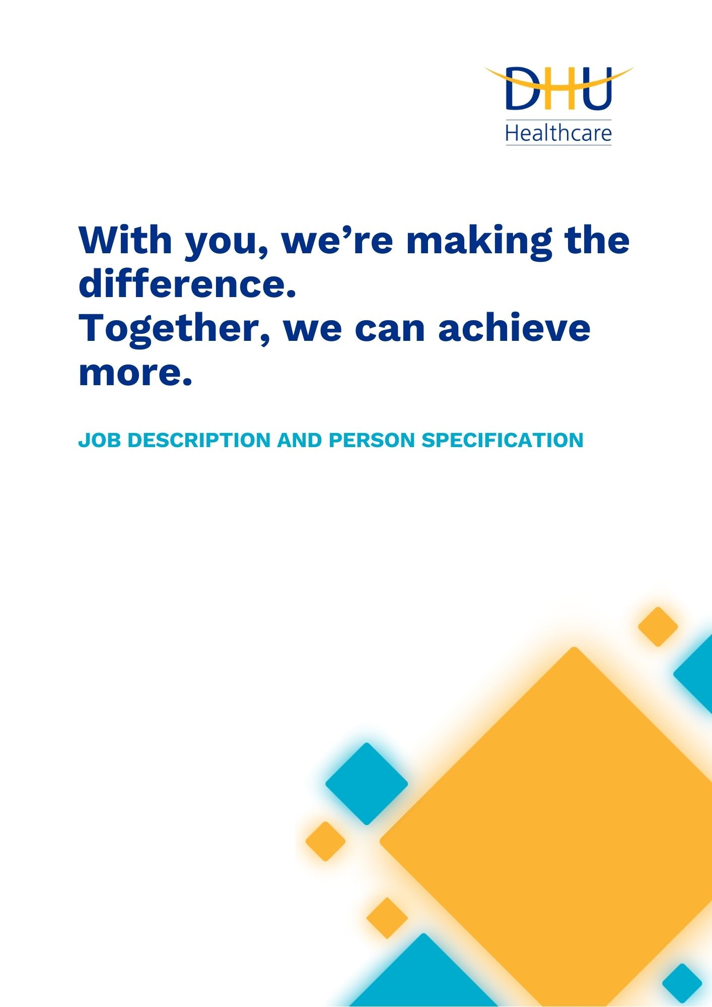
Talent Acquisition Coordinator
Corporate Services
Reference: F3082
Issue: 1.0
Date: 06/2025
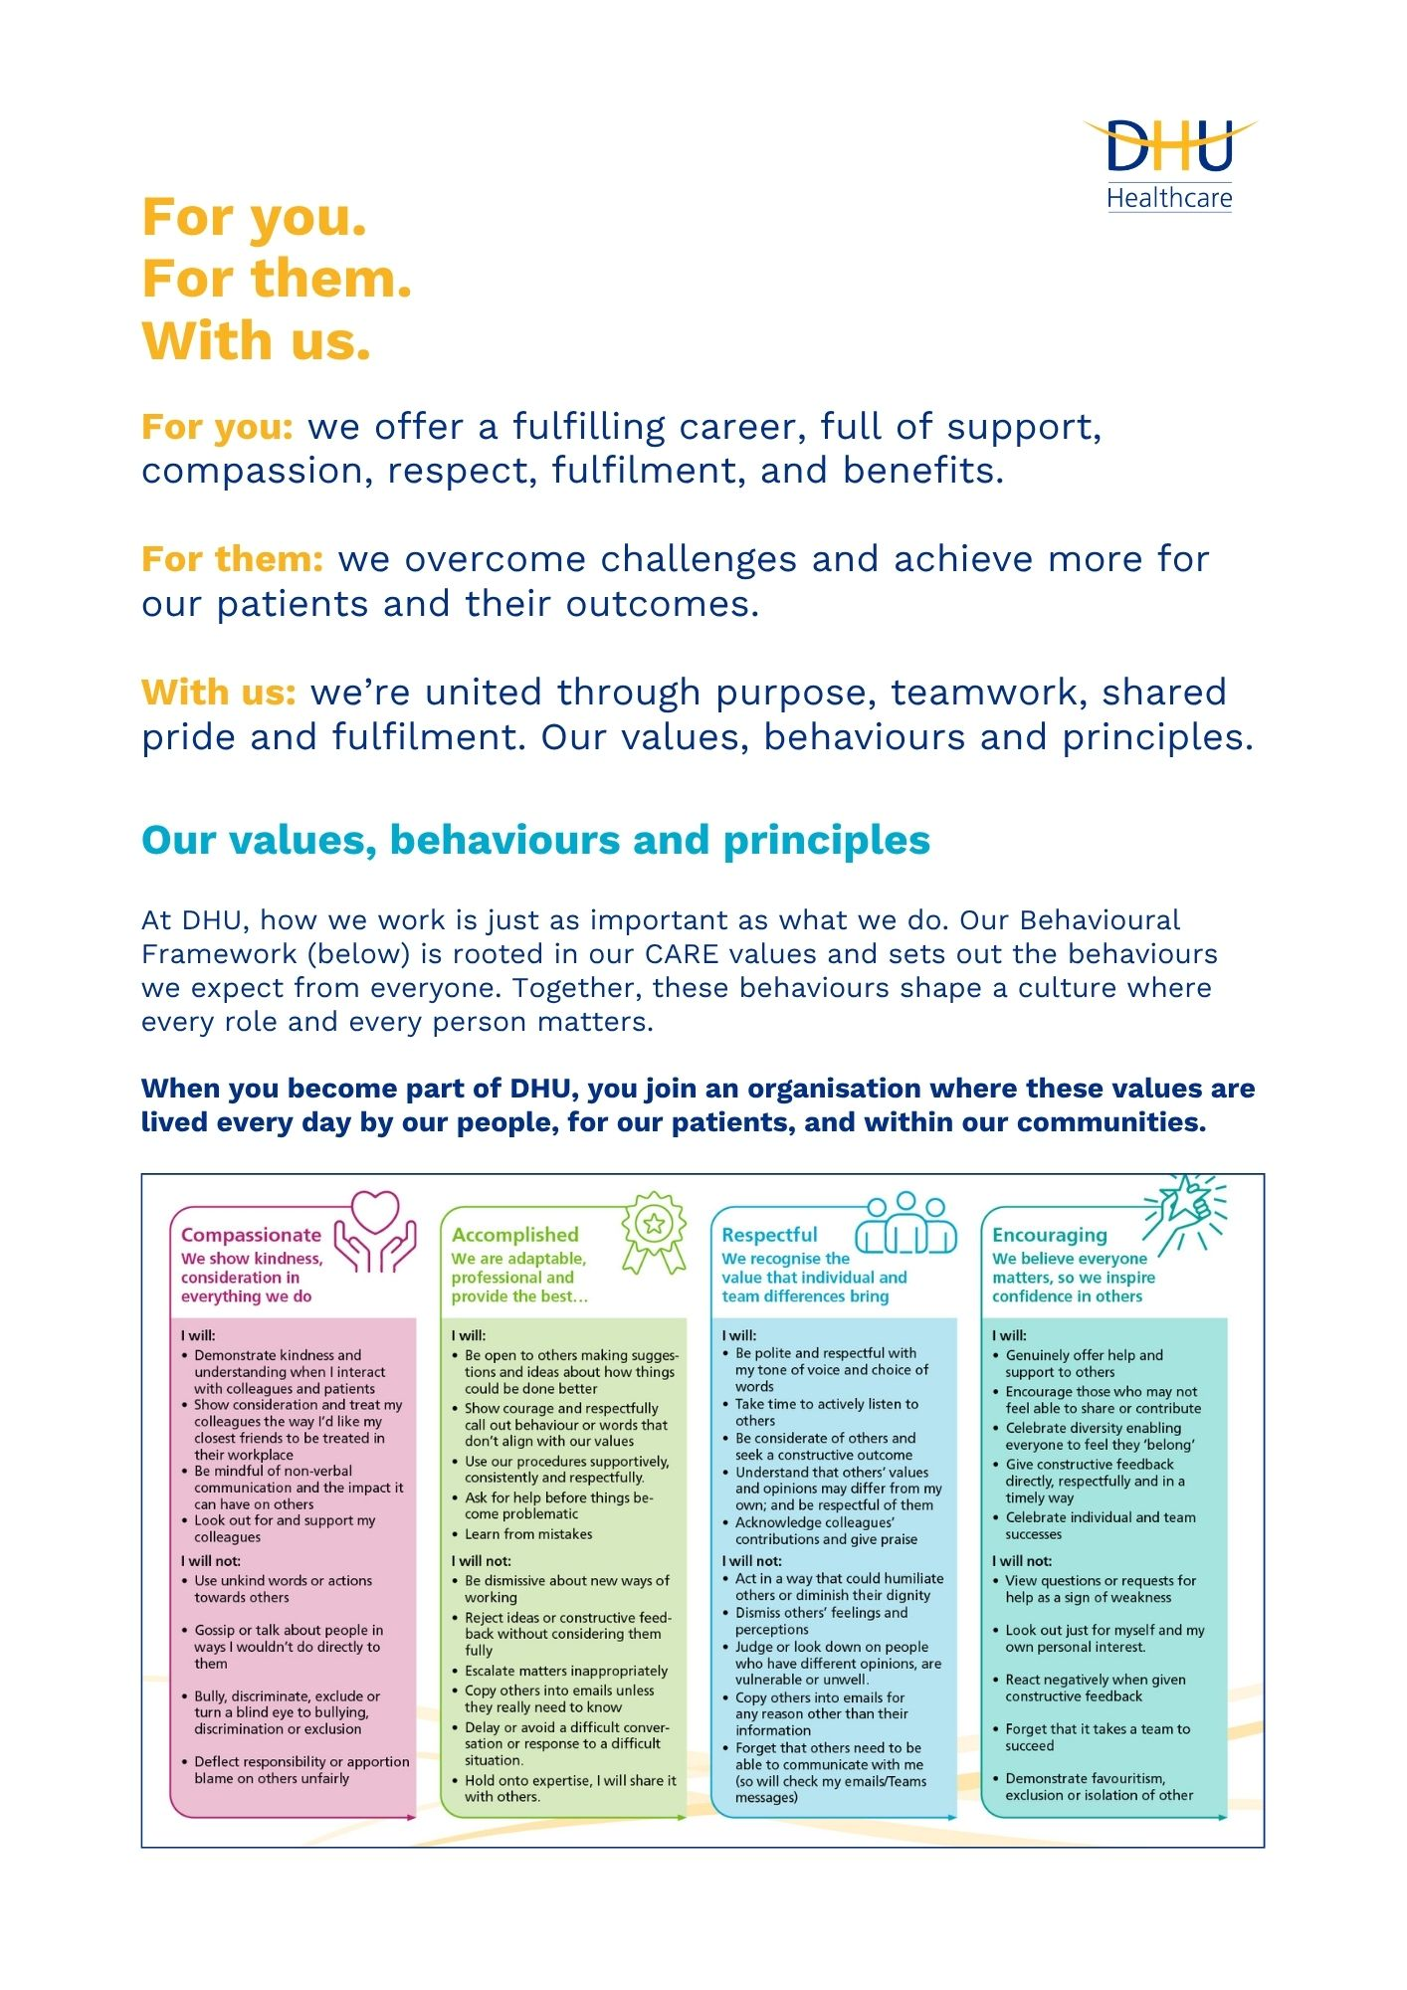

Job Description and Person Specification
Position: | Talent Acquisition Coordinator
Division: | Corporate
Location: | Derby or Oldbury with some travel involved
Reporting to: | Senior Talent Acquisition Coordinator / Talent Acquisition Business Partner
Band: | 4.0
Last reviewed: | June 2025

Purpose of the role
- As a Talent Acquisition Coordinator, you’ll provide end-to-end recruitment for a wide range of roles across DHU, acting as a trusted partner to hiring managers and a key ambassador for our brand. From vacancy briefing through to offer, you’ll coordinate and deliver a smooth and responsive hiring process that meets business needs while ensuring a great candidate experience.

- You’ll work closely with hiring managers to understand their requirements, advise on recruitment best practices, source candidates directly, and manage assessments and interviews. This is a great opportunity for someone with recruitment experience looking to make an impact in a fast-paced, healthcare setting.
Performance measures
- Time-to-hire and vacancy fill rates are consistently improved and maintained within agreed targets across critical roles and hard-to-fill areas.
- 100% of candidate and manager queries responded to within 2 working days.
- ≥90% positive feedback on communication and support via candidate surveys.

- ≥90% positive feedback from hiring managers on recruitment support and service.

- Successfully fulfilling all recruitment service delivery, recommending areas of improvement to recruitment processes.

- Maintain 100% accuracy of candidate’s data within the ATS, ensuring effective role management, updating and closing requisitions in the ATS.
- Extensive stakeholder and candidate engagement both internally and externally, offering an exceptional level of service alongside recruitment delivery.
- All roles fully compliant with pre-employment and onboarding requirements.
- KPI reports submitted accurately and on time.
Key areas of accountability and responsibility

Recruitment Delivery
- Carrying out recruitment duties including gathering role requirements, drafting job adverts, sourcing candidates, and managing updates in the applicant tracking system (ATS) where applicable.
- Writing job adverts based on vacancy briefing to attract a strong calibre of candidates.
- Creating talent pools of candidates for roles that need additional recruitment support.
- Directly source candidates using various job aggregators/platforms.
- Pre-screening and shortlisting candidates against vacancy briefing document/job description.
- Maintain complete and error free candidate records, with 100% accuracy in data entry and stage progression tracking in the ATS.
- Conduct regular audits to verify that all candidate information is current and aligned with the appropriate recruitment stages.
Hiring Manager Support & Stakeholder Engagement
- Build strong, consultative relationships with hiring managers to understand their recruitment needs and advising on best practice procedures.
- Assist in the development of training tools to support hiring managers when recruiting.
- Maintain relationships with third party suppliers including local job centres and recruitment agencies.
Candidate Experience & Communication
- Be a brand ambassador as the first point of contact for both candidates and hiring managers, ensuring all interactions embody our values, behaviours and commitment to excellence.
- Consistent communication with candidates at all stages of the recruitment process to promote DHU’s reputation and ensure a quality recruitment experience.
- Providing constructive candidate feedback to unsuccessful candidates.
Interview & Assessment Coordination
- Preparation and coordination of various selection processes including interviews and assessment centres.
Compliance & Reporting
- Producing regular KPI reports and providing input to MI as required.
- Ensuring all standard operating procedures and KPI’s are delivered.
Process Improvement & Projects
- Identify and deliver service improvement activity across the business through process improvements.
- Participation and support of cross-functional projects within HR & Resourcing.

Person specification
This role would suit someone who is:
- Is skilled at partnering with hiring teams to build effective sourcing, assessment, and closing approaches with an ability to manage stakeholder expectations through a deep understanding of ROI.
- Is motivated by getting it right, first time, every time for candidates and stakeholders alike by delivering a best-in-class service.
- Wants to work as part of a team and has a collaborative approach.
- Is willing and able to work out of usual office hours and at alternative locations should the need arise.
- Has experience in operational and high-volume recruitment delivery.
- Has experience working in a fast-paced environment.

Experience & Qualifications
- Significant recruitment experience in either an agency, RPO or in-house environment.
- Demonstrable experience working in several sectors delivering entry level, junior, middle & senior manager type roles.
- Demonstrable experience showing ability to build and manage key relationships with both internal & external stakeholders.
- Experience of working in an operational environment with multiple hiring managers.
- Flexibility of approach is important as well as confidence in own ability.
- Excellent communication skills – both verbal & written with a credible, professional approach.
Knowledge & Skills

- Knowledge of inclusive recruitment practices and their practical application.
- Familiarity with applicant tracking systems (ATS) and recruitment technologies.
- Understanding of workforce planning and workforce supply challenges in healthcare.
- Knowledge of NHS frameworks and healthcare recruitment regulations.
- Ability to work to deadlines, manage competing demands and prioritise tasks effectively.
- Data analysis and reporting skills to inform recruitment strategy.
Personal Attributes
- Professional, approachable, and values driven.
- Detail-oriented with a high standard of presentation and accuracy.
- Confident in building relationships and communicating with diverse stakeholders.
- A team player with initiative, creativity, and a proactive mindset.
- Flexible and open to working across a range of projects and subject areas.
- Enthusiastic about DHU’s mission and committed to supporting patients, colleagues, and communities.
- Curious and innovative mindset, with a desire to challenge the status quo.
- Resilience and adaptability in a fast-changing environment.

Reference: F3082
Issue: 1.0
Date: 06/2025
Signature: Date:
Surname:
First name:
Key policies and what we expect from each other
Belonging: At DHU, we want everyone to feel like they truly belong. We believe our team should be just as diverse as the people and communities we care for. Whoever you are, wherever you're from - you’re welcome here. We’re all about building a culture where everyone feels seen, heard, and valued.
Diversity: We’re proud of the different backgrounds, experiences and perspectives our people bring. That’s what makes us strong. We treat everyone fairly and respectfully, and we’re committed to creating a workplace that celebrates what makes each of us unique. No one should ever feel left out, left behind, or treated differently.
Safeguarding: Keeping people safe is at the heart of what we do. Whether it’s patients or colleagues, children or adults - we all share a responsibility to look out for one another and speak up if something doesn’t feel right.
Health & safety: Everyone has a part to play in staying safe at work. Be mindful of how your actions affect others and follow our health and safety guidance. If you see something that’s not safe, speak up.
Infection prevention and control: A clean and safe space is everyone’s responsibility. Stick to our infection prevention guidance - it helps protect you, your team, and the people we care for.
Looking after our planet: We all have a part to play in protecting the environment. At DHU, we do our bit by using resources wisely and keeping waste to a minimum. That means recycling and sorting waste properly, switching off lights and equipment when we’re not using them, reporting heating or cooling issues as soon as they happen, and cutting down on unnecessary travel. Small actions, big difference - especially when we all do them together.
Teamwork: As part of our DHU team, you might be asked to take on different tasks now and then to help us meet our goals. We all pitch in where we can, support each other, and stay flexible to keep things running smoothly.
Postholder acknowledgement
I acknowledge receipt and confirm my understanding and acceptance of the responsibilities specified in my Job Description.
Please Note: If you are unclear of any requirement in this document obtain clarification from your line manager.

DHU Healthcare is the trading name of DHU Health Care C.I.C., a limited company registered in England and Wales. Registration no. 05834163. Registered office: No:2, Roundhouse Rd, Derby, DE24 8JE.

