
Operations Manager
Urgent Care Northamptonshire
Reference: F3082
Issue: 1.0
Date: 01/2026
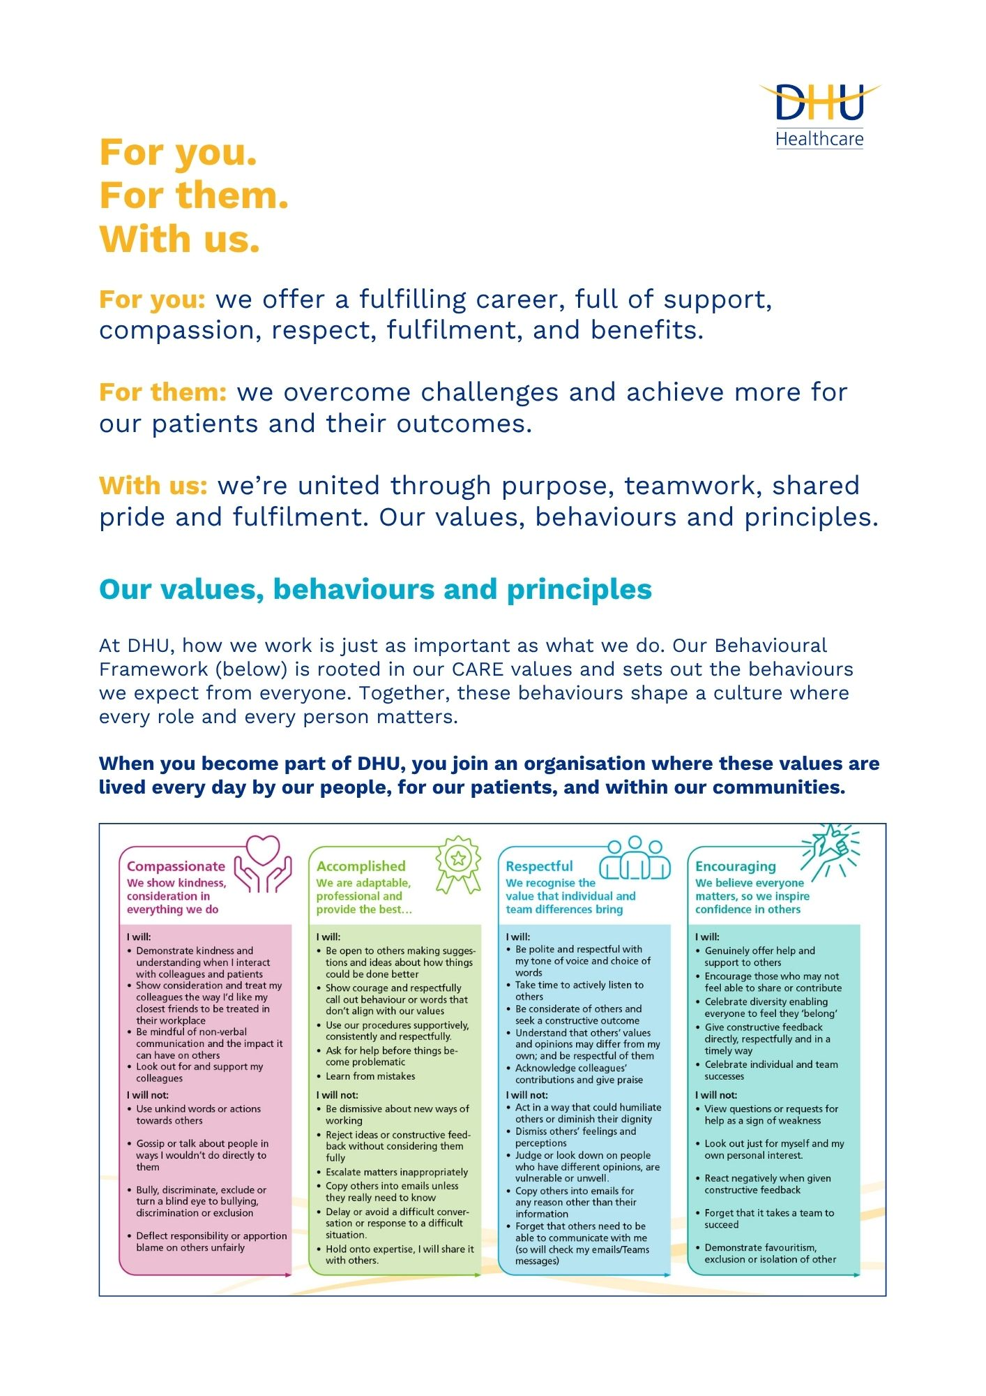

Page 3
Job Description and Person Specification
Position: | Operations Manager
Division: | Urgent Care - Northamptonshire
Location: | Sites across Northamptonshire including
Reporting to: | Head of Service
Band: | 7
Last reviewed: | January 2026

Purpose of the role
- The post holder will support the Clinical Director and Head of Clinical Services in the delivery of our In and Out of Hours service provisions across the Northants contracts. The post holder will provide operational leadership and line management to all non-clinical staff within UEC Northants Region ensuring that processes are in place to support the achievement of organisational goals, a culture of patient safety and high standards of service delivery.

- The post holder will ensure the delivery of an effective and efficient service in line with commissioned contracts and will be committed to providing a quality focused service. The post holder will be integral in the future development and co-ordination of the contracts commissioned to DHU. As an integral part of the role is to ensure that service provision across DHU is of the highest quality and offers maximum effectiveness in meeting patients’ needs and expectations visibility will be required during the In and Out of Hours period.

- The post holder will ensure the delivery of responsive, safe, high quality healthcare services, motivating and mobilising teams to ensure all performance and quality indicators in all contracts with our commissioners.

- The post holder will attend and represent the core services performance at contracting meetings with the commissioners alongside the Head of Clinical Services, and at other forums where required, at their request. The post holder is ultimately responsible for the day-to-day management of all divisional UEC Northants operations including the Deputy Operations Managers, workforce and operational teams and clinic locations.

- The post holder will be responsible for service, workforce and financial planning within his/her department and will work closely with other with the Executive Team, Senior Leadership Team, Managers and clinicians to support company-wide objectives.

The post holder will also work closely with the Head of Clinical Services; and other Senior Divisional Leads; to ensure a culture of continuous quality improvement, that builds on our areas of strength but also develops areas that require service development and quality improvement.
- Deliver on completion of staff appraisal and statutory mandatory training with a target of ≥ 95% compliance. Provide monthly report for assurance to senior management team.
- Deliver on completion of Datix and complaints response within the agreed timeframes, providing a monthly report for assurance to senior management team.
- Ensure Palliative Care services are delivered within agreed budgetary parameters while continuously improving workforce productivity and value for money, without compromising quality or patient safety.
- Always maintain full rota coverage, ensuring appropriate skill mix aligned to service demand and clinical risk, providing a monthly report on vacant hours and agency use for assurance to senior management team.
Page 4
Key areas of accountability and responsibility
Key responsibilities include, providing visible and accessible leadership creating a climate where individuals understand their role and responsibilities including rota management and operational support to all colleagues engaged in service delivery, including days, evenings, nights, weekends, bank holidays (inclusive of Christmas and New year); ensuring positions on the rota meet financial modelling whilst ensuring patient safety, and adequate resources provide business efficiency, continuity and colleague satisfaction.

The post holder will actively seek and develop business opportunities within the healthcare community, presenting capabilities of the service formally to potential commissioners.

Performance of the Service
- To provide full support to the Senior Management Team to ensure services operate effectively and efficiently meeting contractual requirements
- Undertake responsibility for the management of all non-clinical staff
- To ensure that the service maintains operational efficiency at all times through correct allocation of staff whilst ensuring budget constraints are adhered to
- To support the development of policies and protocols and implement them, ensuring compliance with DHU Policies and Procedures and legislative requirements
- Pro-actively manage staffing requirements within DHU Operations and Clinical Services and ensure that needs are met
- Responsible for recruitment and selection, performance, appraisal and employment issues across the staff group
- Responsible for identifying and assessing the training needs of staff and the delivery and review of training programmes through the relevant DHU Corporate Services
- Identifies service delivery issues, requirements or areas of underperformance and takes the necessary action to resolve.
- Ensure the effective dissemination of information to staff
- To support capacity planning and resourcing to ensure capacity is appropriate to deal with all unscheduled care demands
- Responsible for the establishment of robust mechanisms that deliver continuous operational; service improvement; and contract performance monitoring. Takes action to address any areas of concern and underperformance

Management of Staff
- Keep the team fully informed of changes in relation to service delivery and duties including organisational policies, ensuring effective communication systems within the team, including chairing monthly staff meetings
- Provide cover for sickness, bank holidays, annual leave etc. for any associated member of the rota team
- Maximise the performance and development of direct reports including performing annual appraisals
- Provides regular briefings to staff communicating priorities. Builds effective relationships with colleagues at all levels through open communication and constructive feedback.
Proactively manages good and poor performance and addresses grievance/disciplinary issues swiftly in accordance with organisational policies and procedures and with input from the People and Culture Teams
- Assumes delegated responsibility for aspects of the service budget to a level commensurate with the grade of the post, identifying and implementing efficiency savings
- Ensure contingency planning is undertaken and that the service is prepared for major and minor incidents
- Work with the Head of Clinical Services and GP Clinical Director to plan ahead to ensure seasonal variations in demand are met and the service is prepared for bank holiday periods and emergency events
- Extract and interpret data and produce reports as required
- Proactively engages and builds relationships with the ICBs and key stakeholders to understand and identify potential opportunities for generating new business opportunity and improvements in patient satisfaction levels
- Maintain competence in respect of IT systems and programs to an advanced level as appropriate
- Work with the Governance Team in relation to adherence in all areas
- Building stakeholder relationships through meetings and performance
- Deal with matters raised under the complaints procedure/protocol and using the procedure/protocol when answering queries and complying with requests from the Complaints Manager for statements and information requests within the specified timeframe, i.e. 5 days for statements
- Is responsible for ensuring that business continuity plans are in place for operational services, and that teams are cognisant (relevant to their role) of their existence
- Ensure the provision of all necessary equipment and supplies across all locations
- Participate in an on-call / duty manager rota to provide leadership and management support to the service across a 24-hour, 7 day period.
- Any other duties appropriate to the grade of the post that may be reasonably required by an appropriate manager.

Page 5
Page 6
Communications and Working Relationships
- Staff within DHU Health Care, related organisations and local GP surgeries
- Agencies and third-party providers
- Clinical and managerial staff
- Clinical and other appropriate staff in local primary and secondary care services
- Staff within local authority Social Services
- Commissioners and stakeholders
- Urgent Care- and other related services within the local health economy

Any Special Conditions
- To complete Audits within the service when required
- Ensure that computer records are accurate
- Travel to other sites may be necessary in course of duties
- The post holder may occasionally be required to work out of normal office working hours
- Flexibility in hours and duties
- As you will expect the organisation may change from time to time and you will be expected to meet the operational requirements
- Any other reasonable duties as required from time to time

Post: Head of Service – Palliative Care
Qualifications | Essential | Desirable | Assessment Criteria
Educated to degree level or equivalent experience | x |  | Certificate /Application
Valid UK driving licence (roles require travel across Northamptonshire). | x |  | Certificate /Application
Ideally Excel qualification | x |  | Certificate /Application
Experience | Essential | Desirable | Assessment Criteria
Previous suitable/management experience managing a large team including management and motivation of staff | x |  | Application / Interview
Previous NHS management responsibility and experience | x |  | Application / Interview
Previous experience of working with staff in a busy service environment | x |  | Application / Interview
Staff rostering experience including experience of budgets | x |  | Application / Interview
Communication with a variety of people | x |  | Application / Interview
Managing change – instrumental in the implementation and development of change initiatives | x |  | Application / Interview
High level of computer experience (e.g. Word/Excel and other packages) including databases | x |  | Application / Interview
Knowledge & Skills | Essential | Desirable | Assessment Criteria
Excellent interpersonal/communication skills | x |  | Interview/Reference
Ability to manage change | x |  | Interview/Reference
Ability to prioritise workload and delegate effectively | x |  | Application / Interview
Ability to interpret data at an operational level | x |  | Application / Interview
Effective time management – strong organisational skills | x |  | Interview/Reference
Accurate record keeping | x |  | Application / Interview
Ability to use initiative | x |  | Application / Interview
People Management | x |  | Application / Interview
Problem solving skills | x |  | Application / Interview
Job Circumstances | Essential | Desirable | Assessment Criteria
Ability to work flexible including unsocial hours | x |  | Application / Interview
Travel to other sites across region | x |  | Application / Interview
To attend mandatory or professional development training as required
Commitment to the role | x |  | Application / Interview
Personal Attributes | Essential | Desirable | Assessment Criteria
Effective team player | X |  | Application / Interview / Reference
Self Starter | x |  | Application / Interview
Flexibility in hours and duties

Maintains perspective and resilience, using an appropriate sense of humour to create a positive and supportive working environment. | x |  | Interview
Demonstrates sound judgement, dependability, and the ability to remain composed under pressure. | X |  | App/Int/Ref
Shows energy, commitment, and passion for service improvement and compassionate care. | X |  | App/Int/Ref
Acts with transparency, fairness, and integrity, inspiring confidence and trust across teams and partners. | X |  | App/Int/Ref

Page 8

First name:
Signature: Date:
Surname:
Reference: F3082
Issue: 1.0
Date: 03/2025
Key policies and what we expect from each other
Belonging: At DHU, we want everyone to feel like they truly belong. We believe our team should be just as diverse as the people and communities we care for. Whoever you are, wherever you're from - you’re welcome here. We’re all about building a culture where everyone feels seen, heard, and valued.
Diversity: We’re proud of the different backgrounds, experiences and perspectives our people bring. That’s what makes us strong. We treat everyone fairly and respectfully, and we’re committed to creating a workplace that celebrates what makes each of us unique. No one should ever feel left out, left behind, or treated differently.
Safeguarding: Keeping people safe is at the heart of what we do. Whether it’s patients or colleagues, children or adults - we all share a responsibility to look out for one another and speak up if something doesn’t feel right.
Health & safety: Everyone has a part to play in staying safe at work. Be mindful of how your actions affect others and follow our health and safety guidance. If you see something that’s not safe, speak up.
Infection prevention and control: A clean and safe space is everyone’s responsibility. Stick to our infection prevention guidance - it helps protect you, your team, and the people we care for.
Looking after our planet: We all have a part to play in protecting the environment. At DHU, we do our bit by using resources wisely and keeping waste to a minimum. That means recycling and sorting waste properly, switching off lights and equipment when we’re not using them, reporting heating or cooling issues as soon as they happen, and cutting down on unnecessary travel. Small actions, big difference - especially when we all do them together.
Teamwork: As part of our DHU team, you might be asked to take on different tasks now and then to help us meet our goals. We all pitch in where we can, support each other, and stay flexible to keep things running smoothly.
Postholder acknowledgement
I acknowledge receipt and confirm my understanding and acceptance of the responsibilities specified in my Job Description.
Please Note: If you are unclear of any requirement in this document obtain clarification from your line manager.

DHU Healthcare is the trading name of DHU Health Care C.I.C., a limited company registered in England and Wales. Registration no. 05834163. Registered office: No:2, Roundhouse Rd, Derby, DE24 8JE.

Reference: F3082
Issue: 1.0
Date: 03/2025

