
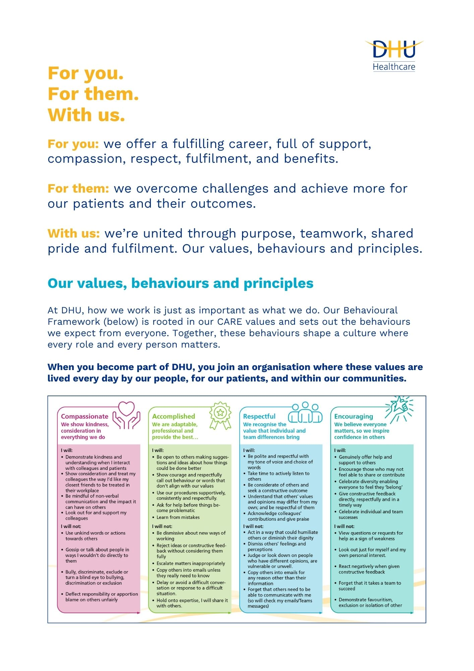

Job Description and Person Specification
Position: | Programme Lead – Absence Improvement Programme
Division: | People & Culture
Location: | Multi-site with regular travel across DHU locations
Reporting to: | Chief People Officer
Band: | Band 8b
Last reviewed: | Month 2025

Purpose of the role
The Programme Lead – Absence Improvement Programme will provide strategic leadership and operational oversight for DHU's Board-approved Absence Improvement Programme.
The postholder will be accountable for the successful delivery of programme objectives, ensuring that improvements in attendance management translate into enhanced colleague experience, improved operational resilience, reduced organisational risk and delivery of agreed financial benefits.
Operating across organisational boundaries, the Programme Lead will establish effective governance arrangements, oversee programme implementation, lead a multidisciplinary programme team and work collaboratively with operational leaders to embed sustainable improvements in attendance management practice.
The role requires a highly credible leader with experience of delivering large-scale workforce change, influencing senior stakeholders and translating strategic ambition into practical operational delivery.

Key areas of accountability and responsibility

- Programme Leadership and Delivery
- Lead the design, mobilisation and delivery of the Absence Improvement Programme.
- Translate programme objectives into detailed delivery plans with clear milestones, dependencies and success measures.
- Ensure programme delivery remains aligned to organisational priorities and Board expectations.
- Monitor programme progress, identify risks and implement mitigation strategies where required.
- Ensure the delivery of agreed benefits, including financial savings, workforce improvements and enhanced colleague experience.
- Track, report and assure delivery of agreed financial savings linked to improved absence performance.
- Governance and Assurance
- Establish and maintain effective programme governance arrangements.
- Provide regular progress reports to Executive teams and Board committees.
- Develop programme dashboards, metrics and reporting frameworks.
- Escalate barriers to delivery appropriately.
- Ensure robust evaluation and benefits realisation processes are in place.
- Maintain a programme risk, issue and dependency log, ensuring risks are actively managed and escalated through agreed governance routes.
- Develop and oversee transition plans to ensure programme outputs are embedded into business-as-usual practice.
- Stakeholder Leadership
- Develop strong relationships with senior operational leaders across DHU.
- Influence and challenge leaders to improve accountability for attendance management.
- Facilitate collaborative working across People & Culture, Operational Services, Occupational Health and Workforce Planning.
- Build and maintain programme sponsorship and engagement across the organisation.
- Develop and oversee the programme communication and engagement approach, ensuring leaders, managers and colleagues understand the purpose, progress and expected outcomes of the programme.

Key areas of accountability and responsibility
- Stakeholder Engagement
- Build effective relationships with operational leaders, People colleagues and specialist services.
- Work collaboratively with People Practices teams to ensure aligned support.
- Act as a trusted advisor and critical friend to managers.
- Encourage engagement and ownership of improvement activity.
- Support local communication and engagement activity to encourage ownership and participation across services.
- Leading Change
- Develop and implement change management approaches to support sustainable improvement.
- Identify and address cultural barriers to attendance improvement.
- Ensure colleagues and managers understand the rationale for change.
- Promote consistency and best practice across services.
- Ensure programme activity supports consistent application of DHU's attendance management policies, employee relations frameworks and wellbeing approach.
- Promote a fair, compassionate and inclusive approach to attendance management, ensuring wellbeing, reasonable adjustments and colleague experience remain central to programme delivery.
- Team Leadership
- Provide leadership and direction to People Programme Managers and other programme resources.
- Foster a high-performing, collaborative programme culture.
- Ensure programme team members are supported to deliver their objectives effectively.
- Success Measures
- Achievement of agreed programme milestones.
- Delivery of agreed financial benefits.
- Sustained improvements in attendance performance.
- Increased management capability and confidence.
- Positive feedback from operational leaders.
- Successful transition of programme outputs into business-as-usual arrangements.

Person specification
- Essential Criteria
- Educated to Masters level or equivalent experience.
- CIPD Level 7 qualification or equivalent experience.
- Significant experience leading complex workforce transformation programmes.
- Experience establishing programme governance arrangements.
- Experience influencing senior stakeholders and Executive teams.
- Experience delivering change across large operational environments.
- Strong analytical and problem-solving skills.
- Demonstrable experience of benefits realisation.
- Ability to operate with credibility, resilience and sound judgement in complex and sensitive workforce environments.

- Desirable Criteria
- Experience of attendance, wellbeing or workforce productivity improvement programmes.
- Experience within NHS, healthcare, urgent care or 24/7 operational environments.
- Knowledge of NHS workforce challenges and absence management.
- Experience of quality improvement or organisational development methodologies.
- Programme management qualification such as MSP, Prince2, Agile or equivalent experience.

Key policies and what we expect from each other
Belonging: At DHU, we want everyone to feel like they truly belong. We believe our team should be just as diverse as the people and communities we care for. Whoever you are, wherever you're from - you’re welcome here. We’re all about building a culture where everyone feels seen, heard, and valued.
Diversity: We’re proud of the different backgrounds, experiences and perspectives our people bring. That’s what makes us strong. We treat everyone fairly and respectfully, and we’re committed to creating a workplace that celebrates what makes each of us unique. No one should ever feel left out, left behind, or treated differently.
Safeguarding: Keeping people safe is at the heart of what we do. Whether it’s patients or colleagues, children or adults - we all share a responsibility to look out for one another and speak up if something doesn’t feel right.
Health & safety: Everyone has a part to play in staying safe at work. Be mindful of how your actions affect others and follow our health and safety guidance. If you see something that’s not safe, speak up.
Infection prevention and control: A clean and safe space is everyone’s responsibility. Stick to our infection prevention guidance - it helps protect you, your team, and the people we care for.
Looking after our planet: We all have a part to play in protecting the environment. At DHU, we do our bit by using resources wisely and keeping waste to a minimum. That means recycling and sorting waste properly, switching off lights and equipment when we’re not using them, reporting heating or cooling issues as soon as they happen, and cutting down on unnecessary travel. Small actions, big difference - especially when we all do them together.
Teamwork: As part of our DHU team, you might be asked to take on different tasks now and then to help us meet our goals. We all pitch in where we can, support each other, and stay flexible to keep things running smoothly.
Postholder acknowledgement
I acknowledge receipt and confirm my understanding and acceptance of the responsibilities specified in my Job Description.
Please Note: If you are unclear of any requirement in this document obtain clarification from your line manager.

DHU Healthcare is the trading name of DHU Health Care C.I.C., a limited company registered in England and Wales. Registration no. 05834163. Registered office: No:2, Roundhouse Rd, Derby, DE24 8JE.

Signature: Date:
Surname:
First name:

