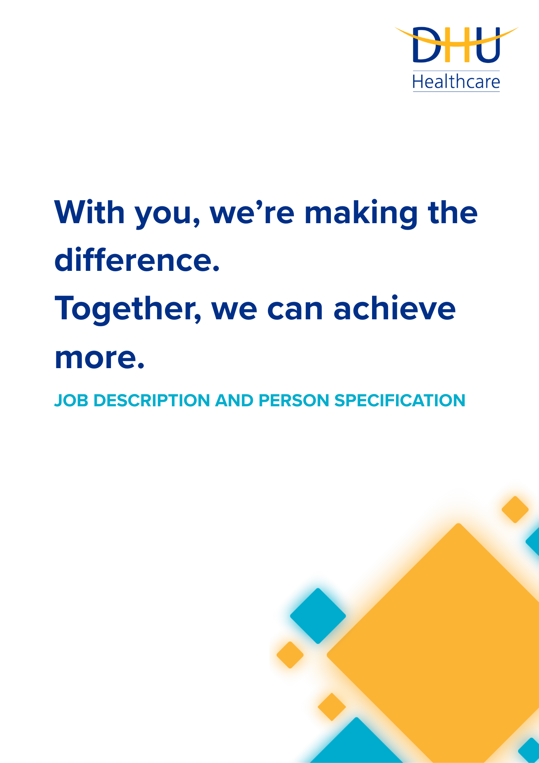
JOB TITLE
DEPARTMENT

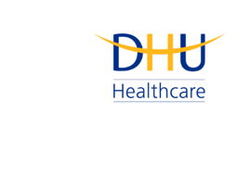
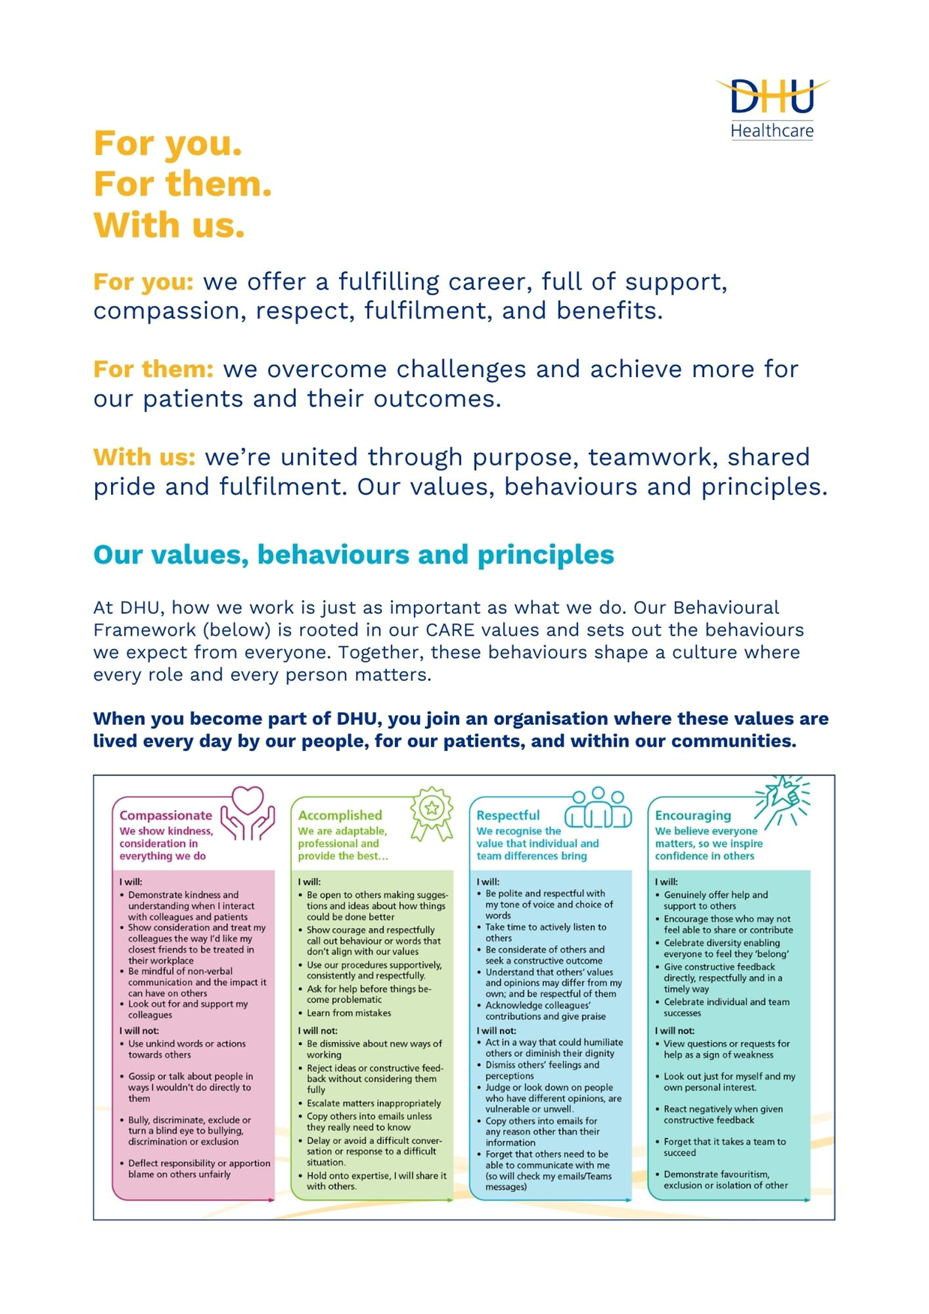

Job Description and Person Specification
Position: | Registered Nurse
Division: | UEC- UTC
Location:
Reporting to:
Band: | 5.0
Last reviewed: | June 2026

Purpose of the role
T The purpose of this role is to provide high-quality, patient-centred nursing care within the Urgent Treatment Centre, supporting the assessment and management of patients presenting with urgent healthcare needs. The role supports DHU’s commitment to delivering safe, effective, and accessible urgent care services. Working collaboratively within the multidisciplinary team, the post holder contributes to positive patient outcomes, an excellent patient experience, and the efficient delivery of urgent care services across the wider health and care system.
Performance measures

- Safe, effective, and patient-centred care consistently delivered in accordance with professional, organisational, and regulatory standards.
- Timely assessment and management of patients, supporting effective patient flow and service delivery within the Urgent Treatment Centre.
- Clinical documentation maintained to a high standard, demonstrating accuracy, completeness, and compliance with information governance requirements and NMC standards.
- Positive patient experience evidenced through feedback, complaints data, and adherence to DHU's CARE values of Compassionate, Accomplished, Respectful, and Encouraging care.
- Effective multidisciplinary working demonstrated through collaborative practice, communication, and contribution to team and organisational objectives.

Key areas of accountability and responsibility

Clinical
- Triage/validate patients, allocate appointment for assessment and prioritise acutely unwell patients using your clinical skills
- Recognise, respond to and escalate safeguarding concerns as per organisational policies
- Develop and maintain competency in core clinical skills including:
  - Vital signs measurement and interpretation
  - Phlebotomy
  - Cannulation
  - Administration of medication- oral, IM, IV and subcutaneous
  - Use of PGDs
  - Wound care- including packing of wounds
  - Wound closure- steristrips and glue
  - ECG recording
  - Bladder scanning
  - Catheterisation
  - Urinalysis
  - Blood Glucose/ Ketone monitoring
  - Application of plaster casts
- Use point of care testing machines

Professional
- Maintain active registration with the Nursing and Midwifery council (NMC) and practice in accordance with the Code and professional standards
- Maintain professional accountability for clinical decisions, working within scope of practice and escalating concerns appropriately
- Act as a positive role model for DHU's CARE values, promoting a culture of compassion, respect, professionalism, and continuous improvement
- Support the learning and development of colleagues, students, and new team members as appropriate to the role
- Maintain accurate and timely clinical records in line with professional, legal, and organisational requirements
- Maintain professional competence through mandatory training, continuing professional development, clinical supervision, and reflective practice.

Patient care experience
- Provide compassionate, patient-centred care that promotes dignity, respect, inclusion, and involvement in decision-making.
- Communicate effectively with patients, carers, and colleagues to ensure accurate information sharing and a positive patient experience.

Person specification
Qualifications and Experience
- Registered Adult Nurse on the NMC register
- Urgent care, Accident and Emergency or triage experience- essential
Knowledge & Skills
- Phlebotomy- Essential
- Cannulation, ECG- Desirable
- Ability to assess, prioritise, and respond effectively to patients presenting with urgent healthcare needs- Essential
- Computer literacy- Essential
- Familiarity with SystmOne- Desirable

Personal Attributes
- Team player- Contributes positively to team culture and service delivery.
- Committed to continuing professional development
- Flexibility to meet service needs
- Communicates and behaves in a professional, respectful, and compassionate manner.

Key policies and what we expect from each other
Belonging: At DHU, we want everyone to feel like they truly belong. We believe our team should be just as diverse as the people and communities we care for. Whoever you are, wherever you're from - you’re welcome here. We’re all about building a culture where everyone feels seen, heard, and valued.
Diversity: We’re proud of the different backgrounds, experiences and perspectives our people bring. That’s what makes us strong. We treat everyone fairly and respectfully, and we’re committed to creating a workplace that celebrates what makes each of us unique. No one should ever feel left out, left behind, or treated differently.
Safeguarding: Keeping people safe is at the heart of what we do. Whether it’s patients or colleagues, children or adults - we all share a responsibility to look out for one another and speak up if something doesn’t feel right.
Health & safety: Everyone has a part to play in staying safe at work. Be mindful of how your actions affect others and follow our health and safety guidance. If you see something that’s not safe, speak up.
Wellbeing: Look after your own health and wellbeing, and help create a positive, supportive workplace for everyone. Use the resources available, treat colleagues with respect, and speak up if something isn’t right. Together, we can make DHU a place where everyone can thrive.
Infection prevention and control: A clean and safe space is everyone’s responsibility. Stick to our infection prevention guidance - it helps protect you, your team, and the people we care for.
Looking after our planet: We all have a part to play in protecting the environment. At DHU, we do our bit by using resources wisely and keeping waste to a minimum. That means recycling and sorting waste properly, switching off lights and equipment when we’re not using them, reporting heating or cooling issues as soon as they happen, and cutting down on unnecessary travel. Small actions, big difference - especially when we all do them together.
Teamwork: As part of our DHU team, you might be asked to take on different tasks now and then to help us meet our goals. We all pitch in where we can, support each other, and stay flexible to keep things running smoothly.
Postholder acknowledgement
I acknowledge receipt and confirm my understanding and acceptance of the responsibilities specified in my Job Description.
Please Note: If you are unclear of any requirement in this document obtain clarification from your line manager.

DHU Healthcare is the trading name of DHU Health Care C.I.C., a limited company registered in England and Wales. Registration no. 05834163. Registered office: No:2, Roundhouse Rd, Derby, DE24 8JE.

