Job Description & Person Specification

Position: | Trainee Advanced Clinical Practitioner | Division: | LLR
Location: | Loughborough Urgent Treatment Centre | Reporting to: | Clinical Service Lead

Purpose of the Role

The post holder will be employed as a UEC Trainee ACP within the UEC contracts run by DHU Health Care. This is a fixed term development post with staged progression to Clinical Practitioner (Nurse/Paramedic/ Pharmacist) and then Advanced Practitioner (Advanced Clinical Practitioner) following successful completion of the Advanced Clinical Practice MSc and the associated competencies.

The post holder will work autonomously in a variety of roles of which they will already be competent e.g. triage role within the walk-in centres, community nursing, vaccination, phlebotomy, long term condition clinics etc for some of their contractual hours. The remaining hours will be utilised for training, development and supervision within the out of hours contracts or primary care and other DHU services.

A commitment to delivering a quality service, excellence in clinical practice and continuous professional development are integral to the role and the development of the service.

The post holder will participate in promoting and advancing DHU Health Care CIC.

Key Success Measures

- Compassionate - We show kindness, consideration and understanding in everything we do – and demonstrate our caring nature to our patients, people and communities.
- Accomplished - We are available day and night – a responsive, adaptable, professional NHS partner, providing the best advice, care and treatment for every individual.
- Respectful - We recognise the value that individual and team differences bring - welcoming views, listening, being honest, and learning from others’ experiences.
- Encouraging - We believe everyone matters, so we inspire confidence in others - promoting ‘speaking up’, fostering career-long learning and development, and supporting improvement ideas.

Key Areas of Responsibility & Accountability

Clinical
- To practice autonomously within a rotered shift.
- Work under direct and indirect supervision within the primary care centers, home visiting and telephone triage.
- New competency is supervised, however work related to professional registration may continue unsupervised.
- To assess, plan, treat and refer patients appropriately and evaluate patient care.
- To recognise the need for, initiate and where appropriate interpret relevant diagnostic investigations.
- To recognise the need for and initiate where appropriate advice from relevant specialism’s.
- To exhibit excellent communication skills when dealing with clients. Nonverbal and verbal skills required. To have the ability to make clear decisions with confidence and communicate these effectively.
- To maintain appropriate clinical records, ensuring that documentation clearly demonstrates the NMC / HCPC / GPhC Guidelines for Records and Record keeping.
- To supply medication under patient group directives/ PSD.
- To work within the parameters of his/her skills and knowledge, to recognise the limitations of one’s own practice and to work within the bounds of one’s training and capability according to the NMC / HCPC / GPhC Code of Conduct.
- To maintain an awareness of developments in clinical practice.
- To optimise evidence-based practice within practice.
- To work effectively as part of a multi professional team in collaboration with other members of the service.
- Complete all required competency documentation and mandatory training within the time frame agreed by your line manager.

Managerial
- Take part in organisational clinical audits and service improvement projects as required.
- To attend professional meetings and participate in team meetings.
- To ensure you remain up to date with DHU communications with your DHU email.
- To work within DHU Health Care CIC guidelines and policies and to support the implementation of policies in own work area and participate in working groups as required.
- To participate in the appraisal process.
- To identify, report and address poor performance issues.
- To diffuse challenging behavior, ensuring that the situation is managed in a sensitive way.
- To ensure efficient and effective use of material resources/supplies.
- To identify any problems with resource use/availability and make recommendations for corrective action.

Clinical Governance
- To participate in the clinical governance requirements within the work of the organisation.
- To practice with the parameters of company policies, protocols and guidelines.
- To participate in quality improvement within the organisation.
- To assess and evaluate outcomes of own practice, service intervention and treatment and identifies any short falls in service reporting to relevant managers.
- To ensure the requirements of Health and Safety policy and legislation are maintained.
- To participate in research and development activities of DHU Health Care.

Education Practice Development
- To complete a bespoke 24-month training programme in Advanced Practice at MSc Level, supported by the DHU Healthcare clinical training team, to practice independently within the designated time frame.
- To complete professional portfolio of practice to support Advanced Practitioner programme.
- To participate in the clinical supervision framework for health care professionals within the company.
- To offer appropriate advice to health and social care professions on care practices, delivery and service development within the parameters of the role and scope of practice.
- To participate in the ongoing individual professional development within the organisation.
- To complete the mandatory training programme, always ensuring compliance.

Professional
- To work within the regulatory requirements, codes and Professional Standards of practice of the NMC/HCPC/GPhC
- To maintain professional and clinical competence through mechanisms of continuing professional development.
- To always act in such a manner to promote confidence and public trust and uphold the reputation and image of DHU Health Care CIC.

Communications and Working Relationships
- Director of Nursing and Quality and other Executive Directors.
- Divisional Clinical Director and Managing Director
- Divisional Heads of Clinical Services
- Divisional Operations and Corporate Teams
- DHU Health Care CIC Governance Team
- DHU Health Care CIC Clinical Training Team
- Clinical and managerial staff within participating Clinical Commissioning Groups (CCG)
- Clinical staff in local primary and secondary care services
- Other related services within the local health economy
- Social Services and local intermediate Care Services

Person Specification

The job holder will have:

Qualification | Essential | - Desirable
Qualifications  Academic/ professional | - Registered Adult Nurse, Paramedic or Pharmacist  - Educated to degree level or equivalent with evidence of level 6 study.  - Evidence of continued professional development throughout career | - Mentorship qualification
Experience | - >5 years post-registration experience  - Can demonstrate knowledge of common conditions in urgent care, adults, and children.  - Has experience in urgent/ primary and emergency care.  - Experience of supplying medicines under patient group directives. | - Experience of telephone triage  - Experience of home visiting
Skills & Knowledge | - Prepared to participate in service development.  - Can give evidence of using effective communication skills within practice.  - Must have excellent verbal and written skills.  - Computer literate  - Demonstrable awareness of accountability in clinical practice  - Prioritises clinical workload and assess associated risks, taking appropriate action, effective time management.  - Commitment to lifelong learning  - Counselling & communication skills  - Facilitation & negotiation skills  - Awareness of UTC standards  - Experience or interest in working with children.  - Interest in minor illness and minor injuries. | - Patient systems-based assessment skills.
Job Circumstances | - Commitment to the role.  - Able to work unsocial hours including bank holidays.  - Flexibility to meet service/Rota needs.  - Be prepared to travel between different DHU services. | - Full driving Licence (All other DHU locations)
Personal Qualities | - Proven team player  - Able to work autonomously.  - Committed to continuing professional development.  - Positive effect  - High level of interpersonal skills  - Willingness to undertake additional training to develop skills as an autonomous practitioner, aiming to achieve a full MSc in advanced clinical practice.

Behavioral Qualities

We value our people our people through a coaching culture offering staff engagement, wellbeing support, career progression and inspirational, visible leadership.

At the heart of everything we do, you will find our CARE values – principles, standards and behaviors we live by:

We CARE for you. We are always….
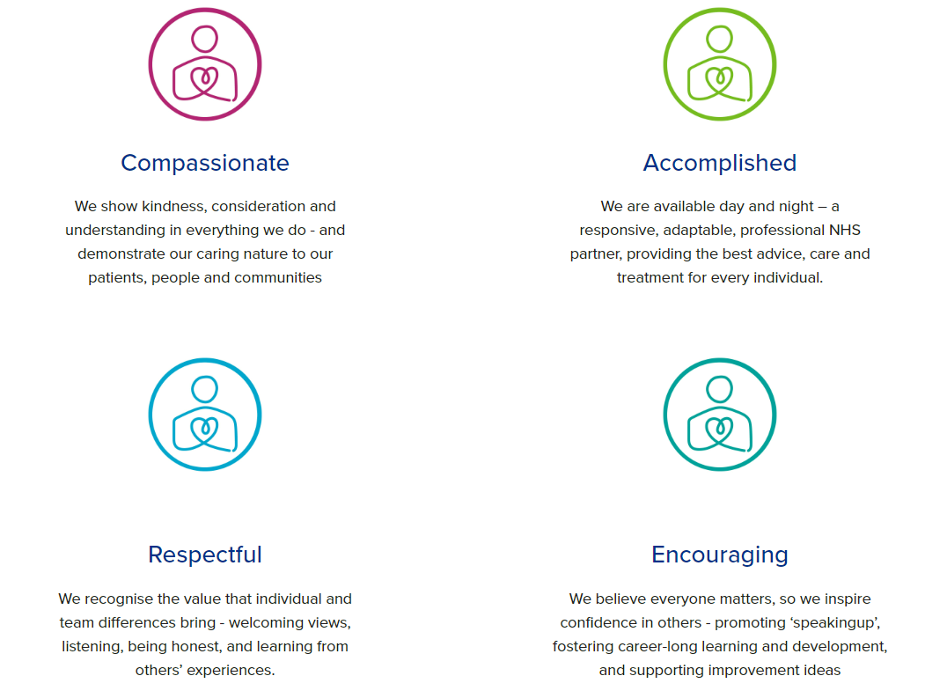

Diversity

DHU Health Care CIC believes our workforce should be as diverse as the range of services we offer, and the communities we serve. We are committed to valuing and encouraging diversity throughout our workforce, regardless of age, disability, gender reassignment, marriage or civil partnership, pregnancy and maternity, race, religion or belief, sex or sexual orientation. As part of our mission, we are dedicated to eliminating discrimination.

Safeguarding

DHU Health Care CIC is committed to safeguarding and promoting the welfare of Adults, Children and Young People and expects all staff and volunteers to share this commitment.

Infection Prevention & Control

Infection Prevention & Control is pivotal in ensuring a safe & clean environment for both patients and staff. IP&C is everyone’s responsibility and strict adherence to the IP&C policy is expected of ALL employees of the organisation.

General
As you will expect, the organisation may change from time to time, and you will be expected to meet the operational requirements of the business and any other reasonable duties as required from time to time.

Acknowledgment

I acknowledge receipt and confirm my understanding and acceptance of the responsibilities specified in my Job Description. Please Note: If you are unclear of any requirement in this document obtain clarification from your line manager.

Signature of Post Holder: |  | Date:
Name:

