Job Description & Person Specification

Position: | First Contact Physiotherapist (musculoskeletal conditions) | Division: | UEC Leicestershire
Location: | LLR - Thurmaston | Reporting to: | Clinical Service Lead

Purpose of the Role
The post holder will be responsible for the autonomous clinical assessment, treatment and/or referral or giving advice as appropriate to first contact patients referred with MSK conditions within the services provided by DHU Health Care CIC through direct contact consultations.

A commitment to a quality service, excellence in clinical practice and continuous professional development are integral to the role and the development of the service.

The post holder will participate in promoting and advancing DHU Health Care CIC.

Key Success Measures
- Caring & Compassion - We will actively listen to understand and empathise with others, with a desire to support both patients and colleagues.
- Always Professional - We will be accountable for consistently delivering high quality healthcare for our patients.
- Respect & Dignity - We will actively listen to each other and our patients to answer their concerns or questions. We will maintain and respect patient’s dignity and must ensure it is never compromised.
- Everyone Matters - We will actively encourage feedback from both patients and colleagues to continually improve our service, ensure everyone has an opportunity to have their voice heard, and everyone has an opportunity to further develop their skills and competencies.

Key Areas of Responsibility & Accountability

Scope of the Role
1. be the first point of contact for expert clinical assessment and diagnosis of patients presenting with MSK conditions in primary care/GP practices. This will include patients who present with a range of multiple needs and underlying pathologies/other primary conditions
2. Use of advanced assessment tools and application of expert treatment modalities/techniques will be required
3. be the link between primary, community and acute services, when the patient is managed via primary care ensuring an integrated care pathway for individual patients that meets their needs. This will include provision of triage to other services and/or directly providing management and advice
4. lead on and develop effective communication between primary care services/GP practices and other relevant care providers. Educate on the role of the FCP, its impact on referral patterns and patient care pathways
5. maintain strong relationships with orthopaedic consultant teams, relevant MDT and physiotherapy services in community and acute settings
6. where appropriate develop relationships with wider health and social care agencies, for example mental health teams, local authorities, third sector providers and patient groups
7. to provide leadership to primary care multi-disciplinary teams on physiotherapeutic management of MSK conditions. This will include the provision of highly specialist advice on issues ranging from the provision of expert opinion on individual patient treatment options to be a contributor to MSK services and related pathway development
8. work independently, without day-to-day supervision, to assess, diagnose, triage, and manage patients, taking responsibility for prioritising and managing a caseload of the PCN’s Registered Patients
9. receive patients who self-refer (where systems permit) or from a clinical professional within the PCN, and where required refer to other health professionals within the PCN
10. work as part of a multi-disciplinary team in a patient facing role, using their expert knowledge of movement and function issues, to create stronger links for wider services through clinical leadership, teaching and evaluation
11. develop integrated and tailored care programmes in partnership with patients, providing a range of first line treatment options including self-management, referral to rehabilitation focussed services and social prescribing
12. make use of their full scope of practice, developing skills relating to independent prescribing, injection therapy and investigation to make professional judgements and decisions in unpredictable situations, including when provided with incomplete or contradictory information, and take responsibility for making and justifying these decisions
13. manage complex interactions, including working with patients with psychosocial and mental health needs, referring onwards as required and including social prescribing when appropriate
14. implement all aspects of effective clinical governance for own practice, including undertaking regular audit and evaluation, supervision and training
15. develop integrated and tailored care programmes in partnership with patients through:
a. effective shared decision-making with a range of first line management options (appropriate for a patient’s level of activation)
b. assessing levels of Patient Activation to support a patient’s own level of knowledge, skills and confidence to self-manage their conditions, ensuring they are able to evaluate and improve the effectiveness of self-management interventions, particularly for those at low levels of activation
c. agreeing with patient’s appropriate support for self-management through referral to rehabilitation focused services and wider social prescribing as appropriate
d. designing and implementing plans that facilitate behavioral change, optimise patient’s physical activity and mobility, support fulfilment of personal goals and independence, and reduce the need for pharmacological interventions

Clinical
16. use advance clinical practice skills and clinical reasoning to provide comprehensive diagnostic and treatment support patients who present with complex musculoskeletal conditions and/or multiple pathologies and/or mental health and/or pain management needs
17. independently request diagnostic tests including routine and specialist x-rays, MRI imaging, ultrasound scans and blood and other pathology tests. Interpret the results alongside traditional physiotherapeutic assessment techniques and non-clinical information to aid clinical diagnosis and decisions on potential treatment options/clinical interventions
18. carry own caseload as an autonomous practitioner, providing direct clinical/physiotherapeutic care for patients with a range of complex musculo-skeletal conditions and who may have significant other primary or secondary conditions/multi-pathologies
19. be able to decide when appropriate to use advanced clinical practice clinical skills that may include:
a. joint/soft tissue injection therapy, including administration of prescription only medication [POM] to aid treatment.
b. joint aspirations
c. non-medical prescribing
20. use professional judgement and advanced clinical reasoning skills to make decisions about safe and effective patient care in unpredictable situations, including when there is incomplete/contradictory information
21. demonstrate understanding of the impact of physiotherapeutic interventions on existing conditions and treatment programmes e.g. podiatric treatment, drug therapies, etc.
22. ensure physiotherapy interventions are integrated and supportive of the whole treatment aims promoting a holistic approach to condition management
23. be able to clinically justify referral onto appropriate MSK pathways within the community or wider healthcare services, including referral to the appropriate stage of the pathway and the use of social prescribing
24. for patients managed as part of own caseload, take the lead for the management of the patient’s journey on their care pathway, acting as the link for the patient between primary care and other services/professionals
25. justify clinically referrals to other specialist services. This will include referral to acute and specialist services such as surgical orthopaedics, rheumatology and neurology, other AHP services, nursing services and to the primary care medical teams. This requires advanced knowledge of the role of other specialist health professionals
26. recognise potential underlying non-MSK related disease and conditions that present as MSK symptoms and to refer appropriately.
27. when needed, accelerate the patient’s referral to other health professionals/ services
28. work in partnership with the patient at all times to attain maximum participation in treatment programmes. This will include working with patients from diverse social background and cultures and understanding how this will affect treatment proposals and models
29. develop integrated and tailored care programmes in partnership with patients
30. use effective shared decision making with a range of first line management options (appropriate for the person’s level of activation)
31. assess levels of Patient Activation to confirm levels of knowledge, skills and confidence to self-manage
32. agree appropriate support for self-management through referral to rehabilitation focused services and social prescribing provision

33. provide expert advice and act as source of expertise in the management of musculoskeletal conditions and provide a specialist advisory service to patients, specialist physiotherapists other specialist healthcare professionals and members of the primary care team, including advising GPs on management of MSK conditions
34. provide advice, instruction and teaching on aspects of management of a condition to patients, relatives, carers and other health professionals
35. continually review and develop specialist clinical and diagnostic skills in response to service need
36. be accountable for decisions and actions via Health and Care Professions Council (HCPC) registration, supported by a professional culture of peer networking/review and engagement in evidence-based practice

Service/Professional Leadership/Consultancy
37. provide leadership and support on MSK clinical and service development across the PCN, alongside learning opportunities for the whole multi-disciplinary team within primary care
38. plan and organise the FCP service efficiently, ensuring delivery in line with service expectations
39. integrate the FCP role into the wider primary care team, proactively working with the primary care team to build robust relationships and integrate working practices. Attending primary care strategic and practice level meetings to represent FCP/physiotherapy when appropriate
40. contribute to the development of referral guidelines for MSK and MSK related conditions from primary care to other NHS services that will direct referrals to other primary care services, community, secondary and tertiary [specialist] services
41. work collaboratively with the primary care team, including working across the PCN and also in partnership with business managers, professional managers and lead clinicians of secondary, community and other care providers to improve service delivery and meet the identified needs of the local patient population.
42. use influence and contribution to the PCN to promote the contribution of FCPs to MSK services in primary care and to the wider related services in the health economy.
43. work with the PCN team to support preventative strategies for local populations, patient groups and individuals
44. participate in peer networking and support underpinned by active engagement in peer review and embracing evidence-based practice
45. contribute to organisational and service policies that support the maintenance of good clinical governance, manage risk and ensure patient safety is paramount.
46. be responsible for identifying and reporting any risk/ clinical governance issues in the FCP service
47. contribute to monitoring and review of service standards for MSK primary care services. Including established clinical, professional and service standards
48. represent the PCN’s FCP service offer at internal primary care meetings and at external forums/service meetings
49. participate in/support investigations into complaints and clinical errors/incidents when appropriate

Education/Workforce Development
50. participate in developing education and training of specialist physiotherapists up-to post-graduate level to support the development of advanced clinical practice skills and knowledge within the wider physiotherapy workforce
51. provide training and supervision, some of which maybe to postgraduate level, for specialist primary care professionals, including GPs in order for them to develop specialist MSK patient referral and management skills
52. provide and receive clinical supervision and be an active provider of mentoring and coaching of specialist clinicians from a range of disciplines
53. maintain a professional portfolio of advanced clinical practice knowledge and skills through participation in internal and external development opportunities

Research and Evaluation
54. promote and lead the integration of evidence-based practice and national guidelines into own and local FCP MSK service practice
55. use expert knowledge of evidence-based guidelines and national frameworks to influence the development of FCP services within the primary care team
56. lead or participate in research and MDT research projects as appropriate. This may include participation in cross organisational research and audit programmes.
57. present and disseminate research and clinical audit findings to the primary care team as required.
58. Provide analysis of local and national data sets to illustrate service improvements and to promote service change
59. maintain an up-date audit and data derived from a range of data sets in order provide statistical reports on outcome measures and achievement of KPIs for a range of audiences
60. use audit and research to develop and improve service guidelines, care protocols, delivery of triage services and referral pathways

Communication/Building Networks
61. take the lead in communicating and influencing across the PCN the benefits of the FCP role in primary care
62. promote and explain the FCP role and what it can deliver to a range of audiences including patient groups, individual patients and other primary care team members, including GPs
63. communicate effectively and appropriately with patients and their carers. This will include explaining the diagnosis, prognosis and treatment choices available to manage multi-pathology and complex conditions. It will also involve communicating limitations on treatment outcomes and managing expectations of patients with chronic or life limiting conditions

Professional
- To work within the regulatory requirements, codes and Professional Standards of practice of the HCPC
- To maintain professional and clinical competence through mechanisms of continuing professional development.
- To always act in such a manner to promote confidence and public trust and uphold the reputation and image of DHU Health Care CIC.

Freedom to Act
- Directed by national guidance as well as local protocols and guidelines, is able to analyse each clinical situation and formulate a management plan.
- Practitioners are accountable for their own professional actions within a locally agreed scope of practice.
- Responsible for ensuring accurate interpretation and dissemination of local and national policies within speciality.
- Practitioners are responsible for managing and prioritising own workload against the needs of patients and service requirements.
- Uses own initiative, acts independently, and takes appropriate action.

Physical Effort
- Performs physical examination and clinical skills.
- Manging patients who are unwell and thus periods of intense physical effort are required on a regular or as per shift basis.
- Moving and handling of patients and equipment.
- Frequent use of a computer to record, review and order results / tests.

Mental Effort
- Required to perform procedures in the management of unwell patients.
- Regular concentration required during clinical procedures.
- Daily concentration on patient assessment and delivery of care.
- Required to respond instantaneously to patient’s needs, thus sometimes unpredictable work arises.

Emotional Effort
  - The practitioners is required to deliver clinical support via a range of treatments and experiences, which can be highly distressing and challenging. i.e. dealing with agitated
  - Discuss diagnosis with patient and their relatives.
  - Provides advice and support to unwell patients/ carers who may be concerned about an aspect of their plan of care.
  - Explaining possible diagnoses for unfavourable test results.
  - Responsible for the counselling and information giving to patients and families within their care.

Working Conditions
- The practitioners will have direct patient contact, delivering direct patient care in a variety of settings in accordance with the need of the patient.

Communications and Working Relationships
- Director of Nursing and Quality and other Executive Directors.
- Divisional Clinical Director and Managing Director
- Divisional Heads of Clinical Services
- Divisional Operations and Corporate Teams
- DHU Health Care CIC Governance Team
- DHU Health Care CIC Clinical Training Team
- Clinical and managerial staff within participating Clinical Commissioning Groups (CCG)
- Clinical staff in local primary and secondary care services
- Other related services within the local health economy
- Social Services and local intermediate Care Services

Health and Safety

In addition to the Trust overall responsibility for your health and safety you have a personal responsibility for your own health and safety. As such, you are required to inform your line manager of any safety issues that you identify that could affect you or others within the workplace. You must co-operate with management and colleagues at all times in achieving safer work processes and workplaces, particularly where it can impact on care.

Person Specification

The job holder will have:

Education / Qualification | Essential | Desirable | Assessment Criteria
Professional Registration with HCPC. | x |  | Cert / PIN
BSc degree in physiotherapy | x |  | Cert
MSc qualification in Physiotherapy |  | x | cert
Non-medical prescribing qualification |  | x | Cert
Completed or working towards a Supplementary Prescribing qualification |  | x | Cert
Can demonstrate working at Level 7 capability in MSK related areas of practice or equivalent (such as advanced assessment diagnosis and treatment) | x |  | cert
Leadership/management course |  | x | cert
Experience | Essential | Desirable | Assessment Criteria
Significant experience of working at advanced level of practice. | x |  | Application / reference
work independently, without day-to-day supervision, to assess, diagnose, triage, and manage patients, taking responsibility for prioritising and managing a caseload of the PCN’s Registered Patients | x |  | Int / app
Experience of receiving patients who self-refer (where systems permit) or from a clinical professional within the PCN, and where required refer to other health professionals within the PCN | x |  | Application / interview
Experience of developing integrated and tailored care programmes in partnership with patients, providing a range of first line treatment options including self-management, referral to rehabilitation focussed services and social prescribing; | x |  | App / int
Skills and Ability | Essential | Desirable | Assessment Criteria
work as part of a multi-disciplinary team in a patient facing role, using their expert knowledge of movement and function issues, to create stronger links for wider services through clinical leadership, teaching and evaluation; | x |  | App /cert/ref/int
Strong leadership skills | x |  | App / Int
Effective communication both written and verbal | x |  | Int/Ref
Time management ~ able to prioritise | x |  | Int/Ref
Computer skills (strong knowledge of Microsoft and GPIT systems, alongside prescribing data monitoring systems) | x |  | Cert / Int / App
Works under own initiative with strong organisational skills and can work to deadlines | x |  | Int/Ref
Able to use problem solving skills | x |  | Int/Ref
Experience of senior level decision making and delivery in a changing environment | x |  | interview
Analytical Skills | Essential | Desirable | Assessment Criteria
Demonstrate an understanding of current developments in the relevant speciality | X |  | App/Int/Ref
Demonstrate the ability to utilise current research finding in practice | X |  | App/Int/Ref
Understand, encourage, and support clinical supervision | X |  | App/Int/Ref
independent thinker with demonstrated good judgement, problem-solving and analytical skills | X |  | App/Int/Ref
Evidence of working in within a primary care setting | X |  | App/Int/Ref
Able to understand and analyse complex issues and balance competing priorities in order to make difficult decisions. | x |  | App/Int/Ref
Ability to analyse and interpret complex/ often incomplete information, pre-empt and evaluate issues, and recommend and appropriate course of action to address the issue | x |  | App/Int/Ref

Safeguarding
DHU Health Care CIC is committed to safeguarding and promoting the welfare of Adults, Children and Young People and expects all staff and volunteers to share this commitment.

Infection Prevention & Control
Infection Prevention & Control is pivotal in ensuring a safe & clean environment for both patients and staff. IP&C is everyone’s responsibility and strict adherence to the IP&C policy is expected of ALL employees of the organisation.

General
As you will expect the organisation may change from time to time and you will be expected to meet the operational requirements of the business and any other reasonable duties as required from time to time.

Behavioral Qualities
We value our people our people through a coaching culture offering staff engagement, wellbeing support, career progression and inspirational, visible leadership.

At the heart of everything we do, you will find our CARE values – principles, standards and behaviors we live by:

We CARE for you. We are always….
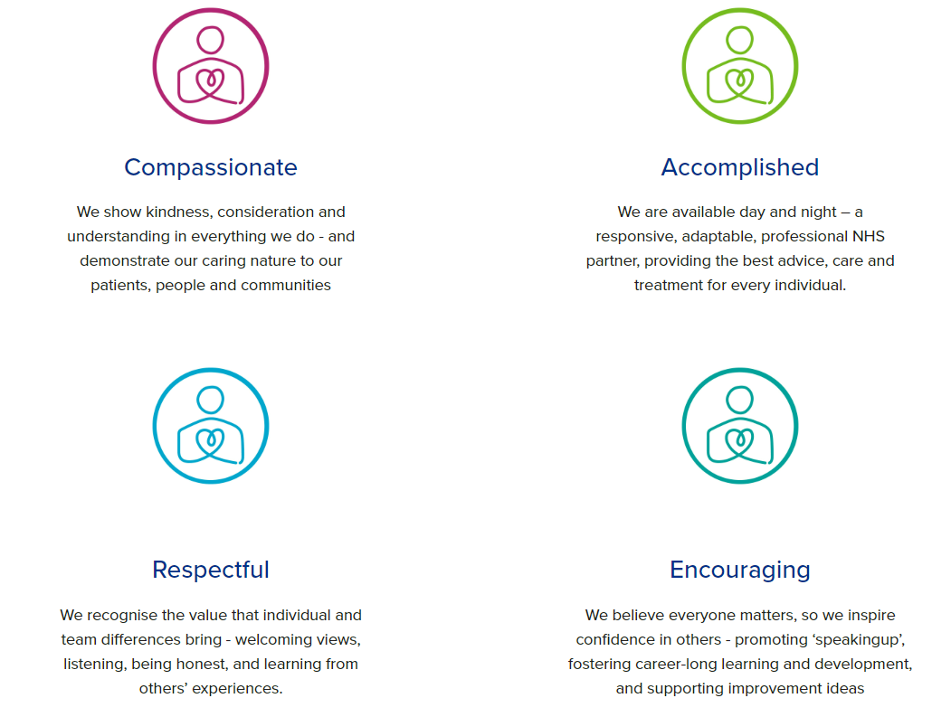

Diversity
DHU believe our workforce should be as diverse as the range of services we offer, and the communities we serve. We are committed to valuing and encouraging diversity throughout our workforce, regardless of age, disability, gender reassignment, marriage or civil partnership, pregnancy and maternity, race, religion or belief, sex or sexual orientation. As part of our mission we are dedicated to eliminating discrimination

Acknowledgment
I acknowledge receipt and confirm my understanding and acceptance of the responsibilities specified in my Job Description. Please Note: If you are unclear of any requirement in this document obtain clarification from your line manager.

Signature of Post Holder: |  | Date:
Name:

