Job Description & Person Specification

Position: | UEC & Primary Care Trainee ACP | Division: | All divisions
Location: | All locations | Reporting to: | Clinical Service Lead

Purpose of the Role

The post holder will be employed as a UEC Trainee ACP within the UEC contracts run by DHU Health Care. This is a fixed term development post with staged progression to Clinical Practitioner (Mental Health Nurse, Nurse/Paramedic/ Pharmacist) and then Advanced Practitioner (Advanced Clinical Practitioner) following successful completion of the Advanced Clinical Practice MSc and the associated competencies.

The post holder will work autonomously in a variety of roles of which they will already be competent e.g. Team Up Frailty for some of their contractual hours. The remaining hours will be utilised for training, development and supervision.

A commitment to delivering a quality service, excellence in clinical practice and continuous professional development are integral to the role and the development of the service.

The post holder will participate in promoting and advancing DHU Health Care CIC.

Key Success Measures

- Compassionate - We show kindness, consideration and understanding in everything we do – and demonstrate our caring nature to our patients, people and communities.
- Accomplished - We are available day and night – a responsive, adaptable, professional NHS partner, providing the best advice, care and treatment for every individual.
- Respectful - We recognise the value that individual and team differences bring - welcoming views, listening, being honest, and learning from others’ experiences.
- Encouraging - We believe everyone matters, so we inspire confidence in others - promoting ‘speaking up’, fostering career-long learning and development, and supporting improvement ideas.

Key Areas of Responsibility & Accountability

Clinical
- To practice autonomously within a rostered shift.
- New competency is supervised, however work related to professional registration may continue unsupervised.
- To recognise the need for, initiate and where appropriate interpret relevant diagnostic investigations.
- To recognise the need for and initiate where appropriate advice from relevant specialism’s.
- To exhibit excellent communication skills when dealing with clients. Nonverbal and verbal skills required. To have the ability to make clear decisions with confidence and communicate these effectively.
- To maintain appropriate clinical records, ensuring that documentation clearly demonstrates the NMC / HCPC / GPhC Guidelines for Records and Record keeping.
- To supply medication under patient group directives/ PSD.
- To work within the parameters of his/her skills and knowledge, to recognise the limitations of one’s own practice and to work within the bounds of one’s training and capability according to the NMC / HCPC / GPhC Code of Conduct.
- To maintain an awareness of developments in clinical practice.
- To optimise evidence-based practice within practice.
- To work effectively as part of a multi professional team in collaboration with other members of the service.
- Complete all required competency documentation and mandatory training within the time frame agreed by your line manager.
- Provide expert care and advice to a complex and dynamic caseload of patients presenting with a diverse range of medical conditions.
- Undertake first line comprehensive clinical assessment of patients, including those with complex presentations, employing an extended scope of practice including advanced consultation and physical assessment skills.
- Request, review and interpret diagnostic investigations within the context of other available information utilising a systematic process of clinical reasoning to formulate a differential diagnosis.
- Develops and record a treatment plan consistent with the outcome of assessment and the most likely diagnosis.
- Review and initiate medicines through independent prescribing or Patient Group Directions
- Involve patients, families and carers in the identification of patient-centred concerns and priorities about health and well-being and negotiates approaches available to prevent deterioration or promote comfort and well-being.
- Demonstrate empathy and compassion when communicating sensitive information and advice to patients, carers and relatives.
- Refer to other practitioners and agencies when necessary.
- Evaluate the effectiveness of therapeutic interventions and modifies the management plan accordingly.
- Maintain a visible clinical profile, having both advisory and clinical input into the medical management of patients presenting to the service.
- Advise health and social care teams regarding medical management plans taking into account all aspects of clinical governance to improve the outcomes of patient care.
- Adopt an integrated care approach to meeting an individual patient’s needs across services through collaboration with care teams who refer patients to the service and those who provide on-going care after discharge.
- Ensure discharge plans are safe and effective for the independent or supported living of older people within the community
- Assume a lead role in the safe and effective transfer of care for more complex cases.
- Demonstrate a high degree of autonomy, analytical skills, competency and multidisciplinary knowledge in caring for the older person.
- Assess capacity, gains valid informed consent and works within a legal framework with patients who lack capacity to consent to treatment.
- Provide guidance to the clinical team regarding therapeutic interventions, advance care planning and best interest decision-making for patients who lack mental capacity to make informed choices about their care.
- Recognise deteriorating patients, implements early interventions, and escalates care where appropriate.
- Empower patients to manage their long-term conditions as independently as possible.
- Provide verbal and written advice, teaching and instruction to relatives, carers, and other professionals, to promote understanding and to ensure a consistent approach to patient care.
- Apply expert knowledge in palliative care to symptom control, recognition of dying and advance care planning.
- Demonstrate analytical thinking, decision making, professionalism and leadership to ensure a high-quality patient experience within a multi-professional arena.
- Facilitate the integration of contemporary research and best practice through advanced clinical reasoning and decision making and the implementation of evidence-based protocols of care and clinical pathways.
Managerial
- Take part in organisational clinical audits and service improvement projects as required.
- To attend professional meetings and participate in team meetings.
- To ensure you remain up to date with DHU communications with your DHU email.
- To work within DHU Health Care CIC guidelines and policies and to support the implementation of policies in own work area and participate in working groups as required.
- To participate in the appraisal process.
- To identify, report and address poor performance issues.
- To diffuse challenging behavior, ensuring that the situation is managed in a sensitive way.
- To ensure efficient and effective use of material resources/supplies.
- To identify any problems with resource use/availability and make recommendations for corrective action.

Clinical Governance
- To participate in the clinical governance requirements within the work of the organisation.
- To practice with the parameters of company policies, protocols and guidelines.
- To participate in quality improvement within the organisation.
- To assess and evaluate outcomes of own practice, service intervention and treatment and identifies any short falls in service reporting to relevant managers.
- To ensure the requirements of Health and Safety policy and legislation are maintained.
- To participate in research and development activities of DHU Health Care.

Education Practice Development
- To complete a bespoke 24-month training programme in Advanced Practice at MSc Level, supported by the DHU Healthcare clinical training team, to practice independently within the designated time frame.
- To complete professional portfolio of practice to support Advanced Practitioner programme.
- To participate in the clinical supervision framework for health care professionals.
- To offer appropriate advice to health and social care professions on care practices, delivery and service development within the parameters of the role and scope of practice.
- To participate in the ongoing individual professional development within the organisation.
- To complete the mandatory training programme, always ensuring compliance.

Professional
- To work within the regulatory requirements, codes and Professional Standards of practice of the NMC/HCPC/GPhC
- To maintain professional and clinical competence through mechanisms of continuing professional development.
- To always act in such a manner to promote confidence and public trust and uphold the reputation and image of DHU Health Care CIC.

Communications and Working Relationships
- Director of Nursing and Quality and other Executive Directors.
- Divisional Clinical Director and Managing Director
- Divisional Heads of Clinical Services
- Divisional Operations and Corporate Teams
- DHU Health Care CIC Governance Team
- DHU Health Care CIC Clinical Training Team
- Clinical and managerial staff within participating Clinical Commissioning Groups (CCG)
- Clinical staff in local primary and secondary care services
- Other related services within the local health economy
- Social Services and local intermediate Care Services

Person Specification

The job holder will have:

Qualification | Essential | - Desirable
Qualifications  Academic/ professional | - Registered Mental Health Nurse, Adult Nurse, Paramedic or Pharmacist  - Educated to degree level or equivalent with evidence of level 6 study.  - Evidence of continued professional development throughout career  - Independent Prescribing | - Mentorship qualification
Experience | - >5 years post-registration experience  - Can demonstrate knowledge of common conditions in adults.  - Has experience in Mental Health, urgent/ primary and emergency care.  - Experience of supplying medicines under patient group directives. | - Experience of telephone triage  - Experience of home visiting  - Contemporary clinical experience of older people with complex needs  - Clinical expertise of end-of-life care.
Skills & Knowledge | - Prepared to participate in service development.  - Can give evidence of using effective communication skills within practice.  - Must have excellent verbal and written skills.  - Computer literate  - Demonstrable awareness of accountability in clinical practice  - Prioritises clinical workload and assess associated risks, taking appropriate action, effective time management.  - Commitment to lifelong learning  - Counselling & communication skills  - Facilitation & negotiation skills  - Awareness of UTC standards  - Interest in minor illness and minor injuries.  - Interest in Frailty  - Interest in Mental Health | - Patient systems-based assessment skills.
Job Circumstances | - Commitment to the role.  - Able to work unsocial hours including bank holidays.  - Flexibility to meet service/Rota needs.  - Be prepared to travel between different DHU services and community sites. | - Full driving Licence (All other DHU locations)
Personal Qualities | - Proven team player  - Able to work autonomously.  - Committed to continuing professional development.  - Positive effect  - High level of interpersonal skills  - Willingness to undertake additional training to develop skills as an autonomous practitioner, aiming to achieve a full MSc in advanced clinical practice.

Behavioral Qualities

We value our people our people through a coaching culture offering staff engagement, wellbeing support, career progression and inspirational, visible leadership.

At the heart of everything we do, you will find our CARE values – principles, standards and behaviors we live by:

We CARE for you. We are always….
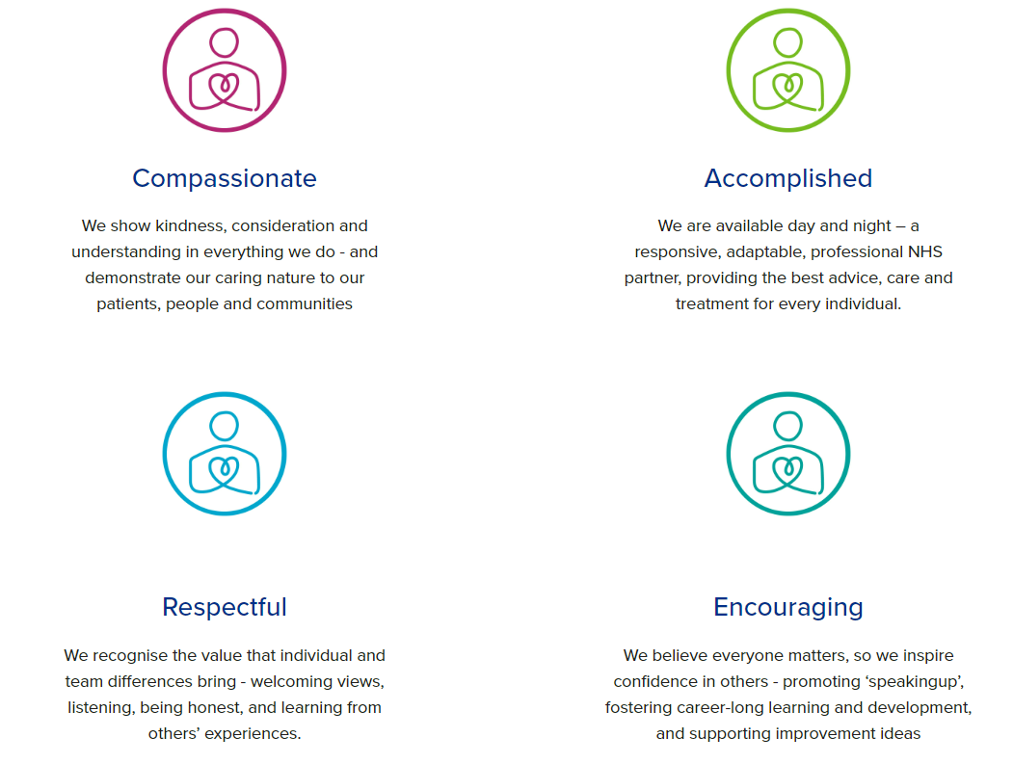

Diversity

DHU Health Care CIC believes our workforce should be as diverse as the range of services we offer, and the communities we serve. We are committed to valuing and encouraging diversity throughout our workforce, regardless of age, disability, gender reassignment, marriage or civil partnership, pregnancy and maternity, race, religion or belief, sex or sexual orientation. As part of our mission, we are dedicated to eliminating discrimination.

Safeguarding

DHU Health Care CIC is committed to safeguarding and promoting the welfare of Adults, Children and Young People and expects all staff and volunteers to share this commitment.

Infection Prevention & Control

Infection Prevention & Control is pivotal in ensuring a safe & clean environment for both patients and staff. IP&C is everyone’s responsibility and strict adherence to the IP&C policy is expected of ALL employees of the organisation.

General
As you will expect, the organisation may change from time to time, and you will be expected to meet the operational requirements of the business and any other reasonable duties as required from time to time.

Acknowledgment

I acknowledge receipt and confirm my understanding and acceptance of the responsibilities specified in my Job Description. Please Note: If you are unclear of any requirement in this document obtain clarification from your line manager.

Signature of Post Holder: |  | Date:
Name:

