Job Description & Person Specification

Position: | Patient Experience & Engagement Lead Nurse / AHP | Division: | Corporate Nursing & Quality
Location: | Roundhouse | Reporting to: | Rhonda Pickering  Deputy Director of Nursing and Quality

Purpose of the Role
The Patient Experience & Engagement Lead Nurse / AHP, will provide senior clinical leadership to deliver DHU’s Patient Engagement & Involvement Strategy (2023–26). The role will strengthen the patient voice, develop patient representatives, embed equality and inclusivity, and lead the full implementation of Civica to drive continuous improvement across services.

Key Success Measures
- Ensure the Civica system is fully embedded across services, with timely reporting of feedback themes and actions.
- Establish and support patient representatives and forums, ensuring diverse voices are actively influencing service development.
- Demonstrate measurable improvements in patient experience through data, stories and outcomes.
- Provide timely, accurate reports and assurance to the Patient Participation and involvement Sub Committee.
- Evidence delivery of equality and inclusivity in engagement activity, ensuring compliance with national standards.

Key Areas of Responsibility & Accountability

- Act as the senior clinical lead for patient experience, accountable for delivery of the DHU Patient Engagement & Involvement Strategy.
- Lead the development and support of patient representatives, advocates, and panels, embedding their input into decision-making.
- Drive equality, diversity and inclusion within all engagement activity, ensuring seldom-heard communities are represented.
- Lead the implementation, training and use of the Civica system, ensuring data drives service improvement.
- Line manage and develop Patient Experience Team
- Provide expert clinical advice to staff and leaders on embedding patient experience in daily practice.
- Ensure compliance with CQC, NHS England and ICS requirements relating to patient experience.
- Produce high-quality reports and evidence for governance and assurance purposes.
- As you will expect the organisation may change from time to time and you will be expected to meet the operational requirements.
- Any other reasonable duties as required from time to time.

Person Specification

The job holder will have:
- Current registration with NMC/HCPC (essential).
- Significant experience in patient experience, service improvement or clinical governance.
- Experience of leading projects or initiatives that improved patient-centred care.
- Experience working with patient representatives, advocates or service user forums.
- Knowledge of CQC, NHS England and ICS standards for patient experience.
- Strong understanding of equality, diversity and inclusion in healthcare.
- Ability to analyse patient feedback data and translate into action.
- Excellent interpersonal, influencing and communication skills.
- Experience of supervising or managing staff.
- Experience of digital engagement systems (desirable).
- Evidence of continuous professional development.

Behavioral Skills

We value our people our people through a coaching culture offering staff engagement, wellbeing support, career progression and inspirational, visible leadership.

At the heart of everything we do, you will find our CARE values – principles, standards and behaviours we live by:

We CARE for you. We are always….

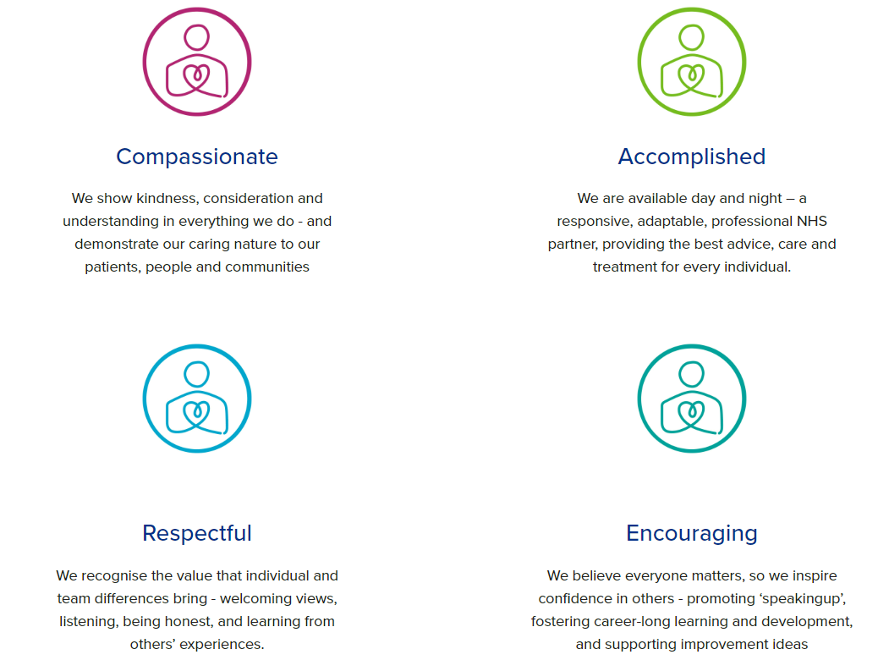

Diversity

DHU believe our workforce should be as diverse as the range of services we offer, and the communities we serve. We are committed to valuing and encouraging diversity throughout our workforce, regardless of age, disability, gender reassignment, marriage or civil partnership, pregnancy and maternity, race, religion or belief, sex or sexual orientation. As part of our mission we are dedicated to eliminating discrimination

Acknowledgment

I acknowledge receipt and confirm my understanding and acceptance of the responsibilities specified in my Job Description.

Please Note: If you are unclear of any requirement in this document obtain clarification from your line manager.

Signature of Post Holder: |  | Date:
Name:

