Job Description & Person Specification

Position: | Advanced Practitioner | Division: | UEC Derbyshire
Location: | Erewash | Reporting to: | Clinical Service Lead

Job Summary

You will be responsible for independently clinically assessing and managing patients booked into an Enhanced Access Hub in Erewash. The hubs are Monday to Friday 1830hrs to 2030hrs at Ilkeston Community Hospital and Long Eaton Health Centre and Saturday and Sunday from 0900hrs to 1700hrs.

You will be responsible for practicing independently, clinically assessing, and managing patients with a wide spectrum of conditions. You must be an advanced practitioner with primary care experience and an independent prescriber.

If you reflect our DHU Values, which are caring and compassionate, accomplished, respectful and encouraging then we want to hear from you!

At DHU you will enjoy the following benefits:-
1. Attractive pay structure.
2. Full NHS PENSION
3. NHS continuous service for annual leave.
4. Maternity and paternity leave
5. Access to private healthcare
6. Funded study leave
7. Funded courses (university, external etc)
8. Pay enhancements for OOH and overtime.

We’re confident in our people - rewarding them for their hard work and commitment. Alongside competitive salaries, you’ll find we offer a career framework that gives individuals the opportunity to grow in our company.

For more information on this role or to arrange an immediate interview contact caroline.hannan@dhuhealthcare.nhs.uk

Key Areas of Responsibility & Accountability

Clinical
• To practice autonomously without direct supervision.
• To utilise advanced clinical skills to assess, diagnose, treat and refer patients requiring the clinical service
• To recognise the need for, initiate and where appropriate interpret relevant diagnostic investigations.
• To recognise the need for and initiate where appropriate advice of relevant specialisms.
• To exhibit excellent nonverbal and verbal communication skills when dealing with patients and carers. To have the ability to make clear decisions with confidence and communicate these effectively.
• To maintain appropriate clinical records in line with current practice guidelines.
• To work within the parameters of your skills and knowledge, recognising the limitations to your own practice and to work within the bounds of your training and capability according to regulatory codes of conduct.
• To maintain an awareness of developments in clinical practice.
• To optimise evidence based practice.
• To work effectively as part of a multi professional team in collaboration with other members of the service.
• To adhere to performance measures.
• To provide health promotion/accident prevention advice for patients and carers.
• To promote the protection of children and vulnerable adults in accordance with local safeguarding procedures.
• To adhere to the Infection Prevention and Control policy for the service being provided.
• To prescribe medication and work within the limitations of current extended Non-Medical Prescribing legislation.
• Discharge or refer patients as appropriate to internal or external clinical pathways.
• The ordering, storage, administration and disposal of medicines in a safe, secure manner in accordance with current policy and legislation.

Managerial
• Take part in clinical audits.
• To attend professional meetings and participate in team meetings.
• The Clinician will work within guidelines and policies and will support the implementation of policies in own work area and participate in working groups as required.
• To lead and participate in clinical audit cycle as required.
• Participate in inductions for newly appointed staff.
• Responsible for day-to-day supervision, delegation and co-ordination of staff making the best use of their abilities as appropriate.
• To participate in the appraisal process for themselves and others as appropriate.
• To identify, report and address poor performance issues.
• To diffuse challenging behavior, ensuring that the situation is managed in a sensitive way.
• To ensure efficient and effective use of material resources/supplies.
• To identify any problems with resource use/availability and make recommendations for corrective action.

Clinical Governance
• To participate in the clinical governance requirements within the work of the organisation.
• To practice with the parameters of company policies, protocols and guidelines.
• To participate in quality improvement within the organisation.
• To assess and evaluate outcomes of own practice, service intervention and treatment and identifies any short falls in service reporting to relevant managers.
• To provide mentorship leadership and training to other team members.
• To ensure the requirements of Health and Safety policy and legislation are maintained.
• To participate in research and development activities of DHU Health Care.

Education Practice Development
• To participate in the clinical supervision framework for health care professionals within the company.
• To offer appropriate advice to health and social care professions on care practices, delivery and service development within the parameters of the role and scope of practice.
• To participate in the ongoing individual professional development within the organisation
• To mentor and role model as appropriate in the development of triage consultation, the mentorship of junior staff and students.
• To complete the mandatory training programme to ensure compliance at all times.

Professional
• To work within the regulatory requirements, codes and Professional Standards of practice of the NMC/HCPC/GPhC
• To maintain professional and clinical competence through mechanisms of continuing professional development.
• To act in such a manner at all times to promote confidence and public trust and uphold the reputation and image of DHU Health Care CIC.

Person Specification

Qualification | Essential | Desirable
Qualifications  Academic/ professional | - Registered Adult Nurse registered with the Nursing & Midwifery Council (NMC), Paramedic registered with the Health Care Professions Council (HCPC) or Pharmacist registered with the General Pharmaceutical Council (GPhC).  - Registered as an independent non – medical prescriber.  - A minimum of 2 modules at Level 7. 1 X module must have included assessment of clinical examination skills. | - MSc (Advanced Practice)  - Mentorship qualification
Experience | - Substantial Autonomous practice working and multi-professional team  - Can show evidence of using autonomous physical examination and assessment skills in practice  - Can demonstrate a broad and sound knowledge of complex and common conditions in primary care in both adults and children  - Has experience in one of the following: nurse led clinics, emergency care centres ,out of hours facilities or walk in centres  - Consolidated Independent Prescribing experience. | - Experience of General Practice
Skills & Knowledge | - Can complete a concise clinical history and physical examination.  - Can formulate a differential diagnosis and management plan.  - Prepared to participate in service development  - Demonstrable awareness of accountability in clinical practice  - Can give evidence of using effective communication skills within practice  - Must have excellent verbal and written skills  - Computer literate  - Is able to use negotiation skills  - skills, employing critical thinking.  - Ability to identify individual client needs  - Able to prioritize, effective time management.  - Commitment to lifelong learning  - Counselling & communication skills  - Facilitation & negotiation skills  - Aware of current structures and developments in out of hours care, health and social care  - Specialist clinical/Technical skills
Job Circumstances | - Commitment to the role. Able to work unsocial hours including bank holidays  - Flexibility to meet service/Rota needs
Personal Qualities | - Proven team player  - Able to work autonomously  - Committed to continuing professional development  - Positive effect  - High level of interpersonal skills  - Willingness to continue with additional training to achieve a full MSc in advanced clinical practice.

Behavioural Qualities

We value our people our people through a coaching culture offering staff engagement, wellbeing support, career progression and inspirational, visible leadership.

At the heart of everything we do, you will find our CARE values – principles, standards and behaviours we live by:

We CARE for you. We are always….
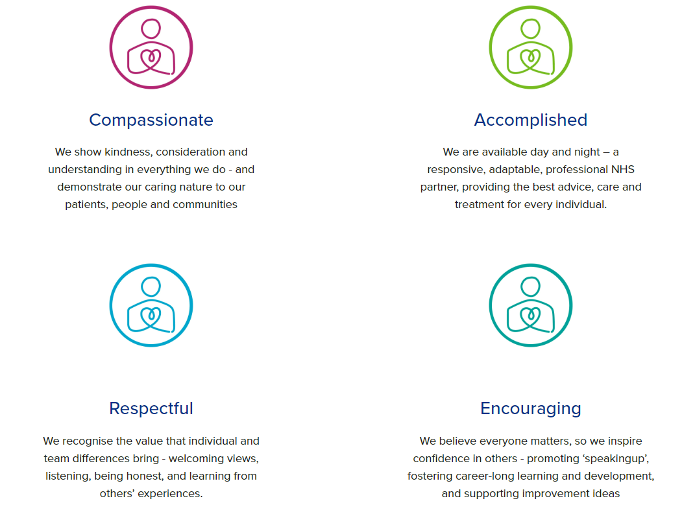
Diversity

DHU believe our workforce should be as diverse as the range of services we offer, and the communities we serve. We are committed to valuing and encouraging diversity throughout our workforce, regardless of age, disability, gender reassignment, marriage or civil partnership, pregnancy and maternity, race, religion or belief, sex or sexual orientation. As part of our mission we are dedicated to eliminating discrimination

Acknowledgment

I acknowledge receipt and confirm my understanding and acceptance of the responsibilities specified in my Job Description.

Please Note: If you are unclear of any requirement in this document obtain clarification from your line manager.

Signature of Post Holder: |  | Date:
Name:

