Job Description & Person Specification

Position: | Care Navigator | Division: | Primary Care
Location: | Eyam Surgery | Reporting to: | Practice Manager

Purpose of the Role

To provide an efficient and friendly service to all who visit the surgery as well as colleagues and clinicians working at the surgery. To always have the best interest of the patients in mind.

Key Areas of Responsibility & Accountability

- As you will expect the organisation may change from time to time and you will be expected to meet the operational requirements.
- Any other reasonable duties as required from time to time.
- Open up and lock up Eyam and Bradwell Surgery
- Be courteous and friendly when speaking to patients on the telephone as well as face to face.
- Make appointments for patients with the clinical team and other services that use the surgery using the clinical system in place.
- Read and adhere to surgery policies and protocols
- Take part in virtual and practical training, and attend team meetings as often as is practical
- Ensure all messages are passed on as quickly as possible to the right member of the team – either by using the electronic message system or by telephone, guided by surgery protocols
- Check incoming emails and respond to them appropriately, as well as checking your own emails on a regular basis
- Signpost patients to other services that are more appropriate than an appointment with a GP, such as: community pharmacists, social prescribing, virtual pharmacists and physiotherapy.
- Inform the patient if the doctor is running late and if they have a student doctor with them.
- Contact patients with test results and other tasks on behalf of the clinicians.
- Accept and process patient's repeat prescription requests and flag any queries to the doctor/pharmacy team.
- Let the secretary know when the daily post has arrived.
- Keep the waiting areas are always tidy, check the posters and leaflets are up to date – and remove anything that is out of date.
- Ensure that the reception area is also kept tidy,
- Tidy and empty the bins in the doctor’s rooms after or before surgery commences each day.
- Travel to, and work at either surgery as or when required.
- Receive monies from patients, record and balance the takings at the end of each shift.
- Be aware of the H&S at work act 1974 for your own safety as well as for others, carrying out tasks following the guidelines written in Eyam Surgery’s H&S policy.
- Always wear the appropriate uniform and name badge.
- Carry out other tasks not featured on the job description.
- Provide appropriate and necessary, flexible support, covering staff absences that are both planned and unscheduled.
- Any conflicts with longstanding personal arrangements will be assessed and discussed with the Practice Management Team should a conflict occur.
- Confidentiality: Always keep all information regarding staff and patients confidential

Person Specification

- Excellent communication and interpersonal skills
- Strong organisational and multitasking abilities
- A patient-focused, compassionate approach
- Confidence using IT and digital systems
- Ability to work well in a busy team environment
- Commitment to confidentiality and safeguarding principles
- Flexibility to support service and rota needs

Behavioral Skills

We value our people our people through a coaching culture offering staff engagement, wellbeing support, career progression and inspirational, visible leadership.

At the heart of everything we do, you will find our CARE values – principles, standards and behaviours we live by:

We CARE for you. We are always….

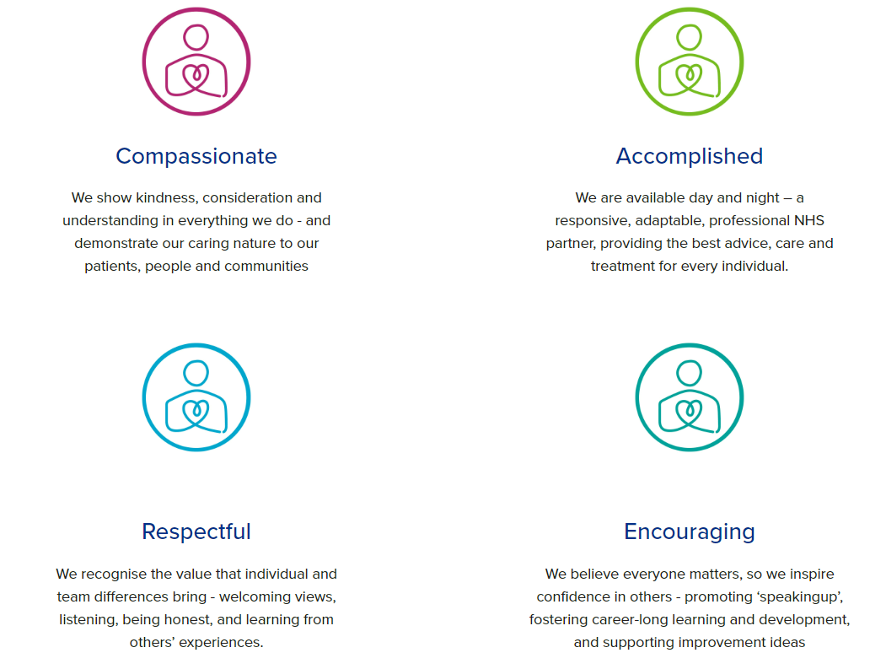

Diversity

DHU believe our workforce should be as diverse as the range of services we offer, and the communities we serve. We are committed to valuing and encouraging diversity throughout our workforce, regardless of age, disability, gender reassignment, marriage or civil partnership, pregnancy and maternity, race, religion or belief, sex or sexual orientation. As part of our mission, we are dedicated to eliminating discrimination

Acknowledgment

I acknowledge receipt and confirm my understanding and acceptance of the responsibilities specified in my Job Description.

Please Note: If you are unclear of any requirement in this document obtain clarification from your line manager.

Signature of Post Holder: |  | Date:
Name:

