Job Description & Person Specification

Position: | Assistant Practitioner- Point of Care Testing | Division: | UEC-UTCs
Location: | Urgent Treatment Centres | Reporting to: | Head of Clinical Services

Purpose of the Role

The Assistant Practitioner for Point of Care Testing (POCT) will be part of a multi-professional/skilled team and will contribute to day-to-day delivery of the POCT service across the Urgent Treatment Centres (UTCs) operated by DHU Health Care CIC. The post holder will have specific responsibilities for providing an efficient, cost effective and timely POCT service to equipment users. This will involve maintaining specialised POCT equipment, including trouble shooting, performing and recording internal quality control and external quality assessment processes, delivering training, and undertaking audits. Following appropriate training, the post holder will work without direct supervision, undertaking delegated tasks and reporting back to the relevant member of the clinical or management team.

Key Success Measures

- Provision of comprehensive support to POCT equipment users.
- Effective management of POCT consumables- including monitoring usage, ordering and storage of these.
- Undertaking of internal and external QC processes and required documentation
- Troubleshooting and fault finding, ensuring remedial action is taken, which may involve liaising with manufacturers.
- Provision and recording of training to all Point of Care equipment users.

Key Areas of Responsibility & Accountability

- To provide support and troubleshooting services to maintain essential POCT equipment used in acute clinical areas. Equipment includes blood analysers, blood glucose devices, urinalysis and pregnancy testing.
- To assist in management, ordering, replenishment, storage of all equipment and consumables used in POCT within the DHU UTCs.
- To assist in the delivery, maintenance and accurate recording of equipment assurance checks in line with quality requirements and agreed schedules of work
- To assist in the delivery of equipment calibration and quality control checks as directed, and in line with quality requirements and agreed schedules of work.
- To support the effective reporting of missing or damaged equipment.
- To perform validation and verification of new equipment for new projects/ developments and replacement equipment
- To provide training of clinical staff in the operation of POCT equipment
- Contribute towards the formulation of policies, standards and procedures for the POCT pathways
- To continue with personal development through academic or practical experience
- To complete mandatory training programme and always ensure compliance with this
- Attend all operational meetings including team meetings.
- Develop, evaluate and share good working practice.
- Report any complaints or incidents on the appropriate forms and provide further information if required in a timely manner.
- To comply with all Company policies, procedures and practices and to be responsible for keeping up to date with any changes to these.
- As you will expect the organisation may change from time to time and you will be expected to meet the operational requirements.
- Any other reasonable duties as required from time to time.

Person Specification

The job holder will have the relevant qualifications, experience and skills to excel in this job role, as further explained in the table below.

(E)- Essential
(D)- Desirable

Academic/Professional  Qualifications | - Good standard of general education including 4 GCSEs Grades A-C or equivalent including English and Maths (E)  - NVQ Level 2 or equivalent (E)  - Completed or undertaking Assistant practitioner foundation degree (E)
Experience | - Experienced in working with Point of Care analysers (D)  - Communication with a variety of people (E)  - Computer experience (e.g. Word/Excel and other packages) as well as email systems and other electronic media (E)  - Previous healthcare experience essential minimum of 5 years in similar role (E)  - Experience of phlebotomy (D)  - Experience of undertaking audit (D)  - Time management and prioritising skills (E)  - Leadership skills (D)
Practical & Intellectual Skills | - Ability to effectively manage own time and prioritise own workload (E)  - Ability to work as both individual and member of the wider team (E)  - Ability to implement and evaluate care programme (D)  - IT skills (E)  - Effective communication skills with a variety of media and all levels of staff with the company as well as external agencies (E)  - Ability to use initiative (E)  - Excellent and accurate record keeping (E)  - Excellent telephone manner (E)  - Good at problem solving (E)  - Listening skills (E)  - Effective time management – strong organisational skills (E)  - Ability to maintain strict levels of confidentiality (E)  - Phlebotomy and cannulation (D)  - Maintenance of IP&C procedures and documentation (D)
Circumstances - Personal | - Full UK driving licence (E)  - Ability to travel to all UTC sites (E)  - Commitment to role (E)  - Able to work unsocial hours (E).  - Flexibility to meet service/rota needs (D)  - Willingness to undergo any training/ development/ adjustment as required by the UTC leadership team and the organization (E)  - Highly motivated(E)  - Flexible and adaptable as may be asked to assist other services to ensure DHU continues to provide care services (E)  - Can manage multiple tasks and work streams concurrently (E)
Disposition/Adjustment/  Attitude | - Proven team player (E)  - Responsive to feedback and proactive in the role development (E)  - Able to work in high pressure environments (E)

We value our people through a coaching culture offering staff engagement, wellbeing support, career progression and inspirational, visible leadership.

At the heart of everything we do, you will find our CARE values – principles, standards and behaviours we live by:

We CARE for you. We are always….

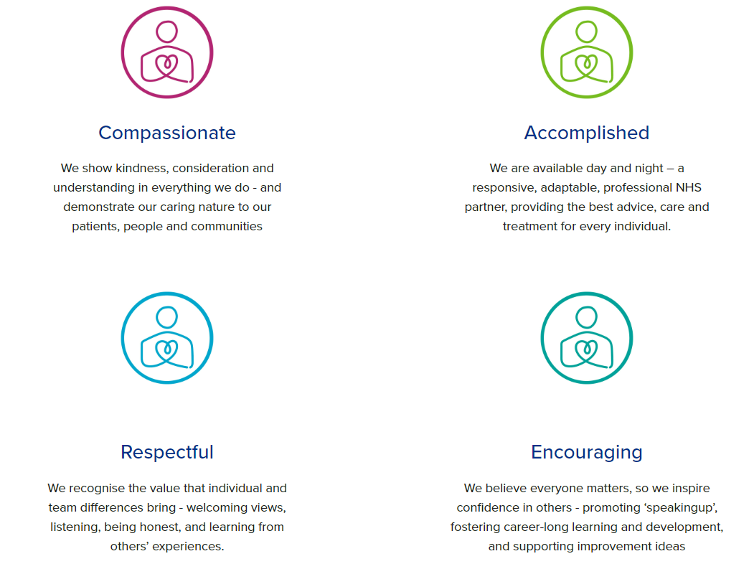

Diversity

DHU believe our workforce should be as diverse as the range of services we offer, and the communities we serve. We are committed to valuing and encouraging diversity throughout our workforce, regardless of age, disability, gender reassignment, marriage or civil partnership, pregnancy and maternity, race, religion or belief, sex or sexual orientation. As part of our mission we are dedicated to eliminating discrimination

Acknowledgment

I acknowledge receipt and confirm my understanding and acceptance of the responsibilities specified in my Job Description.

Please Note: If you are unclear of any requirement in this document obtain clarification from your line manager.

Signature of Post Holder: |  | Date:
Name:

