Job Description & Person Specification

Position: | Business Support Administrator | Division: | Primary Care
Location: | Eyam Surgery & Bradwell Surgery | Reporting to: | Cassie Jackson (Practice Manager)

Purpose of the Role

- To work as an Administrator supporting Primary Care
- To support the delivery of safe and effective services across DHU Urgent Care
- To assist in the efficient and effective provision of administrative support to the Operations and Clinical Teams, required to support the delivery of DHU Primary Care contracts and services
- To ensure compliance with standards in line with agreed policies and procedures; reporting all incidents, complaints, professional feedback and issues occurring
- Any other duties requested by management

Key Success Measures

- To work with a high degree of accuracy in relation to written materials produced
- To deliver work to deadline, managing competing priorities and re-prioritising task as required. Where escalation is required, this should be done in a timely fashion.
- To work with high degree of efficiency and organisation in relation to the areas of responsibility and active task
- To demonstrate cost consciousness in relation to the areas of responsibility: e.g. Fosse House stationary; the sourcing of new suppliers etc.
- At all times ensure own work practices, conduct, behaviour and attitudes provide an example of professionalism for all staff. Be a role model for DHU values.
- At all times ensure that your own actions support and promote equality, diversity and the rights of patients, the public and colleagues within the service.
- Ensure effective management of risk within sphere of responsibility in accordance with DHU Risk Strategy, ensuring compliance with Health & Safety legislation and Clinical Governance Policies and Guidelines

Key Areas of Responsibility & Accountability
- To assist as required in the delivery of general administrative support duties such as (but not limited to): diary management, meeting support, minute taking, collecting information, copying; laminating; filing and other administrative tasks.
- To hold administrative oversight in the timely completion of incidents and complaints.
- To provide support in the administration of agreed meetings: scheduling; room booking; agenda & papers preparation / circulation; minute taking and action log administration.
- To support in the production of required monthly Board Reports within agreed templates. To include (but not limited to) simple data manipulation; the production of tables / graphs within Excel using provided data.
- To provide administrative support in relation to the tracking and compliance with Mandatory Training, appraisals and absences.
- Support with organising events such as PLT / QUEST
- Undertake simple data entry for systems such as FFT / CQRS / audit
- Help prepare induction packs for new starters
- To maintain oversight ensuring good organisation; location; labelling of all files stored on the relevant DHU Shared Drive
- To ensure compliance with standards in line with agreed policies and procedures; Reporting all incidents, complaints, professional feedback and issues occurring
- Contribute towards the formulation of policies, standards and procedures for LLR as required
- To actively participate in promoting and advancing DHU Health Care CIC
- To support any other duties requested by senior management, and chairs of directorate meetings.
- As you will expect, the organisation may change from time to time and you will be expected to meet the operational requirements
- Any other reasonable duties as required from time to time.

Person Specification
- All employees are subject to the requirements of the Health and Safety at Work Act. The post holder is required to ensure, as an employee, that his/her work methods do not endanger other people or themselves.
- All employees are subject to the requirements of the GDPR and must maintain strict confidentiality in respect of patients and staff records.
- All employees must comply with the Equality and Diversity Policy and must not discriminate on the grounds of race, colour, nationality, ethnic or national grounds, sex, marital status, disability or any other grounds which cannot be shown to be justifiable.
- Adhere to all procedures, protocols and other relevant memorandum as appropriate
- Attend training and meetings as and when required to do so by Management
- Notify the appropriate line Manager immediately of any circumstances, which may affect the provision of a high-quality service.
- The job description may be reviewed in the light of changed service needs and developments. Any changes will be fully discussed with the post-holder.

Behavioural Skills
We value our people through a coaching culture offering staff engagement, well-being support, career progression and inspirational, visible leadership.

At the heart of everything we do, you will find our CARE values – principles, standards and behaviours we live by:

We CARE for you. We are always….

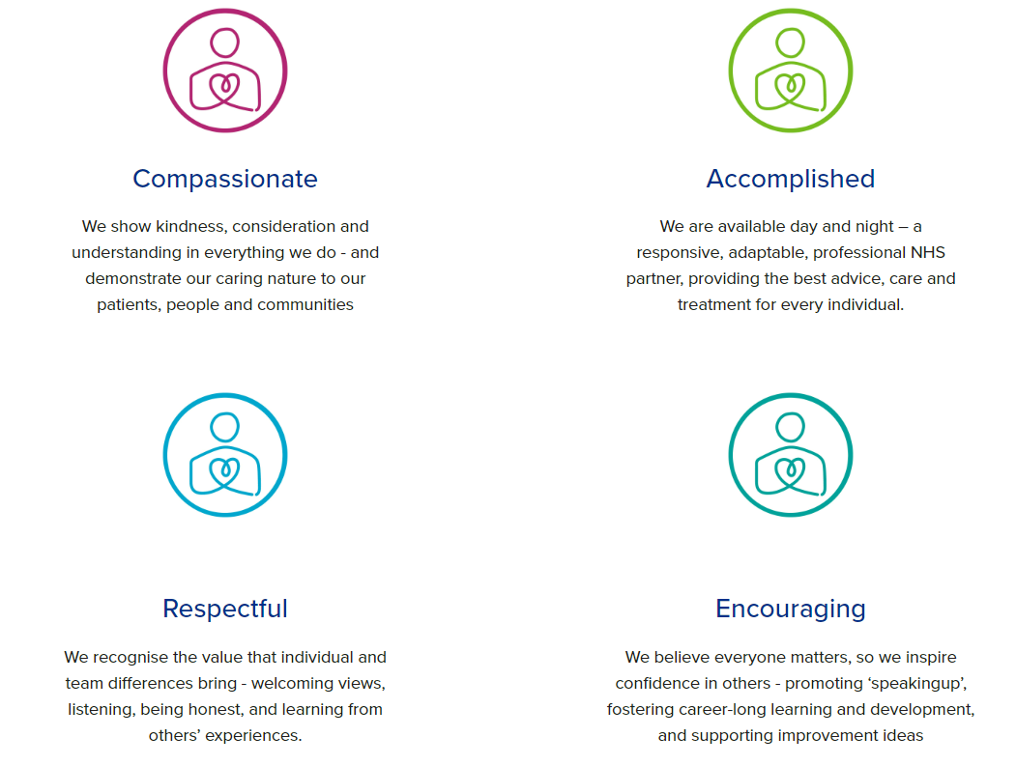

Diversity

DHU believe our workforce should be as diverse as the range of services we offer, and the communities we serve. We are committed to valuing and encouraging diversity throughout our workforce, regardless of age, disability, gender reassignment, marriage or civil partnership, pregnancy and maternity, race, religion or belief, sex or sexual orientation. As part of our mission, we are dedicated to eliminating discrimination

Acknowledgment

I acknowledge receipt and confirm my understanding and acceptance of the responsibilities specified in my Job Description.

Please Note: If you are unclear of any requirement in this document obtain clarification from your line manager.

Signature of Post Holder: |  | Date:
Name:

